QUOTATION

To: Master Box Embalagens Especiais Ltda

Attn: Jose

Date: May 24th, 2017

HM-500B Automatic Box Forming Machine

Picture | Specification | Unit/Price FOB SHENZHEN,CHINA | Delivery Date
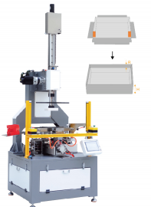 | Box Max size:500x400x120mm | USD18250/set | 18days
 | Box.Min size:90x50x10mm
 | Speed:0-30pcs/min
 | Greyboard Thickness:1.2-6mm
 | Paper Thickness: 80-270gsm
 | Folding-in Depth:10-80mm
 | Corner Edge:10-80mm
 | Power/ Voltage: 3.8kw/AC220V
 | External Pressure: 0.6-0.8MPa
 | Displacement(Max.): 0.1m3/min
 | Net Weight: 1200kg
 | Dimension:1100x1000x2800mm
Function and Features:
1. The movements of mainshaft, molding, wrapping, folding-in, and bubble pressing, which are all driven by servo motors and cam boxes, guarantee a quite and stable operation circumstance and smooth mechanical process.
2. Besides the cam for pressing the contingent bubble, there are 4 cylinders for additional bubble pressing, solving the thicker paper issue and worse glue issue.
3. Every process can be in Inching Model synchronously, helping you to observe the production details and adjust to the best parameters.
4. Folding Corner Edge is up to 80mm as standard, or it can be customized to 150mm, and this is controlled by rails and cylinder, which is adjustable and precise.
5. Vacuum fan to keep the box on the machine, and this tension can be adjusted according to the sizes of the boxes.
6. Controlled by PLC。It takes only 15 minutes to change to another box.
7. Imported optical grating transducer protects the operator from operation injury.
8. Computer control with error auto stop and display.

9. Table board and frame are processed by CNC by one time and enjoy durable quality.

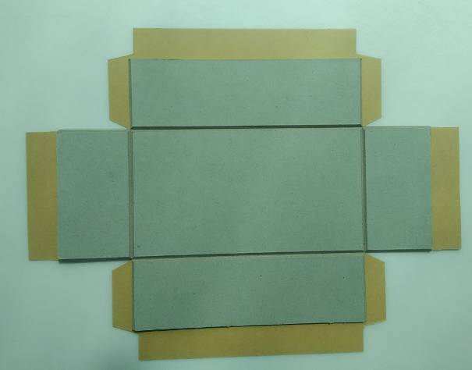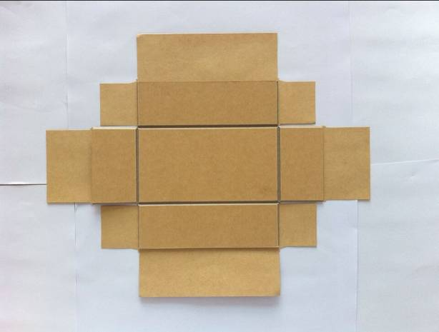

Note:
- Above price is valid for 30days, and it doesn’t include the installation charges

- If customer want manufacturer to send technician to install and train the operation. The customer should bear the come and back ticket fee, housing, eating and transporation fee in customer local side.

- Price is only for standard. Other special requirements should discuss further.

- Guarantee: One year

- Package: Vacumm packing + Wooden Case

