  Changzhou Chaoli Homogenizing Pump Factory |  |  | Date:7,Nov,2017
Tel: +86(519)-88796886 Fax: +86(519)-88790568 |  |  | Expire date: 31,Dec,2017
 | Web Page: http://www.cljzb.com
 | annewang1997@outlook.com
QUOTATION
From: Anne Wang |  | To： zaouadi
Tel: +8615061345090 |  | Tel： 00213661116192
Mail: annewang1997@outlook.com |  | Mail： zaouadimohamedcherif@gmail.com
Changzhou Chaoli
Company: Homogenizing Hump |  | Skype: rentier.666
Factory
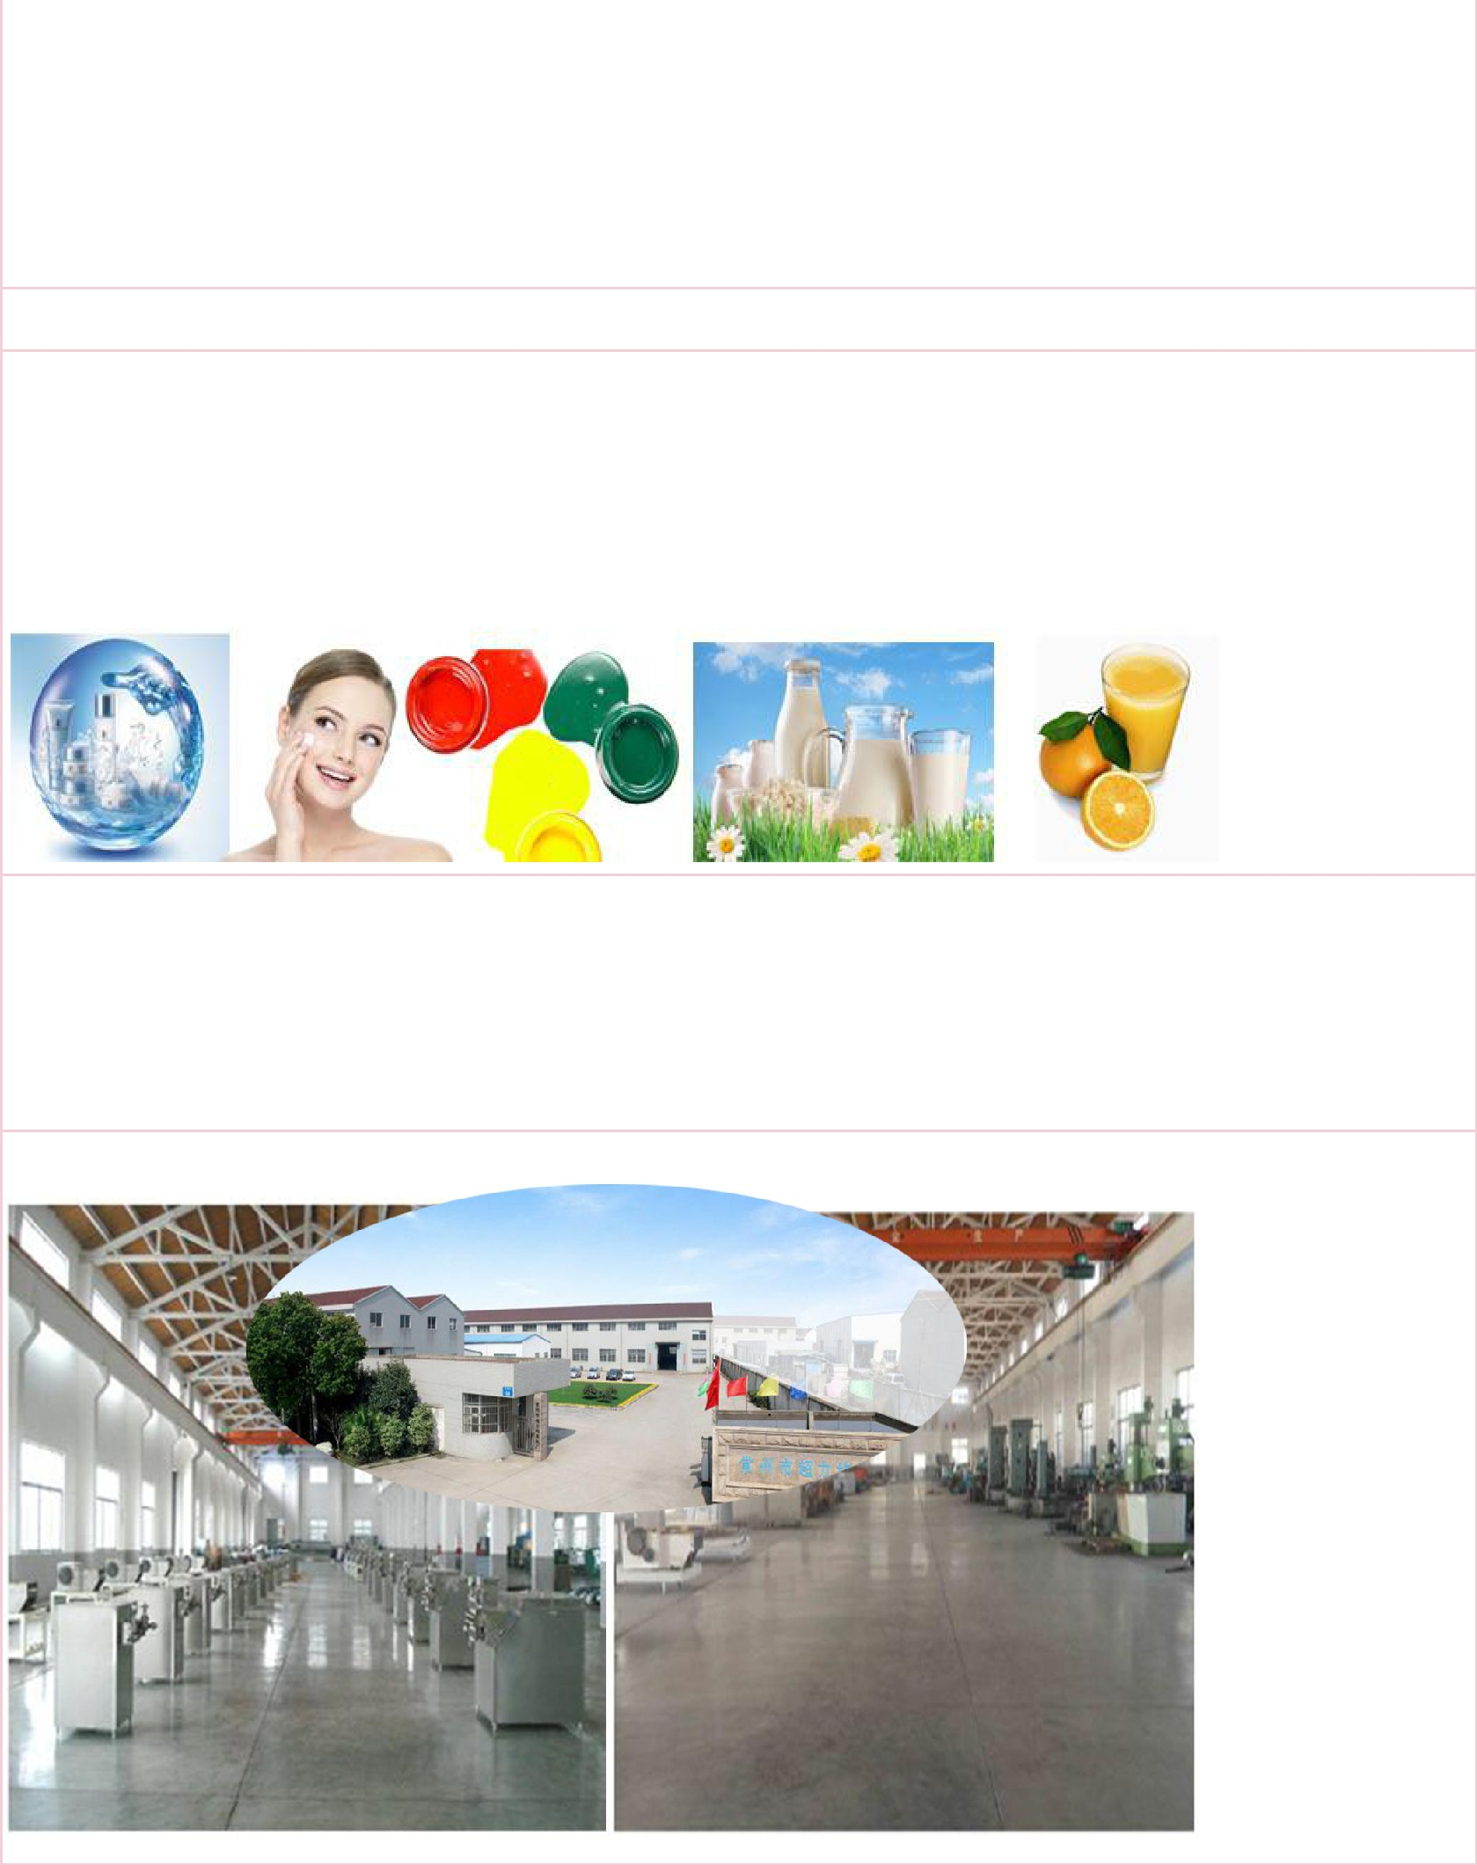
Thank you for your cooperation!

Application:

High pressure homogenizer is a kind of versatile equipment which can make liquid substance into homogeneous thin.
- Apply for drink and food industry such as milk, yogurt, ice cream, honey and so on.

- Apply for cosmetic, lipstick, skin cream, shampoo and so on.

- Apply for medicine, dye, additives, grease.

Advantages:

1.Noise of transmission is lower than noise of motor. The pointer of pressure meter is steady, and also the range of swing of pointer is less than 2M Pa.

2.The machine is very hygienic and easy to clean with fully enclosed stainless steel structure. 3.we have our own factory.

Factory
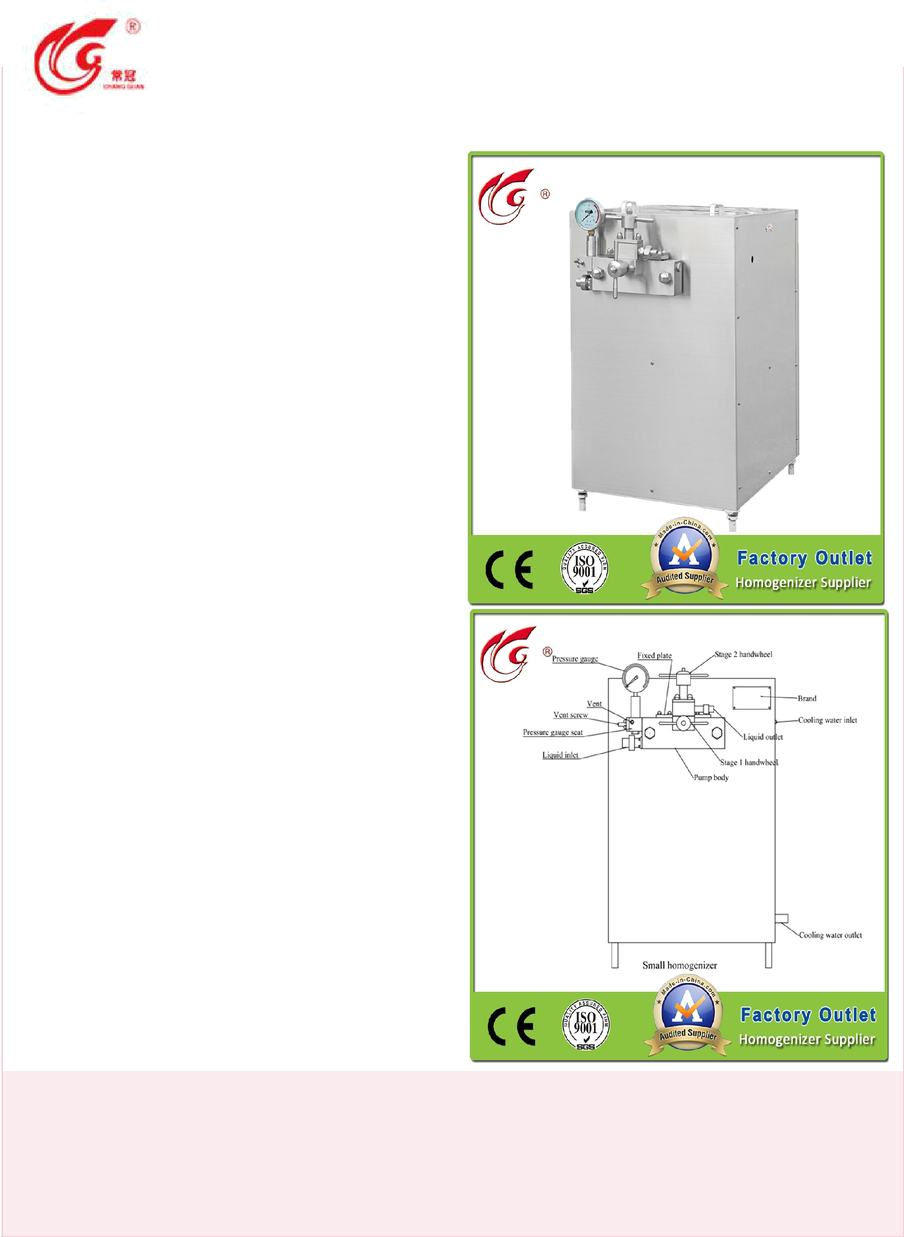 |  | Changzhou Chaoli Homogenizing Pump Factory |  | Date:7,Nov,2017
 |  | Tel: +86(519)-88796886 Fax: +86(519)-88790568 |  | Expire date: 31,Dec,2017
 |  | Web Page: http://www.cljzb.com
 |  | annewang1997@outlook.com
 |  | Product
 | Model | GJB1500-25
 | Material | stainless steel 304
 | Port | Shanghai
 | Certificate | CE, ISO9001
 | Customized | any customized for you
 | Size(cm) | 105x65x110
 | Weight(kg) | 720
 | Power(KW) | 7.5
 | Voltage | 380V， 50Hz, 3phase
 | Pressure(Mpa) | 25
 | Origin | Changzhou
 | Package | Plywood case
 | Brand | CHANGGUAN
 | HS CODE | 8479820090
 | Output | 300 sets/year
 | Rated flow | 1500L/H
 | Price | $3,200
 | (FOB Shanghai) | $3,200
 | Price for electric box | $457
 | （FOB Shanghai)

Notes:1. payment: 40%t/t in advance, the balance to be paid before delivery.

2. producting time:25 days after receiving your 40% payment. delievery time: 5 days after receiving your balance payment.

3.the offer will be expired on 31, Dec, 2017. 4.port of loading: shanghai, china

