FERIA Construction Trade Show 2015
Date: 10.21-10.24.2015
Venue: Santiago Exhibition Centre, Chile
Booth No: 412-EDAD
Sample machine: BMU gondola, SC Construction hoist, STP Material hoist
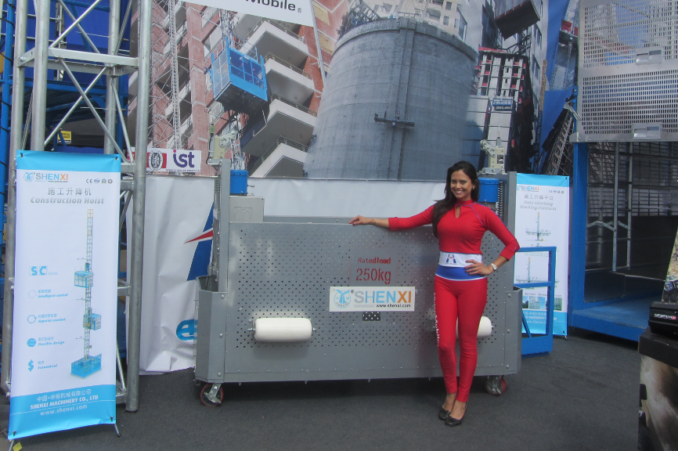

BIG 5 SHOW 2015
Date: 11.23-11.26.2015
Venue: Dubai World Trade Centre
Booth No: Saeed-1 H264-260
Sample machine: Suspension platform, Mast climbing work platform
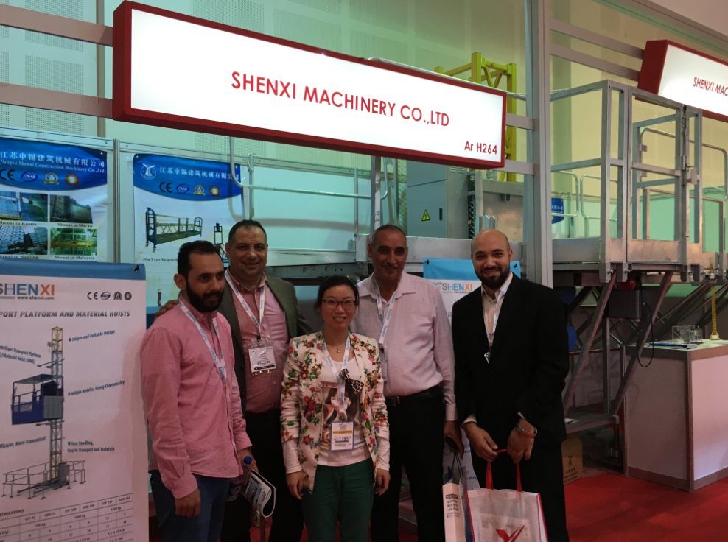

BAUMA Germany 2016
Date: 4.11-4.17.2016
Venue: Messe Munich international
Booth No: A1.514B
Sample machine: Hanging scaffold
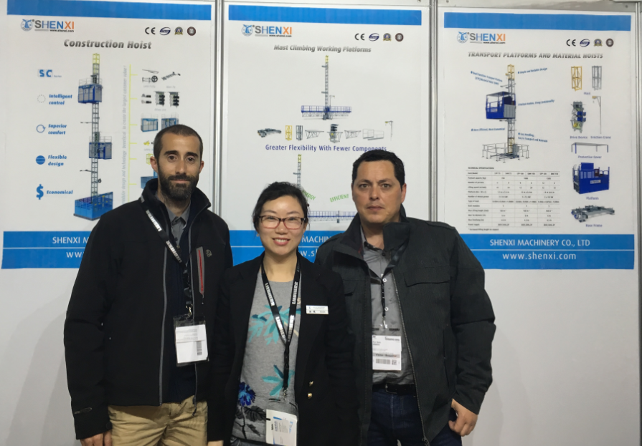
The 123th Canton Fair
Date: 4.15-4.19.2018
Venue: China Import and Export Fair Complex, Guangzhou
Booth No: 4.0H14-15
Sample machine: ZLP Suspended platform, Loading platform


