WUXI ZHENDA AUTOMATION EQUIPMENT CO., LTD.
Add:No.3, C District, Private Economy,Xibei, Wuxi,Jiangsu Province, China
TEL:+86-510-83137670 FAX:+86-510-83135092
Skype: roy5386293 Email:chinazhenda@gmail.com Web:www.zdplatform.com
Contact: Roy Qiu
QUOTATION
Date:22/5/2018

Suspended Platform
Product Model | Configuration | UNIT PRICE(FOB SHANGHAI) | Qty | Amount
ZLP800 | *Material-steel(surface plastic coating)  *2 Hoist Ltd8.0(220v/60hz/3phases/1.8kw)  *1 Electric control panel  *4 Steel Wire rope 100m, dia 8.6mm  *1 Power supply cable 3phase 100m, 3×2.5mm²+2×1.5mm²  *2 Safety locks, anti-tilting type  *1 Set Platform 7.5m(2.5+2.5+2.5)  *2 Set Suspension Mechanism  *2 Wall Wheels  * Without counter weights  *4 pcs Cable Weights(cement)  *1 set Assorted Nuts and bolts  *4 pcs nylon wheels ( under the platform) | 1968 USD | 12 sets | 23616 USD
Freight to Lima Peru:2050 USD
Total CFR Peru:25666 USD

1. Terms of validity: 1 month.
2. Payment: 30% paid in advance by T/T, balance 70% paid by T/T after customer’s inspection before
delivery.
3. Time of Delivery: 15 working days after receipt of the payment.
4. Packing: polywood Pallet
5. Warranty: 1 Year.
6. MOQ: as above.
7. FOC spares with order.

SAMPLE PHOTO FOR REFERRANCE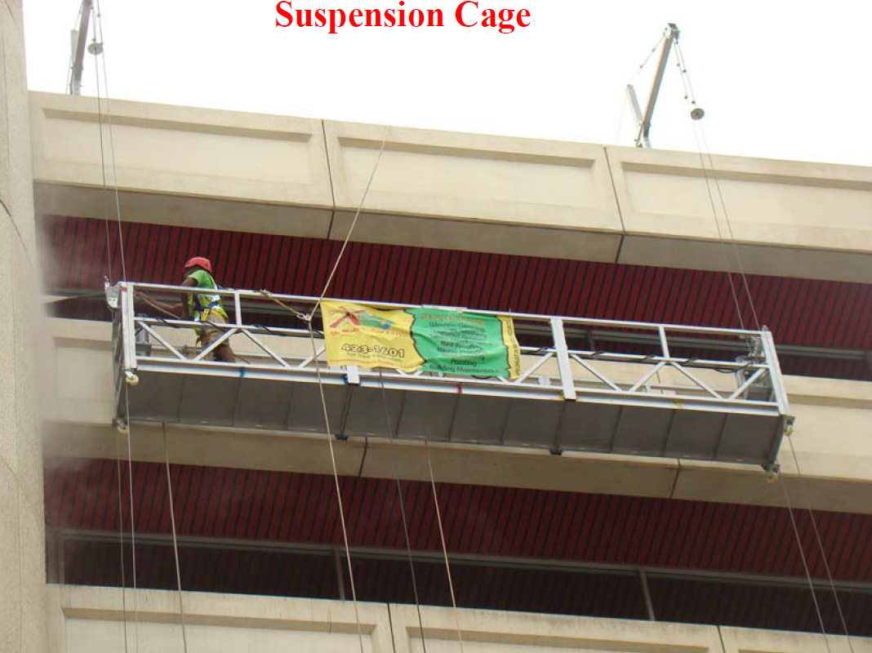
Suspension
Mechanism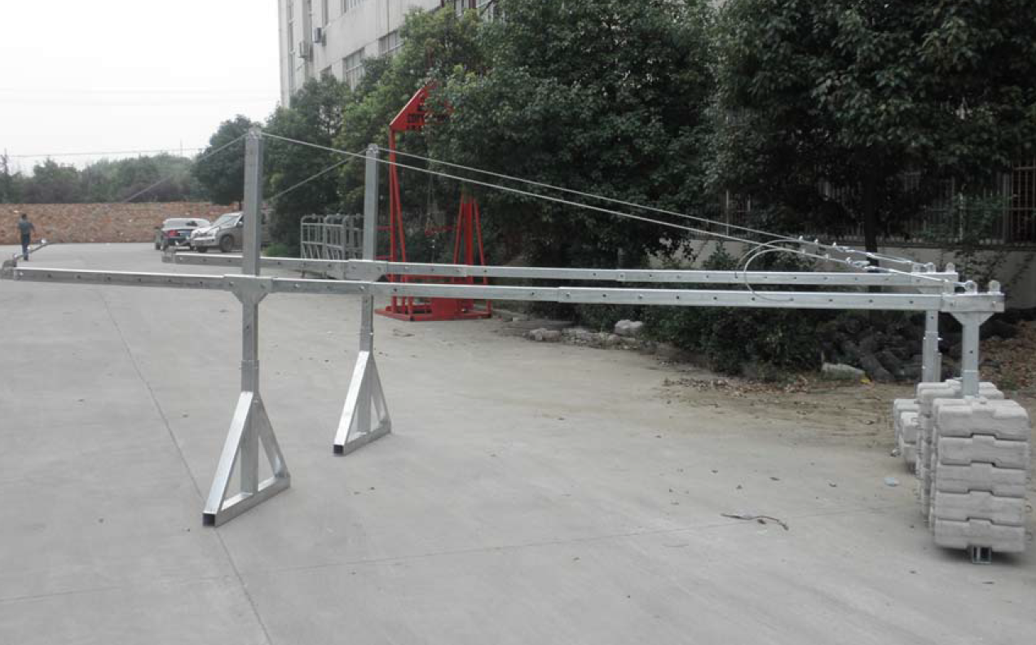

Hoist Safety Lock Electrical Box
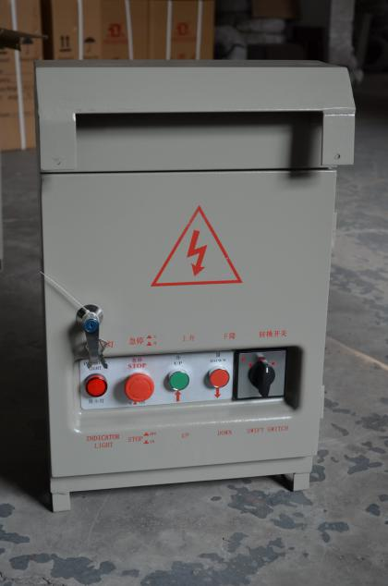
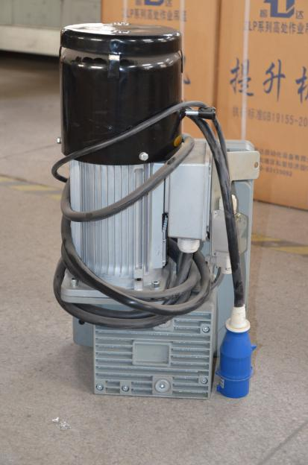
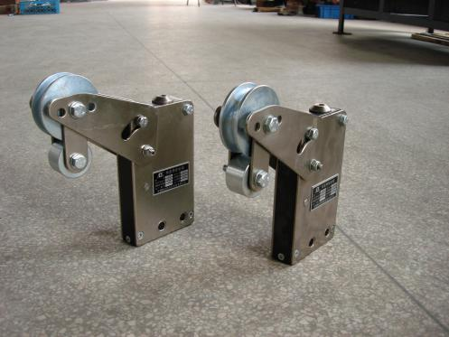

Steel Wire Rope Power Cable Counter weights(without)
