WEIFANG DRAGON MACHINERY TECHNOLOGY CO., LTD

DRAGON RUBBISH SALVAGE BOAT
MODEL: DGTSB-40

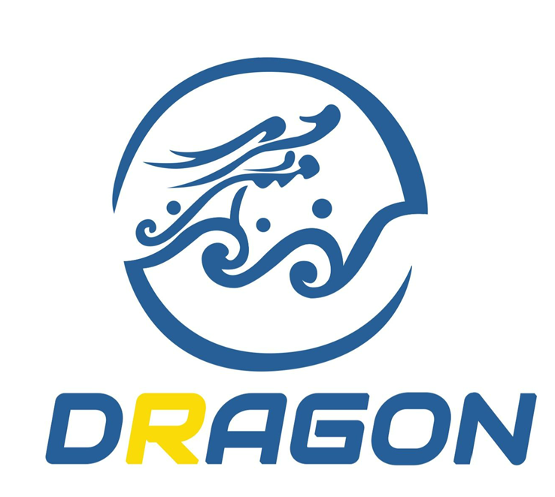

Weifang. China
2018-06-03
Quotation

Description Quantity Unit Price Total Price
------------------------------------------------------------------------------------------------------------------------------------------
DGTSB-40 RUBBISH SALVAGE BOAT 1 set USD 210,000/SET USD 210,000
------------------------------------------------------------------------------------------------------------------------------------------
Total ( FOB QINGDAO, CHINA) USD 210,000
SAY: US DOLLARS TWO HUNDRED AND TEN THOUSAND ONLY.
REMARKS:
- Payment Term:
30% of the total payment should be paid by T/T as deposit;
The balance should be paid before delivery by T/T or L/C at sight.
2. Delivery time: 100 days after receiving the L/C.
3. Delivery method：By bulk vessel
4. Warranty: 12 months.
5. Beneficiary Information:
BENEFICAITY NAME: WEIFANG DRAGON MACHINERY TECHNOLOGY CO., LTD.
ACOUNT NO.:4580 0000 1142 0100 0147 97
BANK NAME: CHINA ZHESHANG BANK, WEIFANG BRANCH
SWIFT CODE: ZJCBCN2N

Arrangement in whole
You can see the following arrangement from foreword to end of the boat:
------Collecting Arm
------Front Collecting Conveyor
------Hull
------Material Hopper
------Baler
------Storage Area
------Jib Crane
------Operation Cabin
------Hydraulic Engine and Hydraulic Pump
------Hydraulic Oil Tank and Fuel Tank
------Main Engine
------Gearbox
------Cooling Pump and Sealing Water Pump
------Propeller
------Toilet
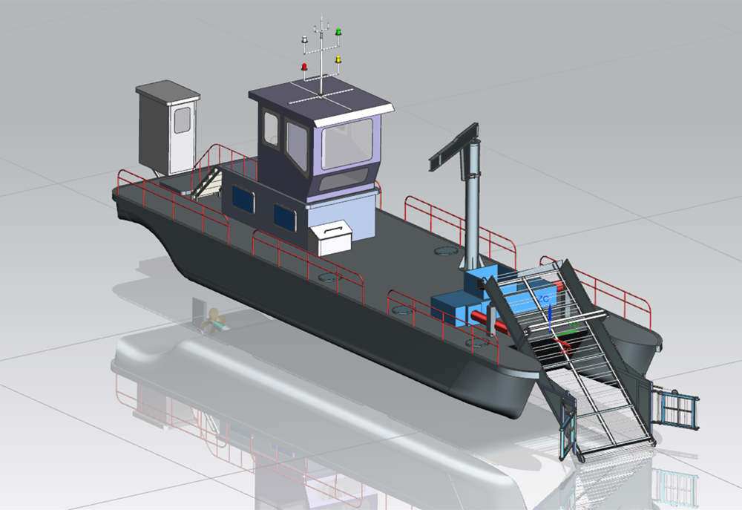

Specification List
Ser | Description | Required Specification |  |  | Remarks
A | Manufacturer | Weifang Dragon Machinery Technology Co., Ltd
B | Brand | Dragon |  |  | Registered Brand
C | Model | DGTSB-40
 | 1. Principle Dimensions
 | (1) Length Overall | 20 m
 | (2) Width Overall | 5.0 m
 | (3) Height Overall | 4.9 m
 | (4) Draft Empty / Fully Load | 0.9m / 1.5m
 | (5) Collection Width | 4.0 m
 | (6) Collection Depth | 1.2 m
 | (7) Carrying Capacity | 10 tons
 | (8) Deigned Working Speed | 3 km/hr
 | (9) Sailing Speed | 20 km/hr
 | (10) Total Installed Power | 274 kw
 | (11) Drive Mode | Hydraulic System
 | 2. Hull
 | (1) Length | 18 m
 | (2) Width | 4.5 m
 | (3) Height | 2.0 m
 | (4) Type | Integrated Hull
 | (5) Plate Thickness- Deck | 6 mm |  |  | Carbon steel, CCSB Grade
 | (6) Plate Thickness- Sides | 5 mm |  |  | Carbon steel, CCSB Grade
 | (7) Plate Thickness- Bottom | 6 mm |  |  | Carbon steel, CCSB Grade
 | 3. Propelling Engine
 | (1) Manufacturer | Cummins
 | (2) Model | NT855-M
 | (3) Rated Power with RPM | 224 KW @ 1800RPM
 | (4) Amount | 1 set
 | - Propeller Diameter | 800 mm |  |  | Driving through Gearbox
 | - Propeller Material | Copper Alloy
 | 4. Hydraulic Engine
 | (1) Manufacturer | Weichai Deutz
 | (2) Model | TD226B
 | (3) Rated Power with RPM | 50 KW @ 1800RPM
 | (4) Amount | 1 set
 | - Hydraulic Pump Type | Gear Pump
 | - Hydraulic Pump Amount | 1 set Twin Pump
 | - Baler Machine
 | - Power | 15 Kw
 | (2) Bale Size | 300x300x600 mm
 | (3) Bale Weight | 25-30 kg
 | - Baling Speed | 80-100 bales/hour
 | - Weight | 2.6 T
 | - Baling Method | Continuously baling and packed in nylon bags
 | 6. Hydraulic System
 | a. Hydraulic Pump
 | (1) Type | Twin Gear Pump
 | (2) Working Pressure | 16 Mpa
 | (3) Amount | 1 set
 | b. Hydraulic Tank
 | (1) Capacity | 1000L
 | (2) Accessories | temperature & level gauge are provided
 | c. Hydraulic System Protection | Relief valves, low oil & clogged filter sensors shall be provided for better working of the hydraulic system.
 | d. Location | In the front of the hull
 | e. Operation Panel | Switches, gauges, warning lights & alarms are provided.
 | 7. Pilot Cabin
 | (1) Type | 360 degree view stable cabin
 | (2) Captain Chair | Adjustable chair with Operation Sticks
 | (3) Operator Protection | All hydraulic lines / valves enclosed & shielded for better safety of operator.
 | 8. Navigation System
 | a. Radar | Brand: Lowrance, USA |  | Specification in attachment 1
 | b. VHF | Brand: ICOM, Japan |  | Specification in attachment 2
 | 9. Lighting System
 | (1) Lights Type | 500w spotlight: 2 pcs  65w floodlight: 6 pcs
 | (2) Signal Mast | Signal lamps required for navigation is to be provided.
 | 10. Conveyor Belting
 | (1) Type | Stainless Conveyor
 | (2) Conveyor Width | 1.8m
 | (3) Driven | Hydraulic Motor
 | (4) Collecting Mouth Width | 3.8 m
 | - Collecting Arm Control | By hydraulic cylinders
 | 11. Frame
 | (1) Material | CCSB Marine Steel
 | (2) Fasteners | Stainless steel
 | (3) Anti-corrosion | 4 layers marine epoxy paint;  Zinc anode protection.

Designing Pictures


