Add: Songjiadai Industrial park, Feiyun Town, Ruian City, Zhejiang Province, China
Quotation
名称Name | MIDDLE SPEED PAPER CUP MACHINE BY OPEN CAM
HS Code | 8441309000
型号Model | LF-70
价格Fob Ningbo | 8500usd/set
对应纸杯尺寸  Paper Cup Size | 2-12oz
材料要求Raw Material | 单淋膜纸  Single PE
速度Speed | 65-75 pcs/min
纸张厚度要求  Suitable paper weight | 170-300g/m²
电压要求Voltage supply | 380V，50HZ
功率General power | 4.5KW
重量Net weight | 1800kgs
尺寸  Measurement (mm) | 主机 Machine | 2300*1150*1800
 | 收杯架Collecting table | L:850mm;W:950mm;H:1700mm
杯身粘合方式  Cup Side Sealing | 热铜条  Normal Heater
底部滚花  Bottom Knurling | 加热圈加热粘合/吹气加热粘合  Normal Heater/AIR HOT SYSTEM
可以按照客户要求定制模具（交货期30-35天）
We can customize machine and mold according to customer’s requirement.
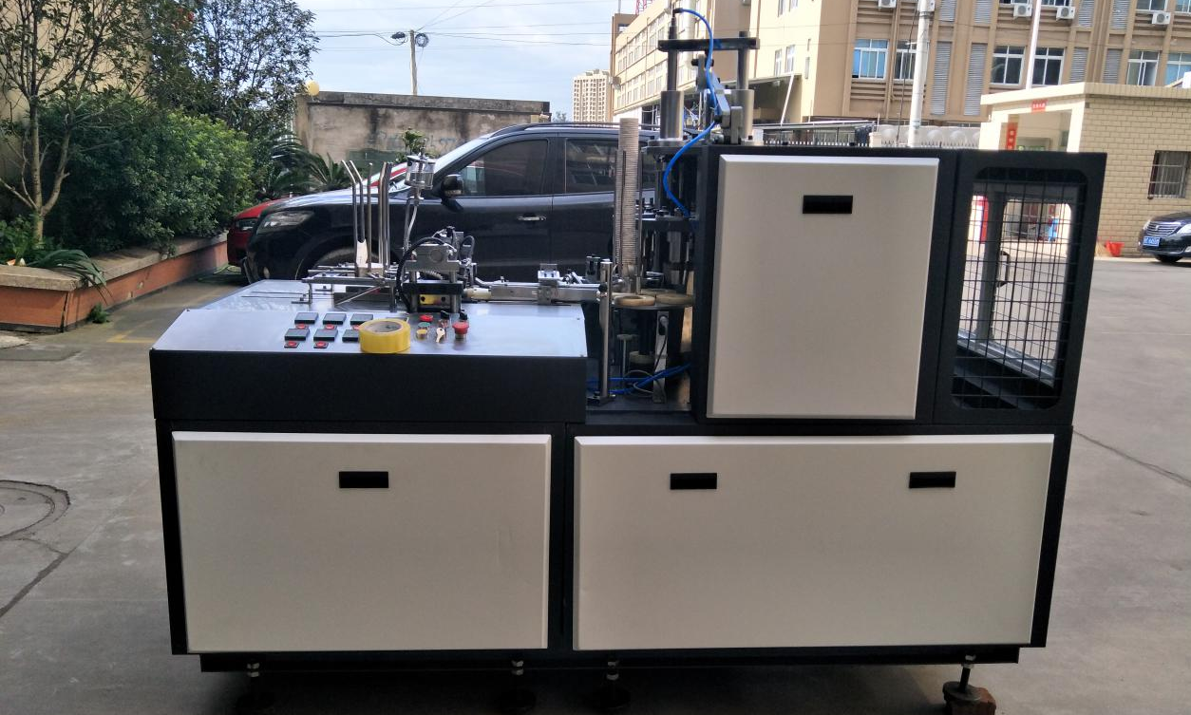
简介：
LF-70型中速机成型机是一种多工位高速自动机械，具有自动送纸，热封成筒，杯口润滑，冲杯底并按放杯底，杯底加热，滚压，上口卷边等连续工序，可适应生产热饮杯，咖啡杯等常用杯型。
Introduction:
LF-70 middle speed paper cup machine is a multi-station high speed automatic machine, through automatic paper feeding, imported heater side seal, cup top lubrication, automatic bottom paper feeding, bottom heater, bottom knurling and curling, it can make cups both single PE and double PE, for cold drinks and hot drinks.

技术简介：
- 采用凸轮和齿轮传动系统，解决了传统转动箱的不实用，机器在高速运转下更加稳定。
Adopt CAM and gear transmission system.machine run stably under high speed operation.
- 采用环抱型钢架结构，机器结构紧凑、固定。
The parts are all made of standardized production,strong commonality,swap performance is good,easy to maintenance.
- 零部件全部采用标准化生产，通用性强，互换性能好，便于设备维修。
The automatic lubrication system,closed,can ensure the machine long time continuous high-speed operation.
- 机型小巧，便于输送和放置
The machine is a compact paper cup machine helping clients to save 60% shipment cost.
- 机器部件精密度高，噪音小
The machine parts have high precision and low noise.

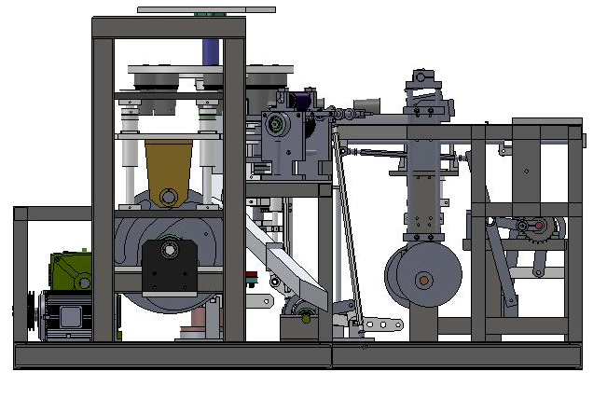

Main Parts List:
NO. | Description of the equipment  电器名称 | Brand/ Specification / Model  品牌、产地
Electric  Appliance  电器部件 | Transducer变频器 | Quanzhou Sanqi中国泉州桑川
 | Contractor继电器 | China CHNT中国正泰
 | Temperature controller  温控表 | Shanghai YATAI中国上海亚太
 | Motor  模具 | Zhejiang MAILI中国浙江
Machine appliance  机器部件 | Interval gear box  传动箱 | ZHENGJIANG ZHONLI  125# for ZB-12A  中国浙江
 | Chain  链条 | China-Hangzhou  DUNPAI/ZIQIANG  中国杭州
 | Axis轴 | 45# steel中国
 | Guide Post  导柱 | CR15  中国浙江
 | Cylinder  气缸 | 80*125  China YIDA  中国
 | Cam  凸轮 | 45#  中国浙江
 | Bottom cutter  冲底刀 | CR15  中国浙江
 | Knurling seat  滚花座 | CR12  中国浙江
 | Knurling wheel  滚花轮 | 40CR  中国浙江
 | Bearing  轴承 | 5204、5203、32008/Japan-NJK日本
 |  | 6201/ China-heerbin中国

设备主要特点解析Equipment main characteristics：
- 机器内部结构优化，使结构更加紧密，机器体积变小，便于运输
Machine internal structure optimization, make the structure more closely, machine smaller in size, easy to transport

2.核心部位采用槽轮传动，取缔老式的分度箱传动，使得传动更精准，速度快，稳定性更可靠
Core part uses the Geneva wheel drive, ban old-fashioned dividing box transmission, makes driving more accurate, faster, more reliable stability
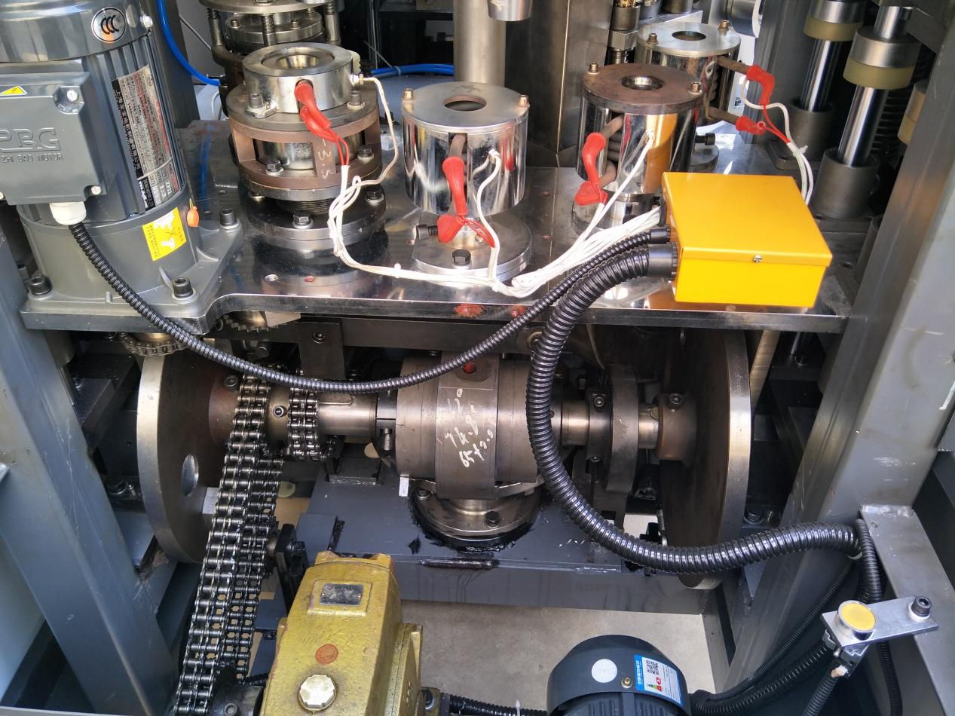

3.零部件全部采用标准化生产；设备底座整体通过大型数控机床精准定位安装孔位、安装面的水平性，使得设备的零部件安装更标准化、通用性强、互换性好、便于设备维修
Parts adopt standardization production; Equipment base as a whole by large nc machine installed precision positioning hole, the level of sex, make the parts of the equipment installation more standardized, good versatility and interchangeability, easy to maintenance
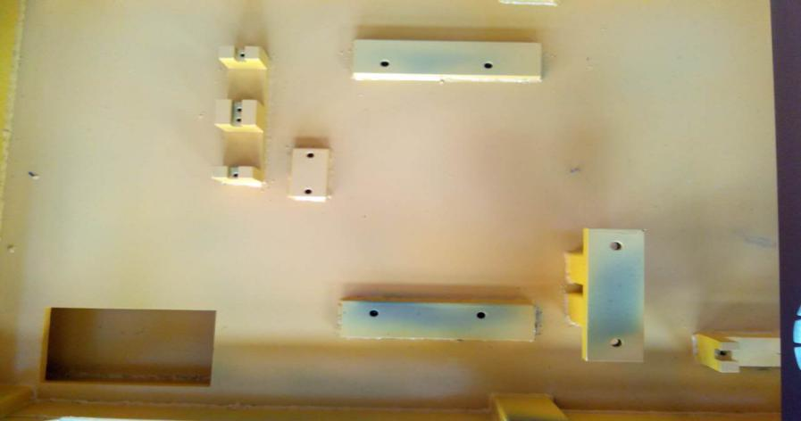
- 简化送底纸工序，机器运行更加合理、高效
Simplifying the paper feeding process, the machine runs more reasonably and efficiently.
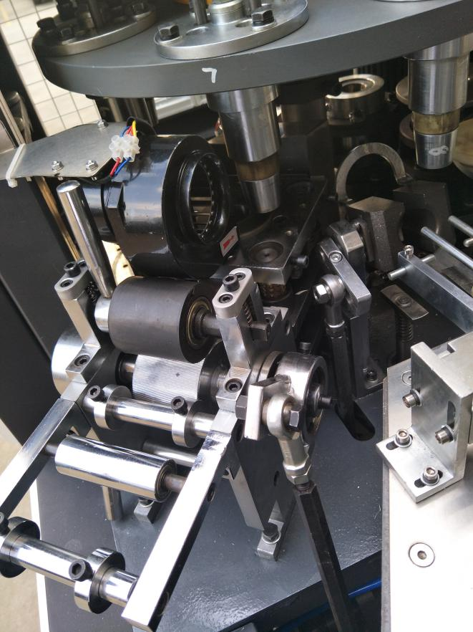
- 其他细节/other details
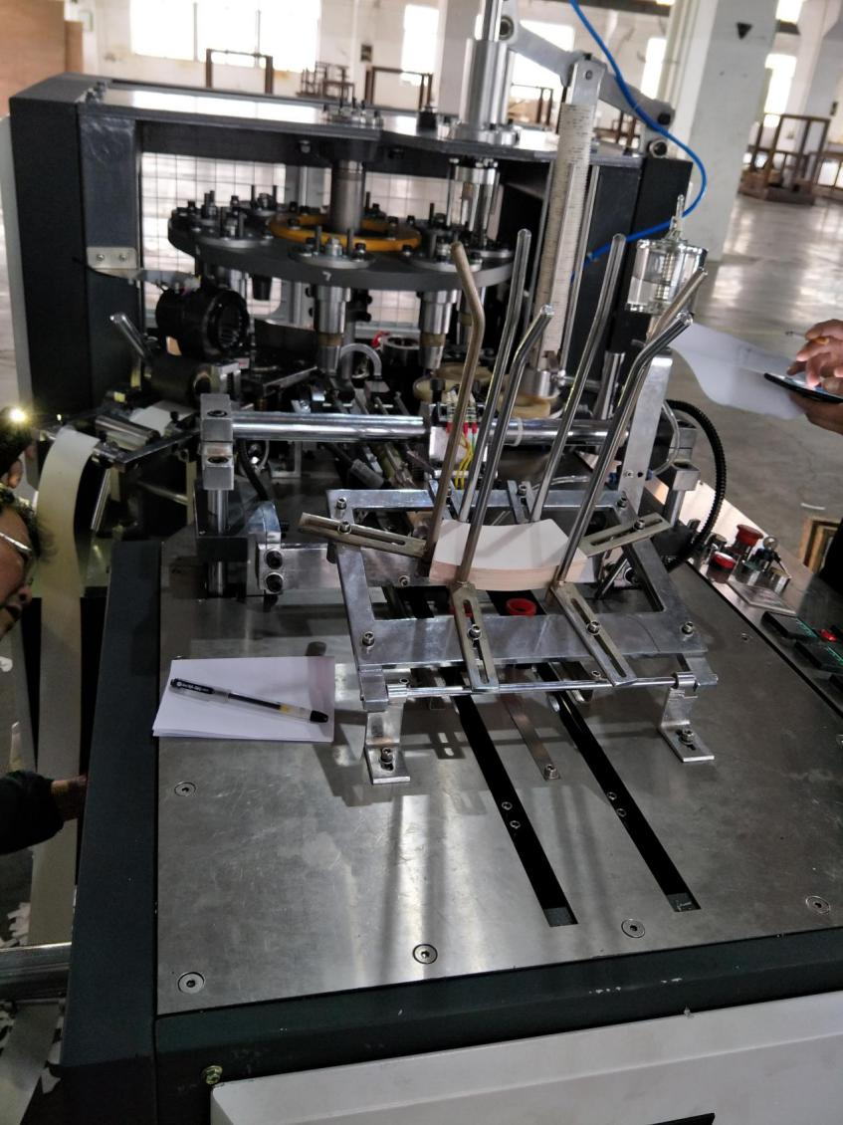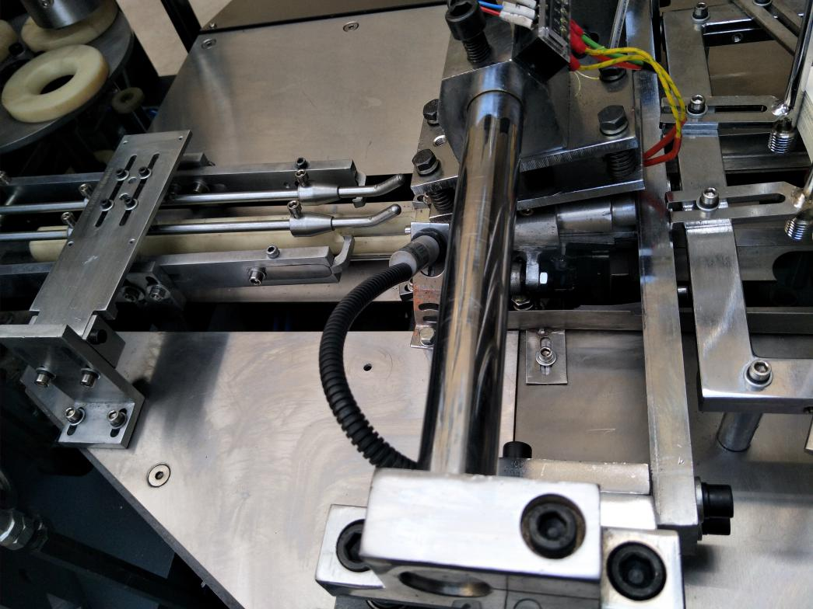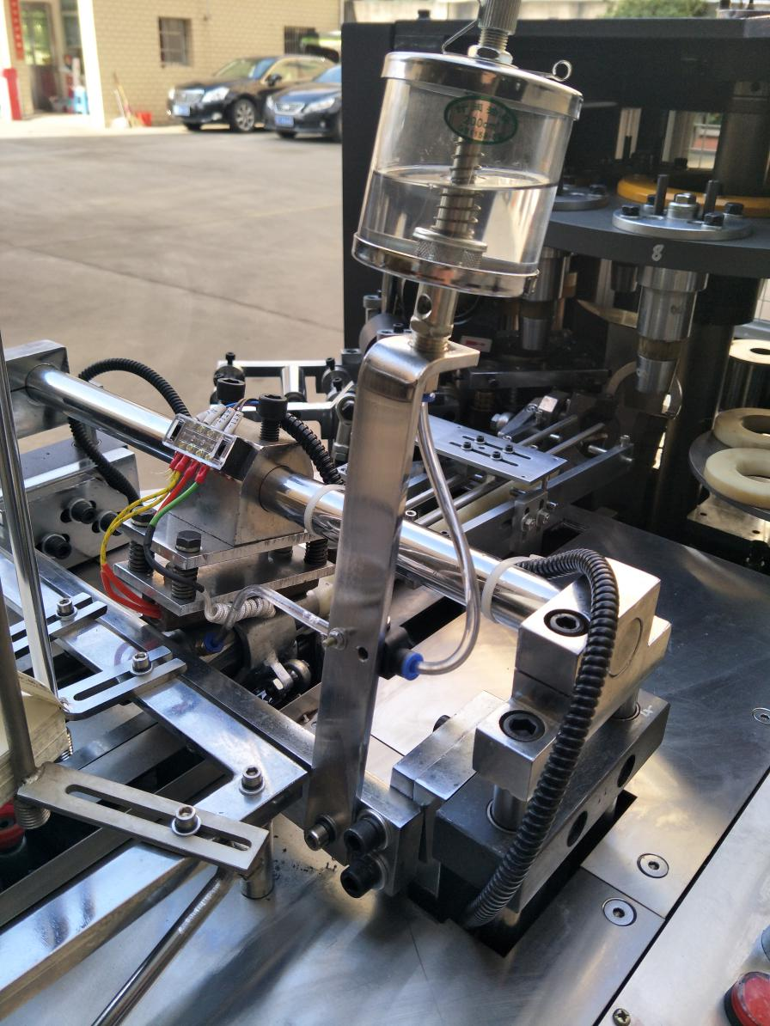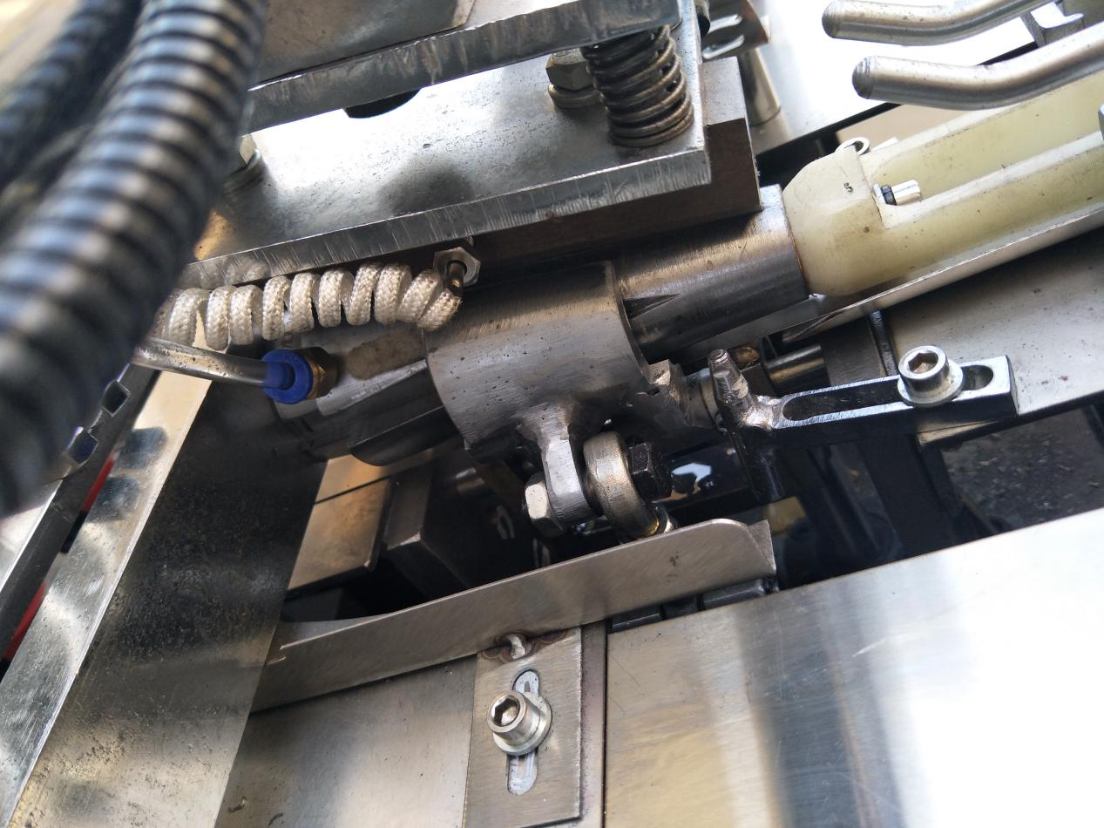

Each machine have one tool box which include following tools and spare parts :
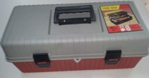 | Box | 1pcs
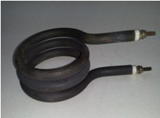 | Heating coil /7rings | 2pcs
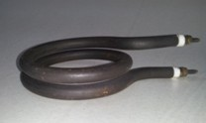 | Heating coil /2rings | 1pcs
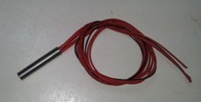 | Bottom heating /φ12*60 | 1pcs
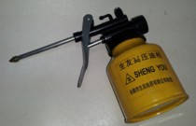 | Oil gun | 1pcs
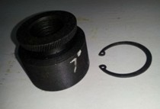 | Knurled wheel | 1pcs
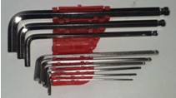 | Allenkey | 1set
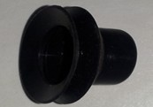 | Double layer Rubber | 4pcs
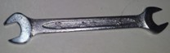 | Tool | 1pcs
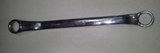 | Tool | 1pcs
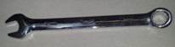 | Tool | 1pcs
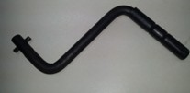 | Tool | 1pcs
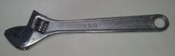 | Tool | 1pcs
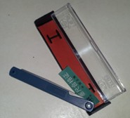 | Feeler gauge | 1pcs
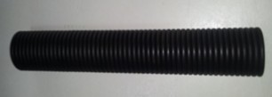 | Spring φ6*330mm | 1pcs
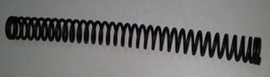 | φ2*φ14*35 | 2pcs
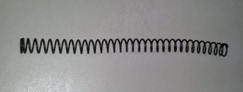 | φ1.2*φ10*32 | 1pcs
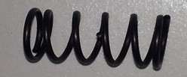 | φ1.2*φ12*6 | 4pcs
Screw | M6*10 | 5sets
Screw | M6*20 | 8pcs
Screw | M8*75 | 4pcs
Air joiner | φ8 T | 1pcs
Air joiner | 1/2 φ8 | 2pcs
Manual |  | 1pcs

1、设备的质量保证以及保修期限：
Quality assurance and warranty period:
- 设备要严格按照买卖双方确认的图纸制作和技术协议验收，保修期以货到买方客户目的地调试签收日期算起一年，在保修期内如果因为卖方制造质量原因造成的故障或损坏，卖方应及时进行处理，需要更换的相关零部件由卖方负责快递给买方客户，所有配件以及快递费用由卖方承担。
The machine shall be strictly checked and approved according to the drawing and the agreement of the technical agreement between the buyer and the seller. The warranty period shall be one year from the date of commissioning and acceptance of the goods to the buyer's customer destination. If the machine is damaged or damaged during the warranty period due to the quality of the seller's manufacture, the seller should promptly handle the relevant parts need to be replaced by the seller responsible for delivery to the buyer, all the accessories and delivery costs borne by the seller.
- 技师可以到买方客户工厂安装调试，买方需要支付签证、机票、食宿以及100美金/天的工资（工资时间按照国内出发日算起，到结束日），技师会提供调试，培训服务，直到买方理解，能操作。
The engineer can go to the buyer's customer's factory to install and debug. The buyer needs to pay visa, air ticket, boarding and lodging and 100 USD / day's salary (the wage time is calculated according to the domestic departure date, and the ending date). The engineer will provide the debugging and training service, Until the buyer understands, can operate.

2、质量/数量异议:
Quality / Quantity Objection:
针对质量/数量异议，需方须在产品到达目的地30天内提出索偿。供方对因海运运输造成的质量异议不承担责任，应由保险公司，船公司或运输组织担责。
For quality/quantity objections, the requesting party must claim the product within 30 days of its destination. The supplier shall not be responsible for the quality objections caused by maritime transport, and shall be held responsible by the insurance company, shipping company or transport organization.

3、仲裁
Arbitration
凡因执行本合同或有关本合同所发生的争执，双方应以友好方式协商解决，如协商不能取得结果时，各方均有权在各自所在地法院提起诉讼解决。
Where any dispute arises as a result of the execution of this contract or any dispute arising out of this contract, the parties shall negotiate in friendly manner and, if no result of the negotiation can be obtained, all parties shall have the right to institute legal proceedings in the courts of their respective places.

