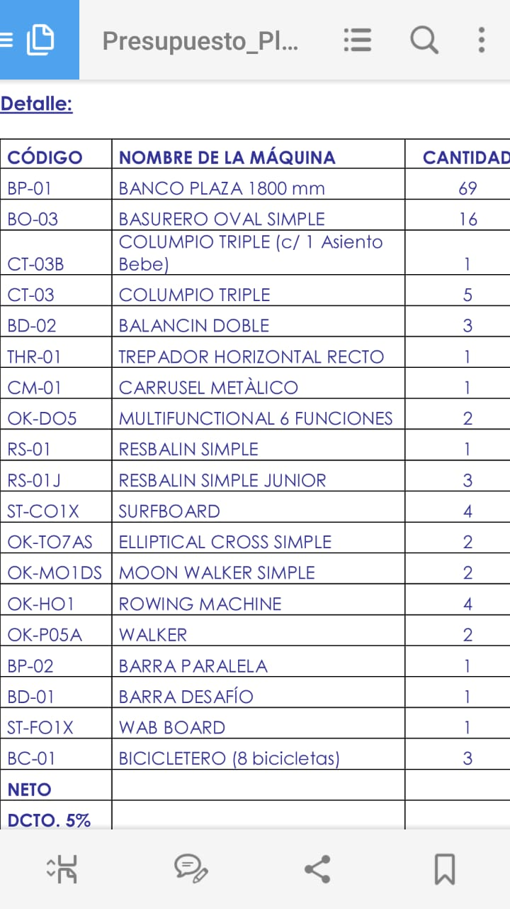

Cod. | Name | Qty.
BP-01 | bench for plaza 1800 mm | 69
BO-03 | simple oval trash can | 16
CT-03B | triple swing (with baby seat) | 1
CT-03 | triple swing | 5
BD-02 | double seesaw | 3
THR-01 | straight horizontal climber | 1
CM-01 | metallic carousel | 1
OK-DO5 | multifunctional exercise machine (6 functions) | 2
RS-01 | single playground slide | 1
RS-01J | single playground slide for children | 3
ST-CO1X | surfboard | 4
OK-TO7AS | single elliptical cross | 2
OK-MO1DS | single moon walker | 2
OK-HO1 | rowing machine | 4
OK-P05A | walker | 2
BP-02 | parallel bars | 1
BD-O1 | challenge bar | 1
ST-FO1X | wab board | 1
BC-01 | bicycle rack (8 bicycles) | 3
NET
5% DISCOUNT

