久鋒國際實業有限公司
JIUFENG(INTERNATIONAL)LIMITED
地址：香港九龍尖沙咀廣東道17號海港城環球金融中心南座13A樓05 至 15室
Add: Rooms 05-15,13A/E., South Tower, World Finance Centre, Harbour City, 17 Canton Road, Tsim Sha Tsui, Kowloon, Hong Kong.
電話Tel：+852 22086053 傳真Fax：+852 30030133
www.gddgjf.com e-mail:sales@dggdjf.com Yuki

Quotation 报价单
需方：
地址 Add：
供方Seller： JIUFENG (INTERNATIONAL)INDUSTRY LIMITED久鋒國際實業有限公司
Date日期2018年09月10日

單組名稱Name | 数量Quantity | 單價(USD)  Unit price | 總價(USD)  Total price
2460半自动糊箱机  Semi automatic gluer | 1台/set | 80,100.00 | 80,100.00

Total : FOB 80,100.00USD
Term of payment付款方式：
- 合同簽署後5個工作日內，買方向賣方支付合同總價的30%為定金，合同生效。70% 貨款需要在出貨前付清
Within five working day. The buyer pay 30% of the total payment as deposit ,the sales contract take effect.70% balance need to be paid before shipping.

交貨期：賣方收到定金60日內交貨。
Delivery time: 60 days at the date of receiving the deposit

保修期：易損耗材除外，整機保修1年
Warranty: expect for the wear out part, the warranty date is 24month.

2460半自动糊箱机
Semi automatic gluer

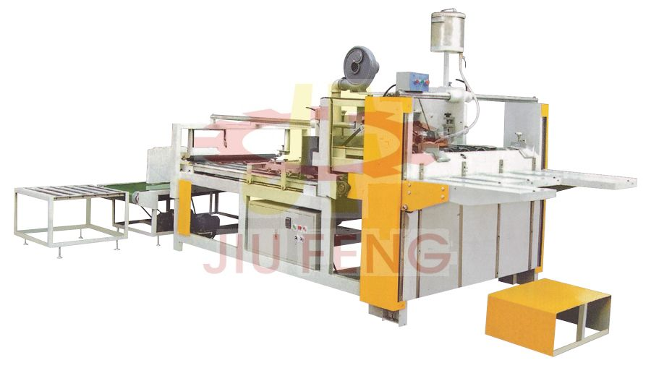
SEMI AUTO GLUER
Model | BF-2460
Max.Speed (m/min)最大速度 | 60
Max.Sheet size (mm)最大纸张规格 | 2500x1515
Min. Sheet size (mm)最小规格 | 340x260
Sheet feeding height (mm)纸张送纸高度 | 900
Main motor power (Kw)功率 | 4
Outer size (LxWxH) (mm)机械尺寸 | 4255x1930x1780
Weight (Kg)重量 | 2150

