Contact: Joyce Mobile: 0086-18659033751
Email: joyce@hengxinmachine.com
Add: Huaxing Road, Changtai Street, Licheng District Quanzhou, Fujian, China.

Quotation
(Valid for one month)
Date: Nov-21-2018
Refer No.:CYQ181121
Automatic Handkerchief Production Line
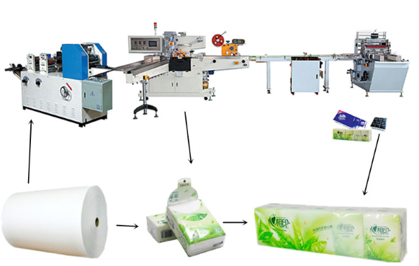

Jumbo Roll Single Bag Packing Multiple Bags Packing

 | Picture | Machine Configuration | Price
1 | HX-ME-210 Handkerchief Machine | ●Production speed: 600-800 pcs/min  ●Product size: （choose one from them）  (1) open:210*210mm fold:53*73mm  (2) open:210*220mm fold: 55*108mm  ●Maximum raw material diameter： 1100mm  ● PLC control  ● Electric counting  ●Motor power: 1.5 kw  ●Machine dimension : 3850X650X1570mm  - Equipment weight: About 2.0T  Option:  Add One color printing +$1,000 USD  Add two color printing +$1,800 USD | FOB XIAMEN $7,000 USD
1 | 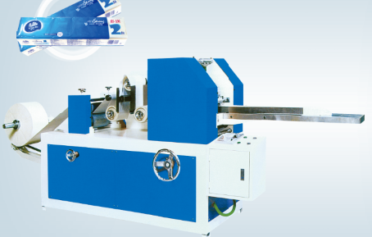 |  | FOB XIAMEN $7,000 USD
2 | HX-BZ Handkerchief Single-bag Packing Machine | - machine speed: 30-100 bag/ min  - Finished product size:  (70-110)L*(50-55)W*(20-28)H  - Inverter: Mitsubishi  - PLC: Siemens  - Air compressor: 0.5-0.6 MPA(supply by client)  - Power: 4.68 KW, 380V 50Hz  - Dimension: 2840*2650*1720mm  - Weight: About 1700 kg | FOB XIAMEN  $19,700 USD
2 | 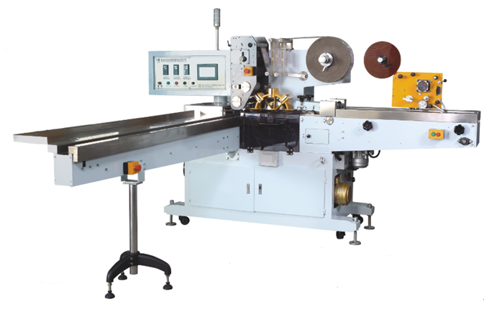 |  | FOB XIAMEN  $19,700 USD
3 | HX-ZBZ Handkerchief Multiple-bag Packing Machine | - machine speed: 20 bag/ min  - Finished product size:  (150-330)L*(70-150)W*(20-84)H  - Inverter: Siemens  - PLC: Siemens  - Air compressor: 0.5-0.6 MPA(supply by client)  - Power: 3.5 KW, 380V 50Hz  - Dimension: 2500*3200*1550mm  - Weight: About 1200 kg | FOB XIAMEN  $19,700 USD
3 | 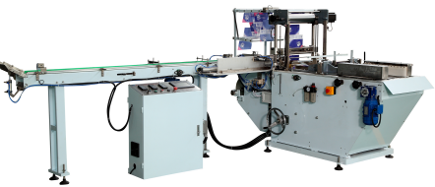 |  | FOB XIAMEN  $19,700 USD
Counting Unit: $9500USD
Conveyor Belt: $3200USD
Total Amount:FOB XIAMEN $59100USD

Machine Description
Embossing Roller (Steel to rubber)
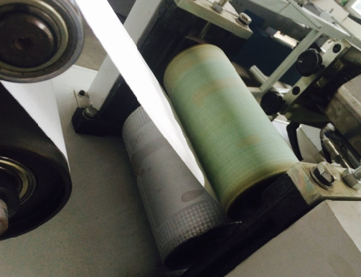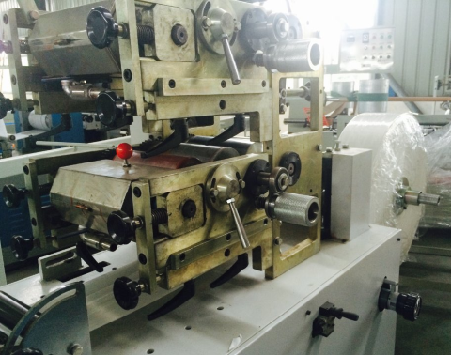
We have differenct embossing patterns for you to choose, and the color printing is optional(1-2 colors)
Folding Units
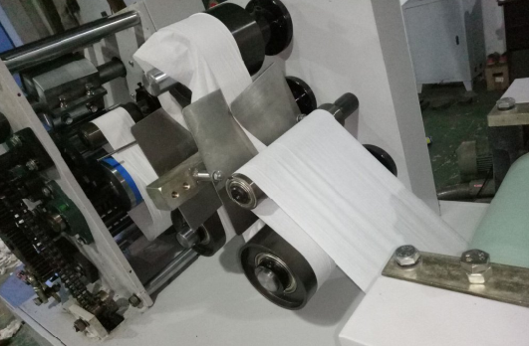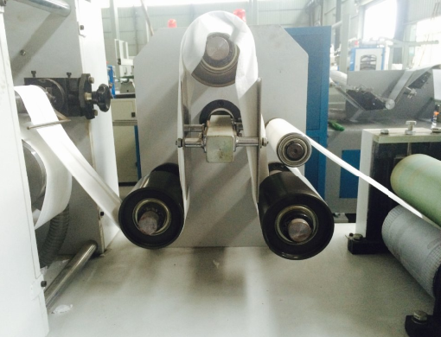
One machine, one folding size
Output and Finished Products
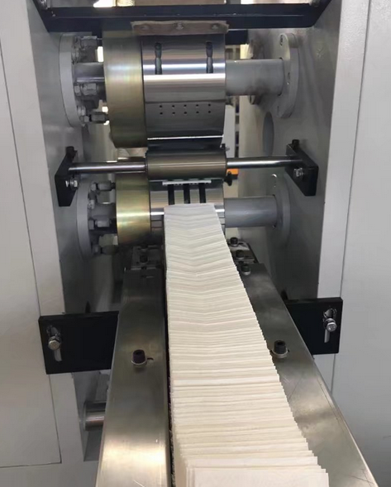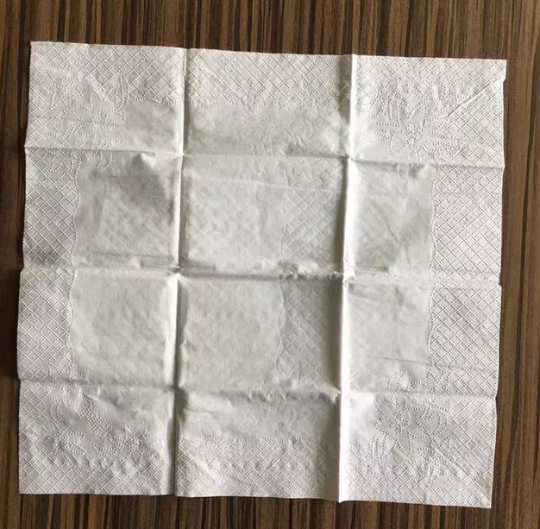
Machine speed is 600-800 pcs/min, machine has automatic counting function

Full View of the Machine
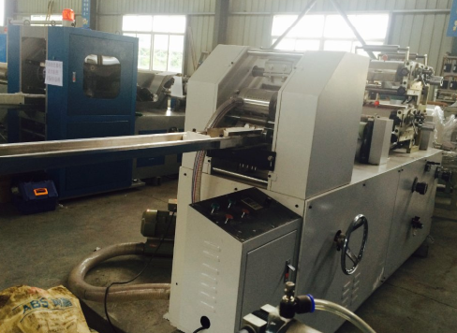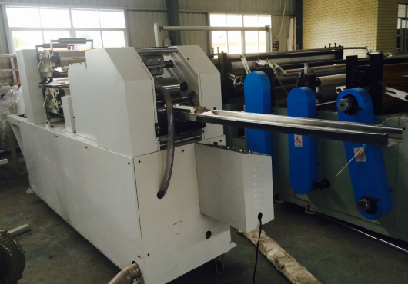

1.Factory Location and Transportation: My factory is located in Quanzhou city, Fujian Province,
The nearest airport: Jinjiang Airport,
Train station: Quanzhou Station.
Welcome visit my factory whenever you want.
2. Payment terms: Client need to pay 30% of the total amount by T/T as advance payment. After machine finished and tested, and client feel satisfied (client can come and test the machine or we send machine testing videos to them) then pay 70% by T/T before shipping.(For other payment terms, need to be agreed by buyer and seller both parts.)
3. Delivery time: 60 days
4. Warranty: Our warranty is one year start from machine arrive the client’s place, the parts can be replaced for free within one year(not including the easy-wear parts like blade), but the after-sales service is all machine lifetime, any problems happen can contact us, we will try our best to help you out of trouble.
5. Other service: If you want to find raw material supplier, like jumbo roll or plastic bag, I can recommend to you, if you want book hotel, I can recommend and book for you, and if you want to book train or flight ticket, I can book for you.

If you have any other questions welcome ask me in whatsApp, I will give you prompt reply.

Factory View


