Maxi Roll Production Line小盘纸生产线

 | Picture | Machine Configuration | Function | Photo of product
1 | HX-GS-2800 Automatic Maxi Roll Rewinding Machine | - Jumbo roll width:2800mm  - Jumb roll diameter:1500mm  ● Speed: 100-230 m/min  ● with one set embossment (steel to rubber)  ● PLC and Frequency Inverter (INVT)  ● with two jumbo roll stands  ● Finish Roll Diameter: Φ80-φ260mm  ● Finish Roll Core Diameter: φ38-φ76mm  ● Perforation Distance: 4 anvil Blades,100-150mm  ● Pneumatic System: 3HP Air Compressor,  Minimum Pressure: 5kg/cm 2Pa（Provide by user）  ● Motor Power: 11 KW  ● Dimension: 8000*3800*1800(L*W*H)  ● Weight: About 5.0T | Used for winding,rewinding paper log one by one.  用于收卷卫生纸，收卷成一长条。 | 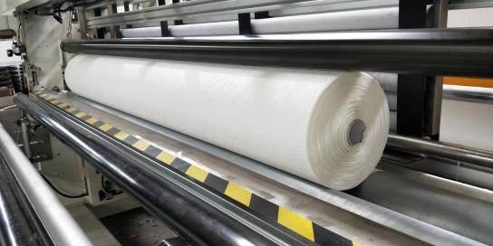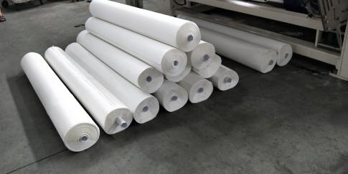
 | 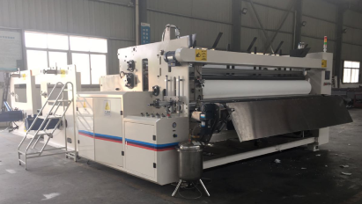
2 | HX-ZDQ-2800 Automatic Maxi Roll Band Saw  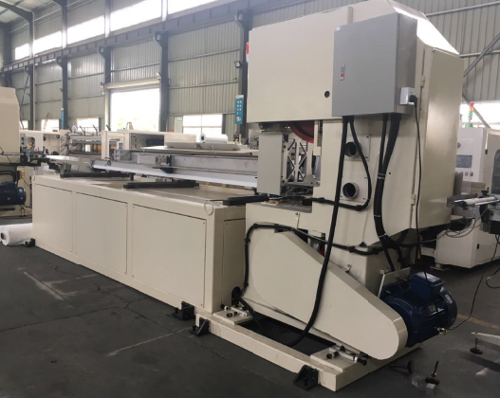 | ●Speed: 20 cut/min  ●Cutting length: 90-300 mm  ●Cutting diameter: φ150-280mm  ●Core thickness: 1.1-6 mm  ●Waste width: 25-30 mm  ●Power: 15 KW , 380V 50Hz  ●Dimension: 5900*2600*2200mm  ●Weight: 3 T | Used for cutting paper roll.用于切割卫生纸，切成一小个。 | 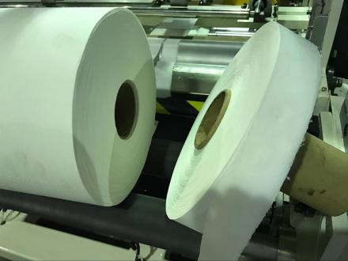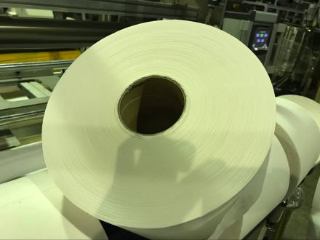
2 | 8 Rolls Packing Machine | ● Speed:about5 bags/min  Packing size:2ply*4rolls=8rolls(per roll size:200X200mm) | Used for packing 8 rolls paper rolls.  用于包装8卷纸。 | 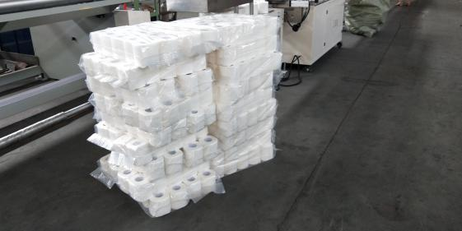

标准复卷机操作说明
Operational instructions for standard rewinder

一．接上电源，电源为三相4线制的，电压等级为AC380V，电流60A。
1. Power Connection: Three Phase,four lanes road, AC380V, 62A.

二．上完电后送上电源开关，人机终端上显示如下画面：2.After power on, Human Interface displays as follows：(You can choose English or Chinese version)

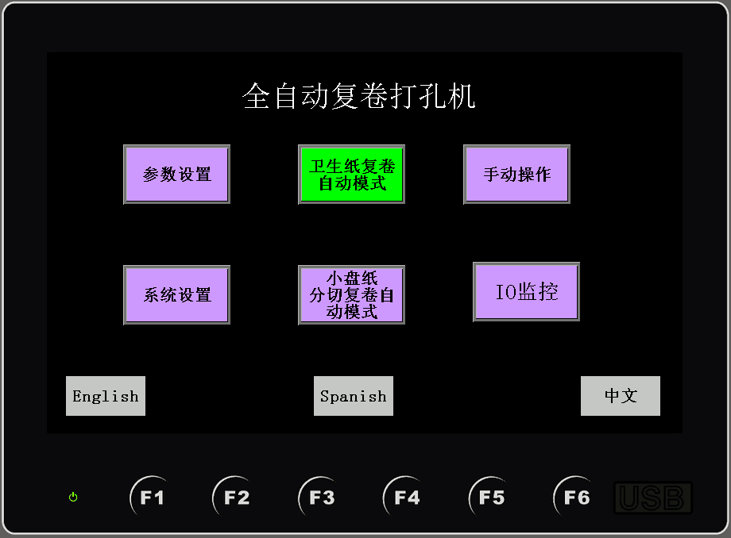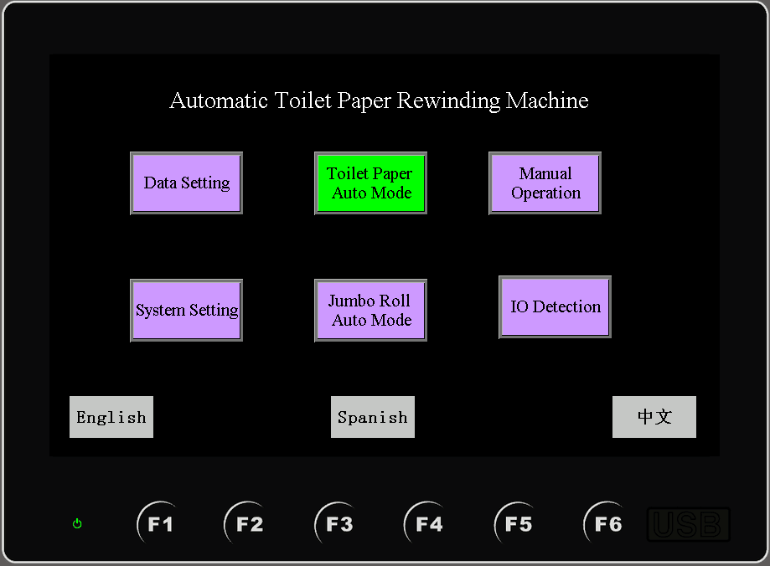

- 参数设置指的是所有机械、气缸、电磁阀之间配合调节。达到运行的最快最佳状态设置；The parameter setting refers to the coordinated adjustment of all machinery, cylinders and solenoid valves. Achieve the fastest and best operating state setting;
- 系统设置指的是复卷、压花、打孔以及材料的运行速度同步设置，此设置一般为出厂参数且为最佳状态、操作者不能随意改变。2、System settings refer to the synchronous settings of rewinding, embossing, punching and material running speed. This settings are generally factory parameters and are in the best state. Operators can not change them at will. 3. Sealing Heating Time: Transverse heating wire heated time, the data can be set between0.2-0.5 seconds, if the time is short, can seal well, if too long, the bag will be burned, or the heating wire will be fused.
- 卫生纸复卷自动模式指的是进入自动运行画面设置复卷节数，材料速度的微调以及各个气缸的是否开启，可以查看给定的速度、产量等；3. The automatic mode of toilet paper rewinding refers to the setting of rewinding knots, the fine-tuning of material speed and the opening of each cylinder when entering the automatic operation screen, which can check the given speed and output, etc.
4. 手动操作指的是进入画面可以单独运行气缸、切刀运行情况还可以设置主机的点动速度。此页面一般为调试的时候使用。4.Manual operation refers to the entry screen can run the cylinder alone, cutting tool operation can also set the main engine's point speed. This page is usually used for debugging.
5. 小盘纸分切复卷自动模式与卫生纸复卷自动模式功能类似，只是没有那么多机械器件。5. The automatic mode of slitting and rewinding small tray paper is similar to the automatic mode of toilet paper rewinding, but there are not so many mechanical devices.
6. IO监控指的是Plc各个输入输出点监控/显示各个输入输出点的运行状态。6. IO monitoring refers to the Plc input and output points monitoring/displaying the operation status of each input and output point.

三．可按人机终端画面《参数设置》按钮进入操作如下图；
Operation Menu: The button can be set according to the parameters of the man-machine terminal screen to enter the operation as follows.
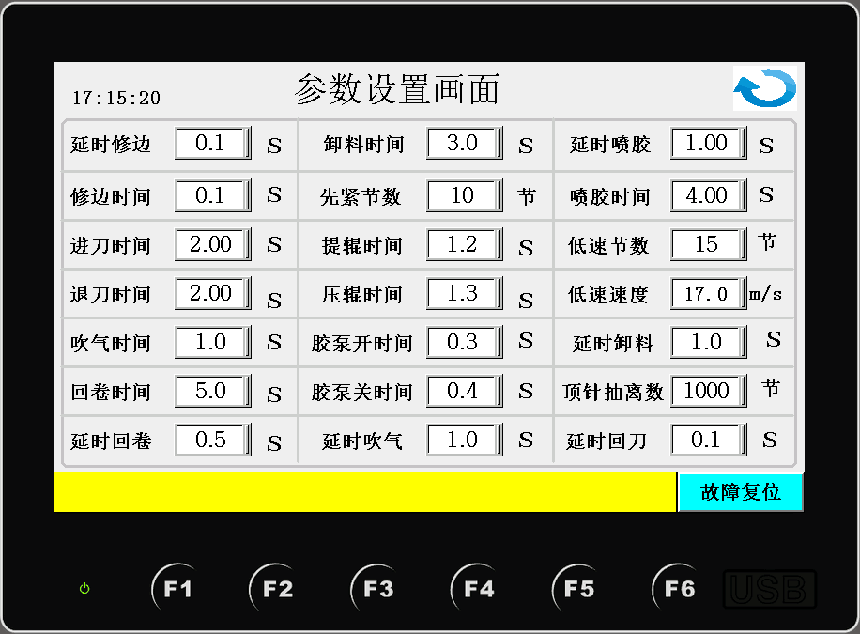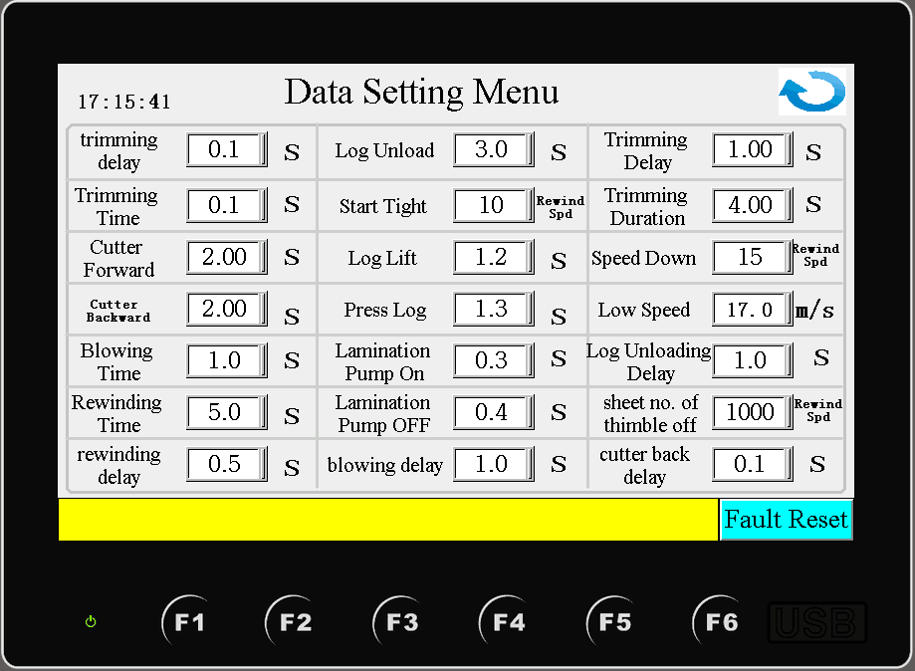
- 延时修边指的是复卷完成后，成品推至回卷装置等待修边时间；1. Delayed trimming refers to the time when the finished product is pushed to the rewinding device to wait for trimming after rewinding is completed.
2. 修边时间指的是成品推至回卷装置修边时间。2. Trimming time refers to the time when the finished product is pushed to the trimming of the rewinding device
3.进刀/退刀时间设置指切刀前进与退回原位的时间。此设置是切刀前进不到位与后退不到位时或前进与后退时间太长才设置。
3. The feed/withdraw time sets the time when the cutter moves forward and returns to its original position. This setting is set when the cutting knife is not in place or when the cutting knife is not in place or when the forward and backward time is too long.
4. 延时吹气与吹气时间设置指的是延时吹气是等待吹气时间而吹气时间纸芯到位后吹气把纸覆盖在纸芯上吹气的时间长短设置。4. The setting of delayed blowing and blowing time refers to the setting of the time for delayed blowing to wait for the blowing time, while the blowing time is the time when the paper core is in place and the blowing time is the time for the paper to cover the paper core and blow.
5. 回卷延时/回卷时间设置指的是切刀切完以后等待回卷的时间叫回卷延时而回卷时间就是切刀完成后把成品卷好的时间。5. Rewinding delay/rewinding time settings refer to the time waiting for rewinding after the cutter has been cut. Rewinding time is the time when the finished product is rolled up after the cutter has been finished.
6. 卸料时间设置指的是卸成品的时间长短。5.The setting of unloading time refers to the length of unloading time.
7. 先紧节数设置指的是开始复卷低速运行的节数，低数运行节数到了进入快速复卷模式。7. Firstly, the number of tightening knots is the number of knots that start rewinding at low speed, and the number of low running knots has reached the fast rewinding mode.
8.提辊与压辊时间设置指的是提、压辊的等待时间即什么时候提压辊。8. The time setting of lifting and pressing rolls refers to the waiting time of lifting and pressing rolls, i.e. when to lift the rolls.
9. 胶泵开/关时间设置指的是运行开始开始上胶是开的时间到胶泵关断是开泵到关泵的延时时间叫关的时间。9. The setting of the opening/closing time of rubber pump refers to the time from the beginning of operation to the closing of the rubber pump and the time from the start to the closing of the rubber pump.
10. 延时喷胶/喷胶时间设置指的是切刀运行到纸的边缘开始喷胶是延时时间从开始喷胶到关断是喷胶时间设置。10. The setting of delayed spraying/spraying time refers to the setting of spraying time when the cutter runs to the edge of the paper.
11. 低速节数设置指的是复卷快结束时低速运行的节数。11. Low-speed knot setting refers to the number of knots running at low speed at the end of rewinding.
12. 低速速度设置指的是复卷快结束时低速运行的速度调节。12. Low speed setting refers to the speed adjustment of low speed operation at the end of rewinding.
13. 延时卸料时间设置指的是成品做好后等待多长时间卸料时间调节。12. The setting of delayed unloading time refers to how long the unloading time will be adjusted after the finished product is ready.
14. 顶针抽离数设置指的是在复卷时两边的顶针在复卷几节后抽离。13. The setting of thimble withdrawal number refers to the withdrawal of the thimble on both sides after several sections of rewinding.
15. 延时回刀时间设置指的是切刀走到另一头返回停留时间。15. The setting of delayed return time refers to the residence time when the cutter goes to the other end.

四、可按人机终端画面右边的《手动模式》按钮进入手动操作如下图；
本画面是各个气缸和电机的手动调试画面。The manual mode button on the right side of the man-machine terminal screen can be used to enter the manual operation as follows.This screen is the manual debugging screen of each cylinder and motor.
注：点动速度一般设置在（15—20）之间，按住主机点动按钮可进点复卷点动操作。Note: Pointing speed is generally set between (15 - 20). Press the main engine button to point rewinding and pointing operation.
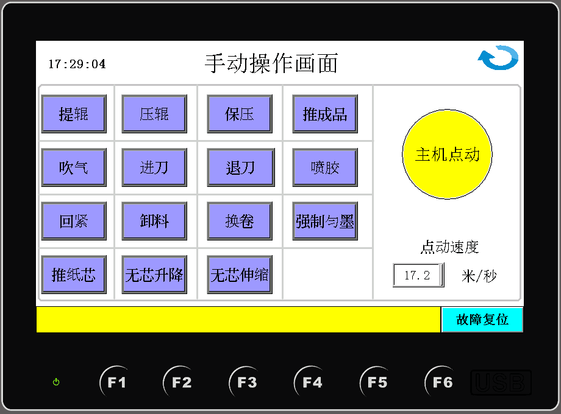
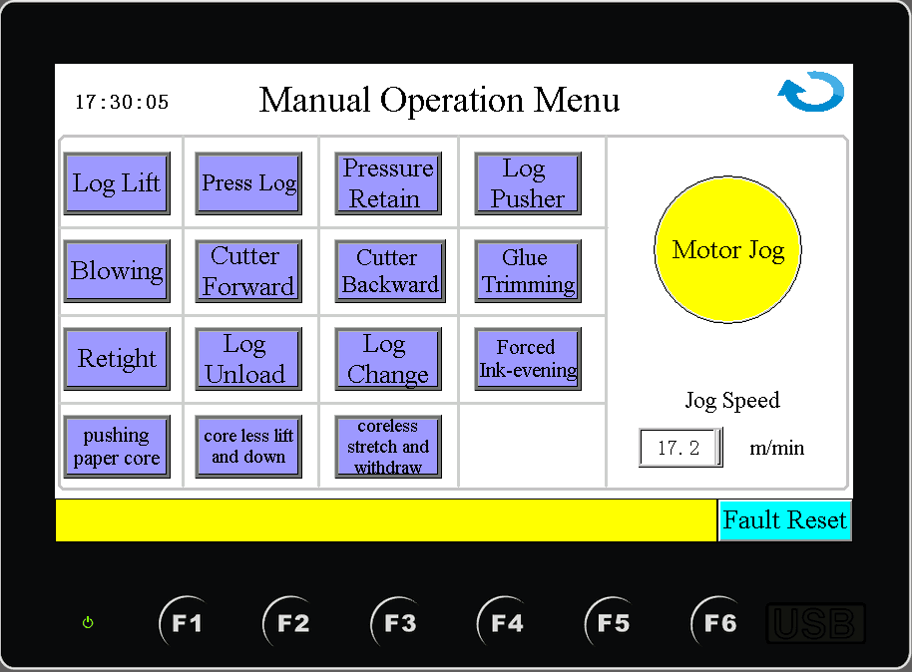

五、可按人机终端画面中间的《卫生纸复卷操作画面》按钮进入自动操作如下图；Fifth, according to the toilet paper rewinding operation screen button in the middle of the man-machine terminal screen, the automatic operation can be entered as follows.
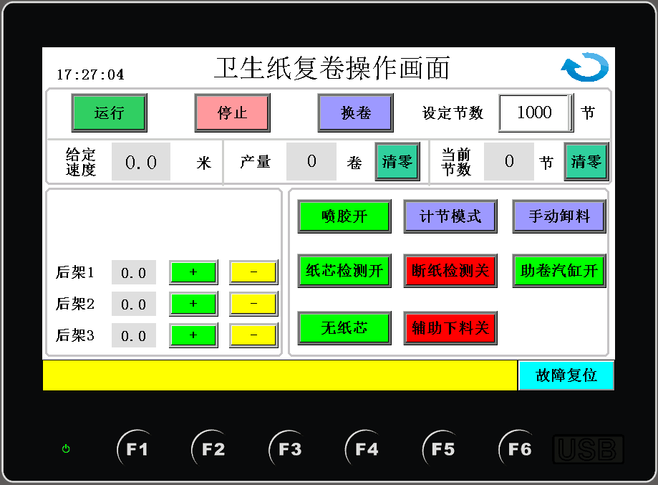
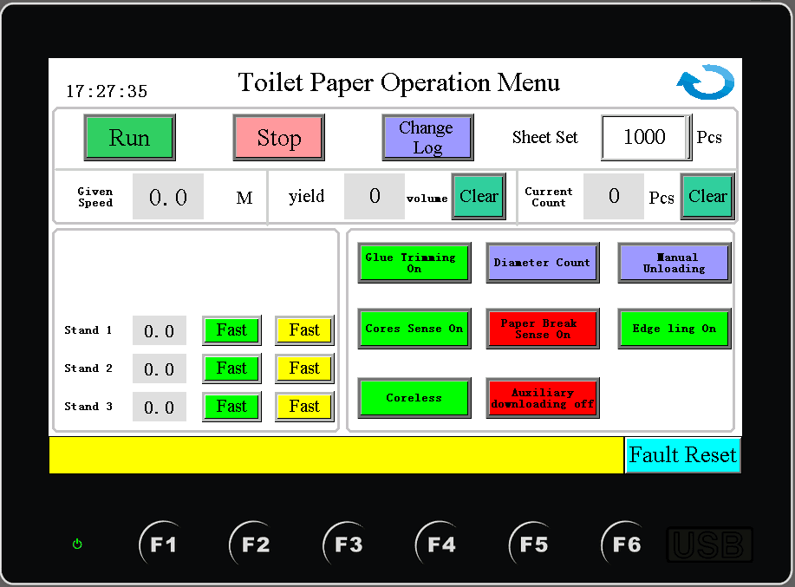
1.此页面点击自动按钮可实现自动运行按停止复卷停止运行。1. This page clicks the automatic button to realize automatic operation, press stop rewinding and stop operation.
2.按换卷要在复卷停止的状态下按下按钮可实现调试过程或运行过程中需要换卷的功能。2. Pressing the button when rewinding stops can realize the function of rewinding during debugging or running.
3.给定速度是显示加减速开关给定的速度。3. The given speed is the speed given by the acceleration and deceleration switch.
4.设定节数与当前节数就是复卷的长度和显示现在节数，可实现清零操作。4. Setting the number of sections and the current number of sections is the length of the rewinding and displaying the number of sections now, which can realize the zero-clearing operation.
5.左边的复、压花、后架1、2、3可查看当前运行速度即时运行米数，可按+、-实现微调。5. Complex, embossing and back rack 1, 2 and 3 on the left can view the current running speed and run meters in real time, and can be fine-tuned according to +, -。
6.左边的按钮喷胶关、计节模式、手动卸料、纸芯、断纸检测、辅助下料、无纸芯、这些按钮可实现这些元器件是打开还是关断的功能。例如：有纸芯就要把有纸芯按钮打开。6. The buttons on the left can realize the functions of opening or closing the components, such as spraying off, knot counting mode, manual unloading, paper core, paper breaking detection, auxiliary blanking, paperless core and so on. For example, if you have a paper core, you should open the button with a paper core.

六.隐藏参数画面：可按人机终端画面中间的系统配置画面按钮进入操作如下图；（在开机画面中点“系统配置”按钮，会出现输入权限密码，密码是5188，如果输入正确的话则可以进入以下画面）6. Hidden parameter screen: you can press the system configuration screen button in the middle of the man-machine terminal screen to enter the operation as follows. (If you click the "system configuration" button in the boot screen, you will get the password of input permission, which is 5188. If you input correctly, you can enter the following screen.)注:此页为出厂厂家参数，需专业人员操作。Note: This page is manufacturer's parameter, which requires professional operation.
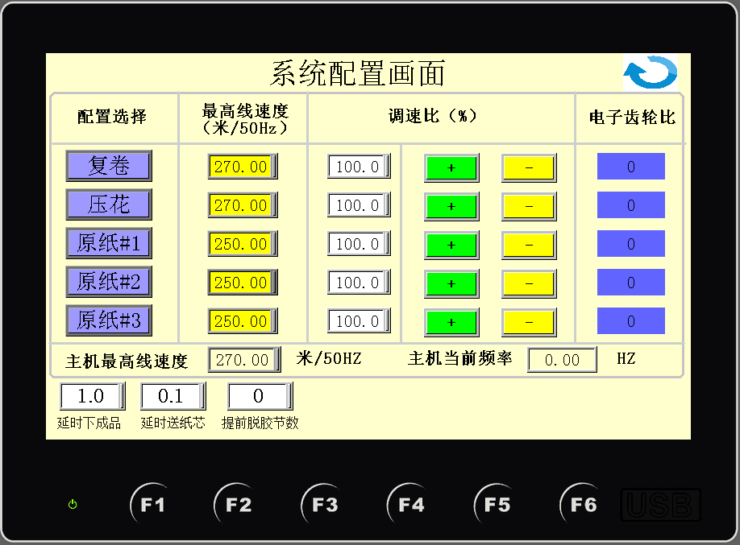
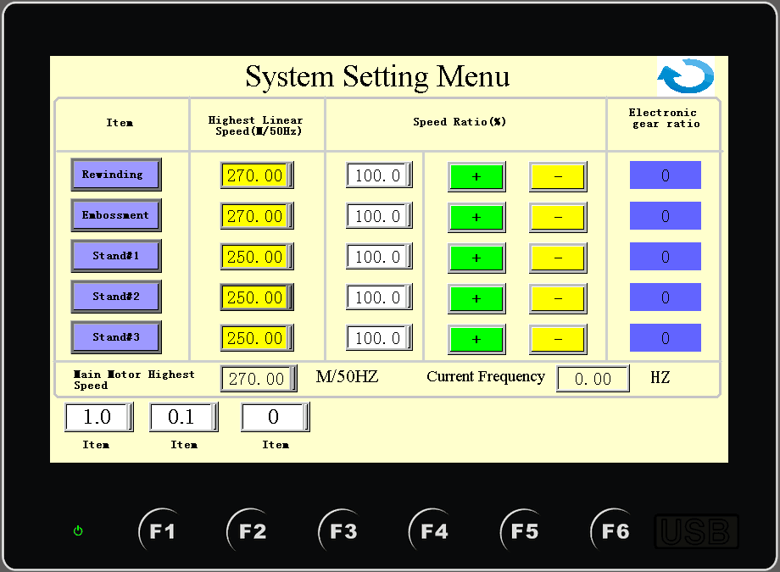
1.左边的复卷、压花、后架1、2、3可设置最高运行速度即通过变频器最高频率走出的速度。按按钮可以单独打开或关闭复卷、压花、后架1、2、3。设置调速比例使所有的运行都能同步。最后显此时电子齿轮比。1. Rewinding, embossing and rear rack 1, 2 and 3 on the left can set the maximum running speed, i.e. the speed out of the highest frequency of the converter. Press the button to open or close the rewinding, embossing and back rack 1, 2 and 3 separately. Set the speed ratio so that all operations can be synchronized. Finally, the electronic gear ratio is displayed. 2.主机最高速度设定。并主机显示当前运行频率。2. Setting the maximum speed of the host. And the host shows the current running frequency.
3. 延时下成品就是延时关闭辅助下料时间。3. Delayed finished product is delayed closure of auxiliary cutting time.
4.提前脱胶节数指上胶复合胶泵停上运行节数。4. The number of degumming knots in advance refers to the number of running knots when the compound rubber pump is stopped.
5．延时送纸芯指送纸芯时间推迟。5．Delayed core feeding refers to delayed core feeding.

七．可按人机终端画面中间的《IO监控》按钮进入PLC里的IO输入输出口监控如下图；7. The IO input and output port of the PLC can be monitored by pressing the IO monitor button in the middle of the man-machine terminal screen as follows.

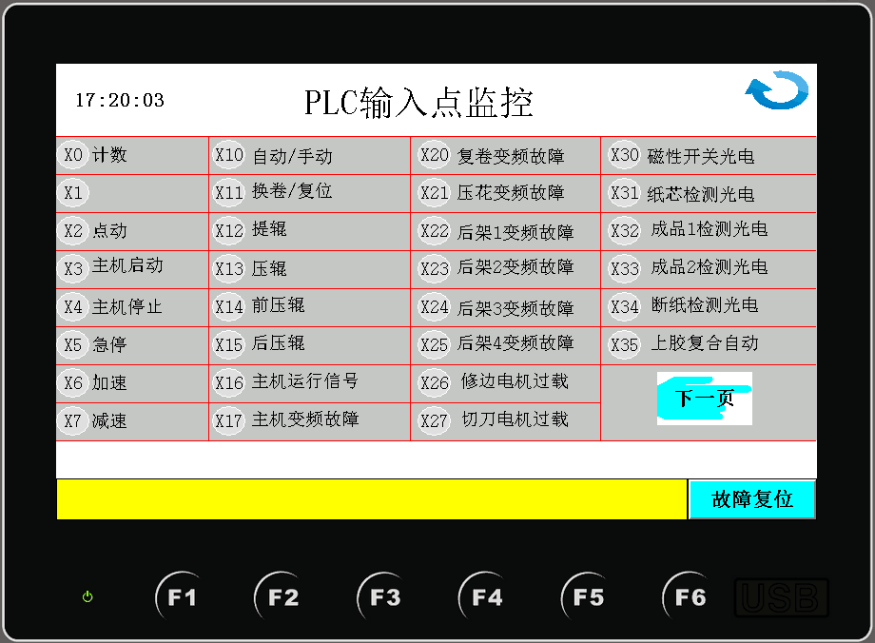
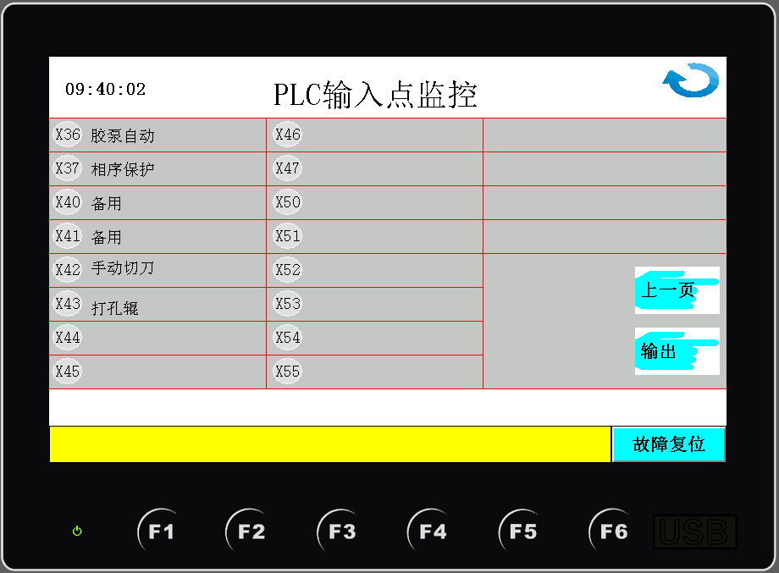
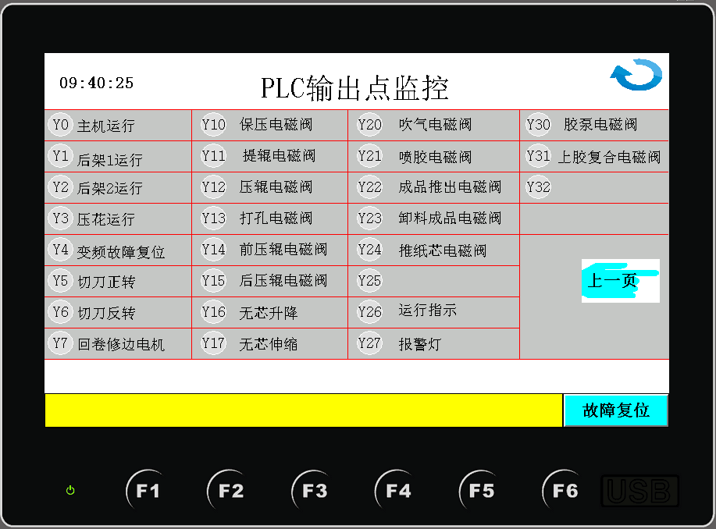
八．其它小盘纸分切复卷自动模式按照卫生纸复卷自动模式调试。8. The automatic mode of slitting and rewinding other small tray paper is debugged according to the automatic mode of toilet paper rewinding.

九．下班后请及时关闭电源，做好日常机台保养，感谢您购买本公司设备。9. After work, please shut the power off in time, do daily maintenance, Thanks for choosing our machines!

