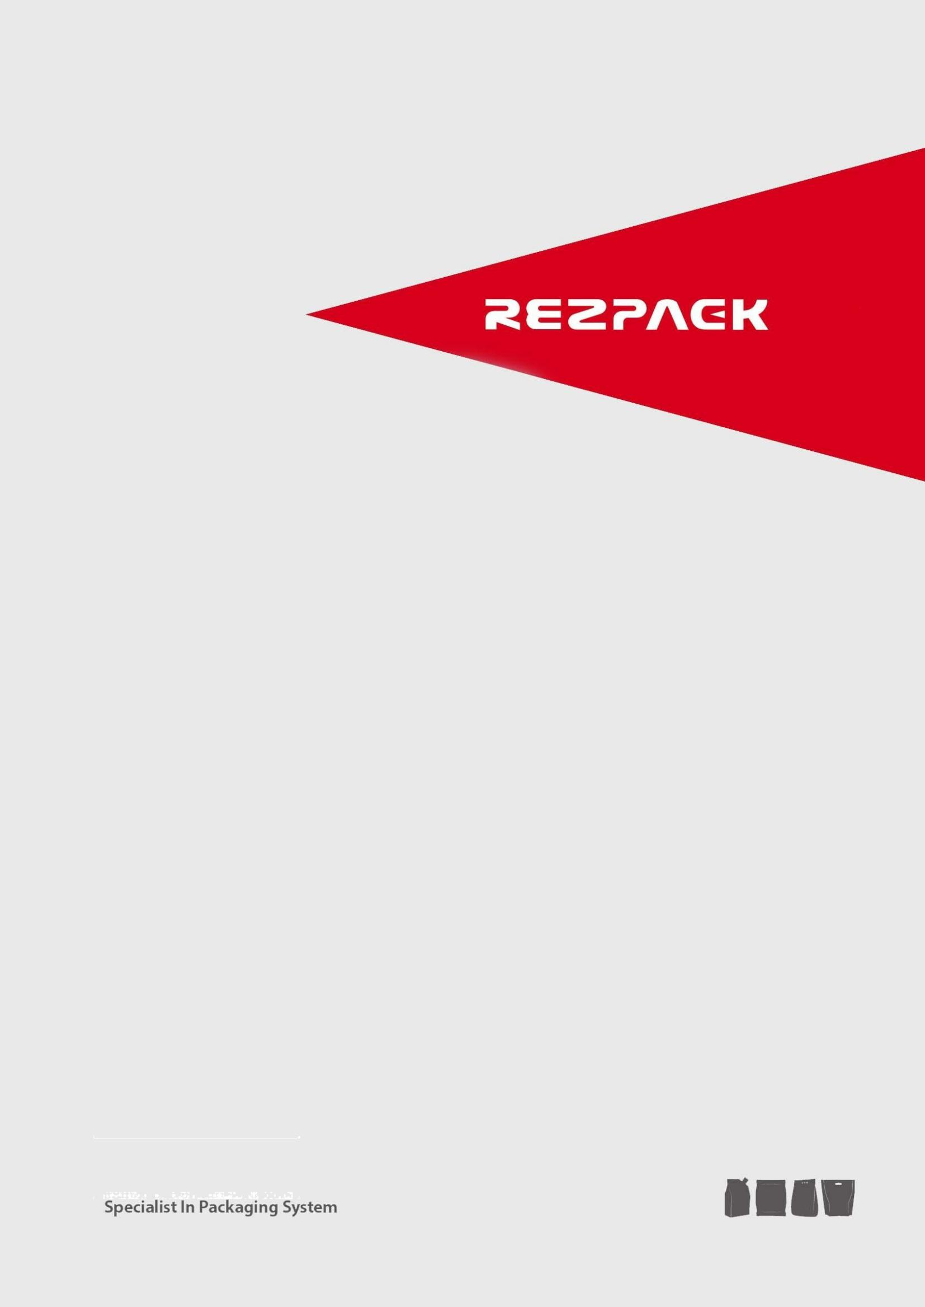
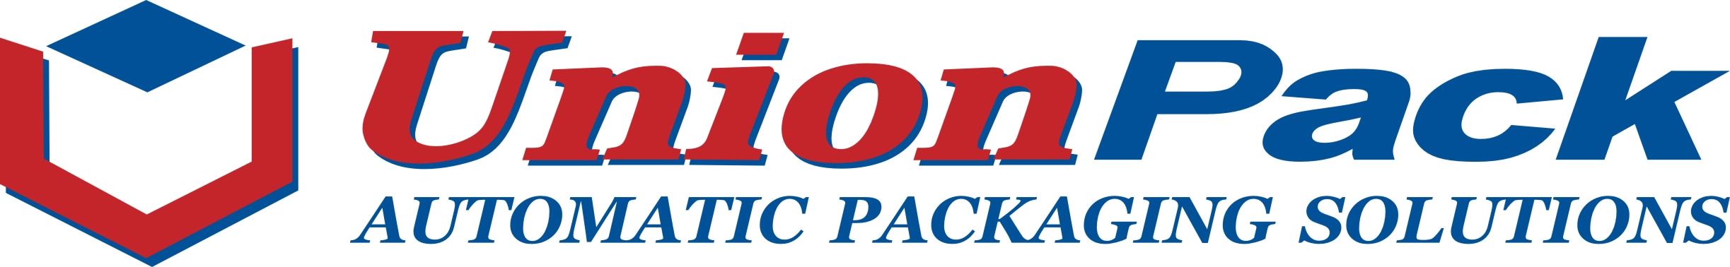

L Type Conveyor

Quotation
Packaging Requirement from Clients:
- Products:
- Output height:
- Required Capacity:
- Power Supply:
- Other Requirement:

Machine Price (FOB China Seaport):
Machines & Models | Price（RMB） | Ref. Price( USD) | Qty | Remarks
L Type Conveyor | 32,000 | 4,700 | 1 set | 304SUS
Notes:
1. The offer is valid for 2 weeks.
2. The above prices will be exchanged to USD according to exchange rate in the payment date.

Conditions:

- Payment: 100% TT advanced, and the balance should be reached us 10 days before shipment.
- Delivery time: 15 working days after receipt of deposit, as well as enough sample product and bags for testing.
- Warrantee: one-year guarantee（excluding the wearing parts), the international freight should be paid by buyer.
- Installation: The buyer shall pay the charge (accommodation, food, round air-tickets, and subsidy) in case of technician installation needed. The salary is USD100 per day per person, the days needed should be according to real situation.

L Type Conveyor

Model | customized
Rotation axis | 304 SUS
Surface treatment | Wire drawing processing
Power | 0.75KW
Voltage | 3 phase / 380 V / 50 Hz
Output height | 2500mm
Throughput | 3-6m3/h
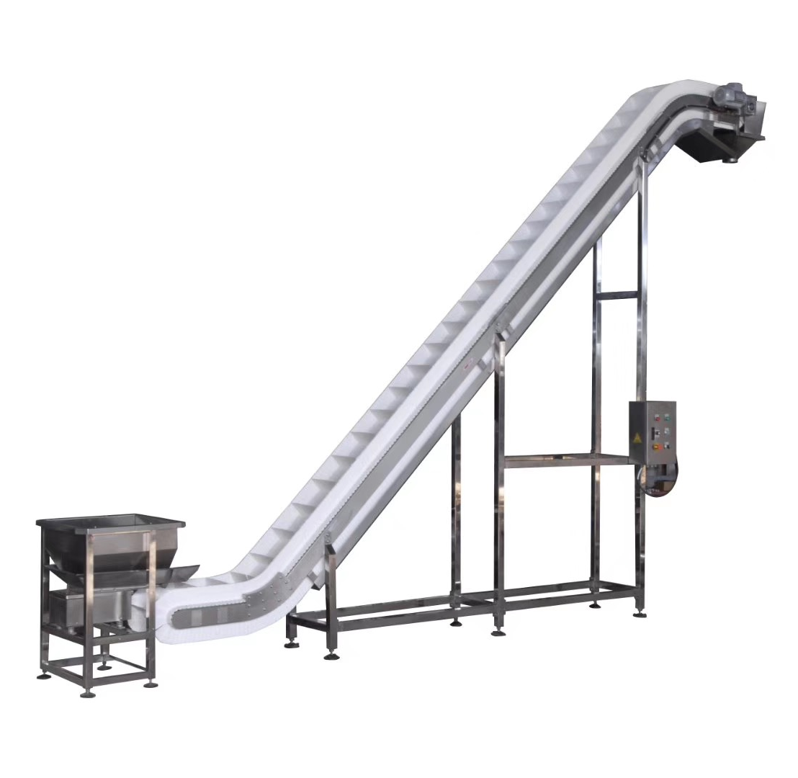

For illustration purpose only

Main Features:
• 机架全部采用304#不锈钢，适合与食品行业防，具有高度安全性。
• 皮带采用食品级塑料聚丙PP制成，安全卫生，清洗方便。
• 设备由控制电路以及料位控制实现自动供料和停止的自动化功能。
• 设备故障率极低。

(1) Belt (2) Vibrating Feeder
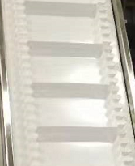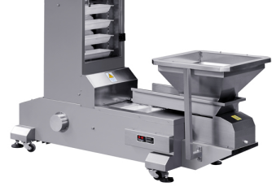

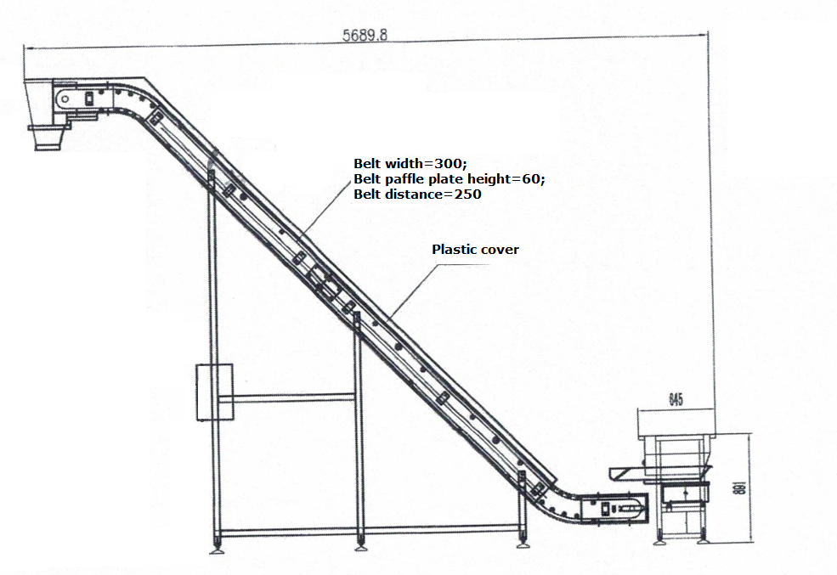
UnionPack International Inc.
RezPack Machinery Inc.
No 518. Kaifaer Road,Economic Zone, Ruian City, Zhejiang Province, China
Contact: Catherine Lin
Cell: +86-18267833029 Tel: +86 577 66618600
Email: sale1@rezpack.com
www.unionpackmachine.com www.rezpackmachine.com

