

WUXI ZHENDA AUTOMATION EQUIPMENT CO., LTD.
Add:No.3, C District, Private Economy,Xibei, Wuxi,Jiangsu Province, China
TEL:+86-510-83137670 FAX:+86-510-83135092
Skype: roy5386293 Email:chinazhenda@gmail.com Web:www.zdplatform.com
Contact: Roy Qiu
QUOTATION
To: Erick Vallejo Date:2019/8/5
Product Model | Configuration | UNIT FOB SHANGHAI PRICE | Qty | Amount
ZLP630 | *Material: Q235 steel with painting surface  *2 Hoist Ltd8.0 (220v/3phase/60hz/1.5kw)  *1 Electric control panel(Schneider Contactors)  *4 Steel Wire rope 100m, dia 8.3mm  *1 Power supply cable 100m, 3×2.5mm²+2×1.5mm²  *2 Safety locks, anti-tilting type  *1 Set Platform 6m(2+2+2)  *2 pcs Roof Suspension Mechanism  *2 Wall Wheels  *36pcs Concrete Counter weights, 25kg each  *4 pcs Concrete Cable Weights  *1 box Nuts and bolts  *4 pcs platform moving wheels | 1800 USD | 10 Set | 18000 USD

1. Terms of validity: 1 month.
2. Payment: 30% paid in advance by T/T, balance 70% paid by T/T after customer’s inspection before
delivery.
3. Time of Delivery:10 working days after receipt of the payment.
4. Packing: Plywood pallet.
5. Warranty: 1 Year.(Please refer to the user manual)
6. MOQ: as above quantity.
7. FOC spares with order.

SAMPLE PHOTO FOR REFERRANCE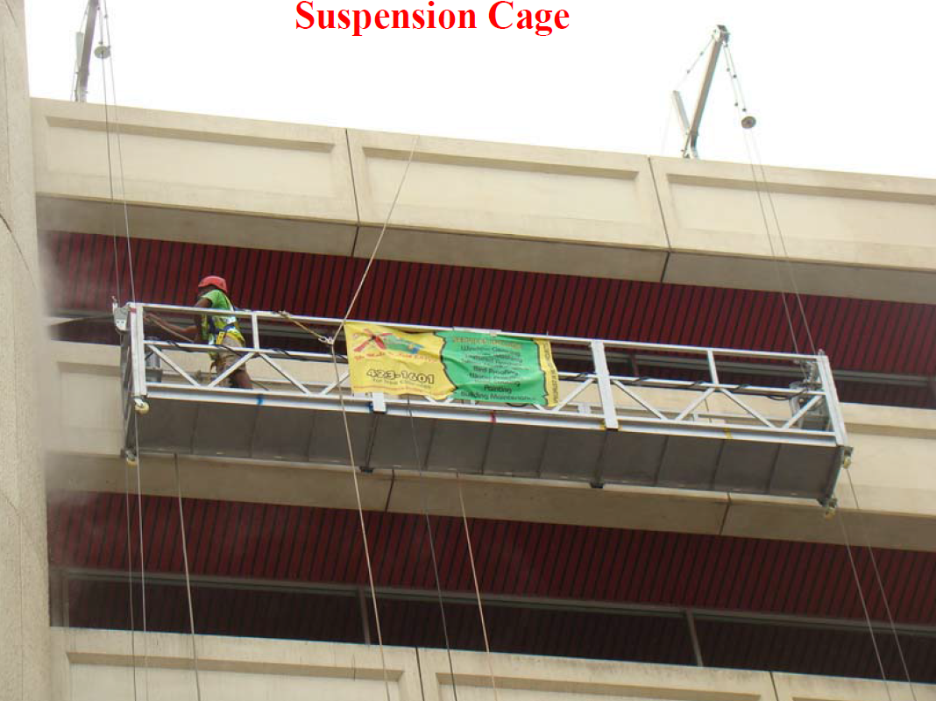
Suspension Mechanism
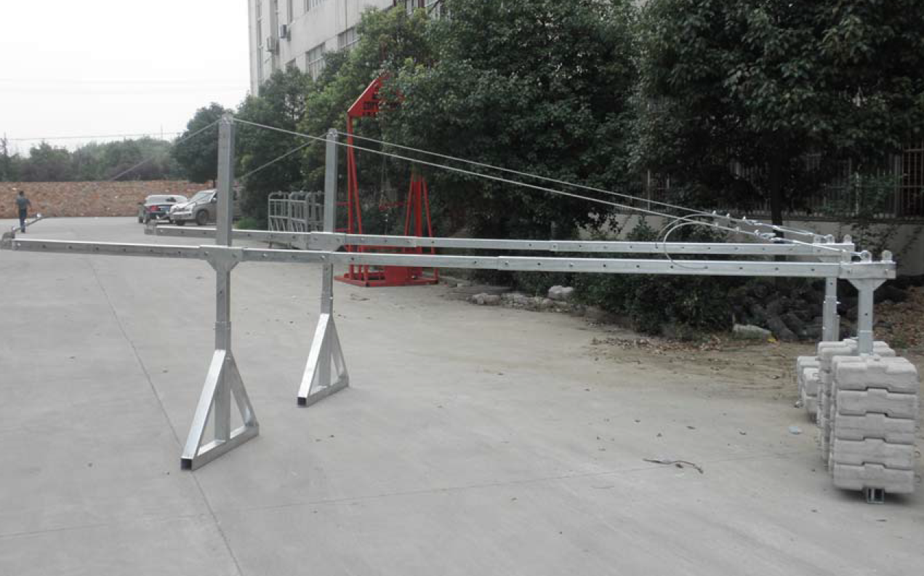

Hoist Safety Lock Electrical Box
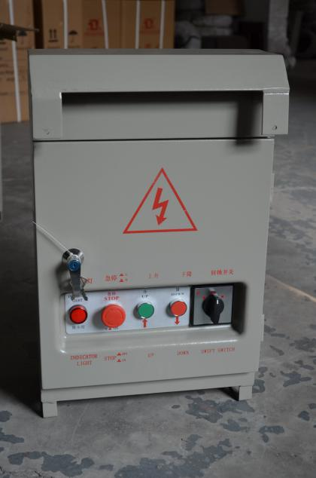
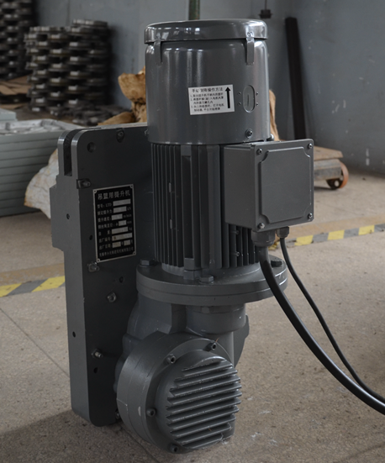
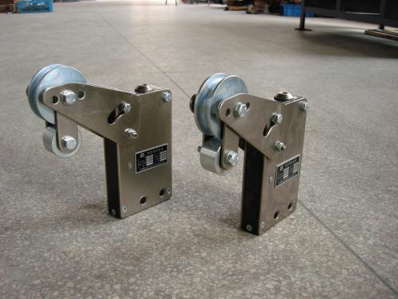

Steel Wire Rope Power Cable Counter weights


