Automatic powder packing solution

Automatic tea bag packing solution

Quotation

No | Type | Quantity  (set) | Unit Price (USD) | Remark
1 | MK-520D powder packing machine | 1 | 13200
2 | Date printer(optional) | 1 | 300
- Total: 13500USD, EXW Price
- Production time: 15-20 working days.
- Package: wooden box.
- Payment term: T/T (30% deposit before production, 70% balance before shipment)
- Warranty: one year.
- Service: lifelong maintain and technical support.
- Validity: 30 days from issuing date.
- Remark: The machine need cooperate with air compressor, customer should provide it by themself

Optional:
1. If different bag width, change bag former: 500 USD/set.

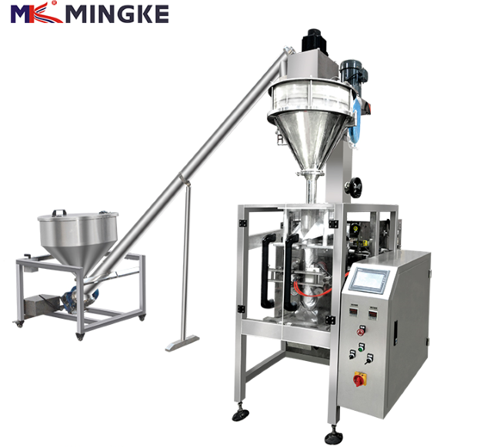
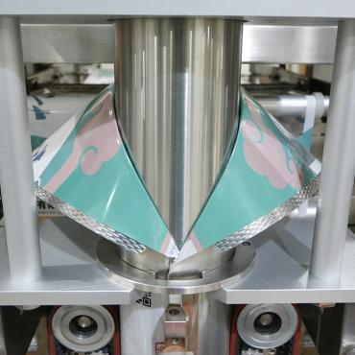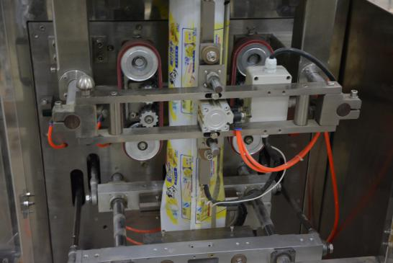

Sample bag :
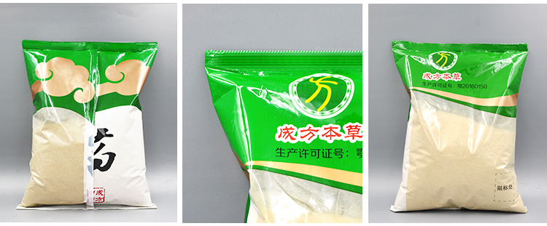

Combined parts
- MK-520 packing machine
- Screw metering machine
- Spiral conveyor
- Finished products conveyor

（1 ）MK-520 packing machine
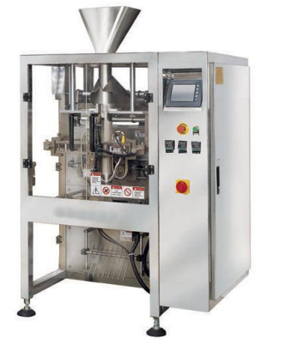

Ⅰ. Main feature:
*Imported PLC computer control system with human-machine interface; touch screen is simple and direct-viewing in operation;
*precise positioning with servo film transporting system; excellent complete machine performance and nice packing;
* minimize the loss with complete automatic warn protection function;
* supported with metric device, the machine will automatically complete all packaging processes from measuring, feeding, filling, bag making etc.
* the way of bag making: the machine can make pillow-type bag and standing bag according to customer’s requirements.

Ⅱ.Technical parameter:
Items | Content
Packing speed | 10-70bags/ min
Bag size | (L)80-350mm (W)90-250mm
Bag making mode | Pillow-type bag
Measuring range | 3000-2500ml
Max film width | 520 mm
Thickness of film | 0.04-0.10 mm
Air consumption | 0.4m3/min 0.6MPa
Main power/voltage | 3KW/220 V 50-60 Hz
Overall size | (L)1430×(W)1200×(H)1700 mm
The weight of switchboard | 550 kg

Component list
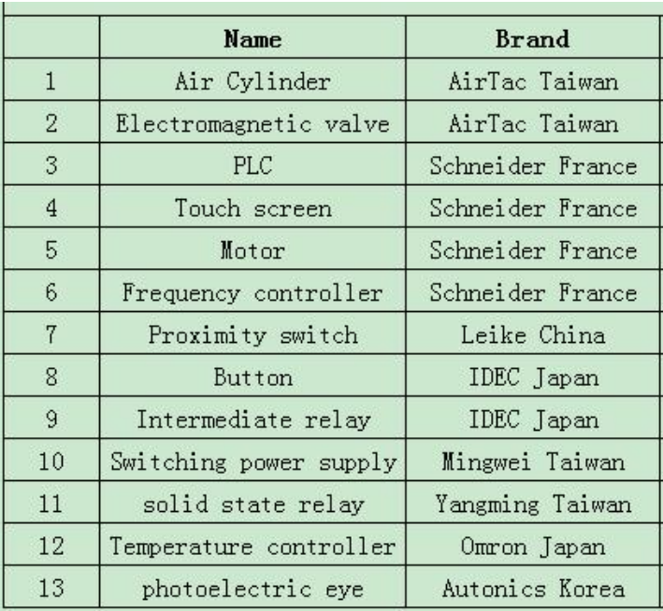

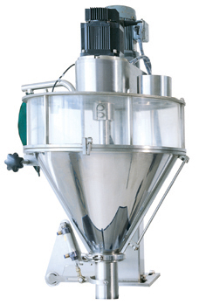
（2 ）screw metering machine

Features:
1.Simple structure, stable operation, simple and convenient maintenance;
2.The machine applies whirl threaded rod feeding, servo coding and micro-computer control technology, which is the most important technical feature for the machine.Integrated coding and controlling into one, it has features such as flexible action, low noise; stable, reliable and rapid dosing speed and high precision, etc. In addition, it also displays the times of dosing.

Technical specification:
Metering system Screw rotary filling
Packaging weight 200-2000g （need change auger filler for large range）
Packaging precision: ≤±1%
Packaging speed 15-60 bags/min
voltage Three phase 380v ( AC 220v) 50HZ
Machine power 1.9kw
Machine weight 100kg
Hopper volume 50L

- Spiral conveyor

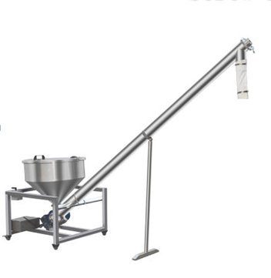

Features
This machine adopt screw conveying material, and the storage can be customized . it is suitable for conveying various powder and little pellets .

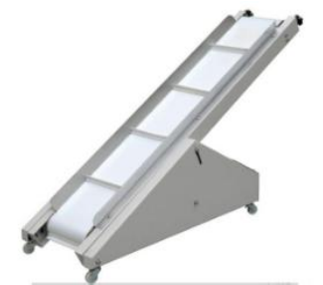
- Finished products conveyor

The machine can send the packed finished
bag to after-package detecting device or
packing platform.
Feeding speed 30m/minute
dimension 2110×340×500mm
voltage 220V/45W

Company introduction:
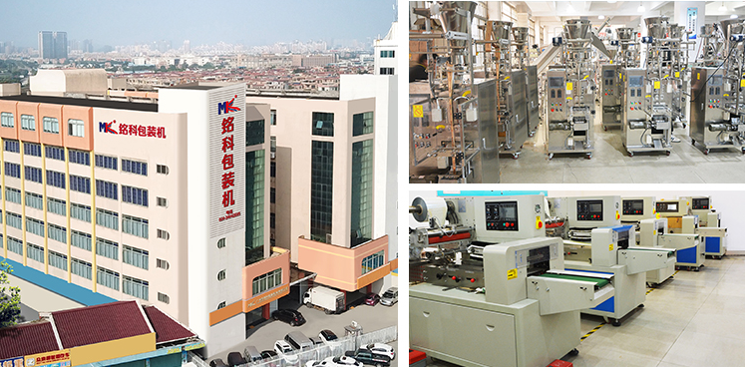

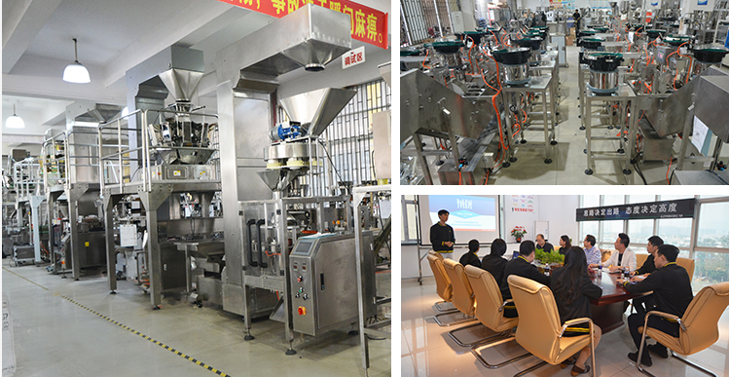

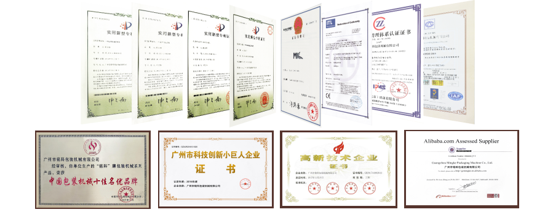

Cooperated company:
Altria Group
Spezia,LLC
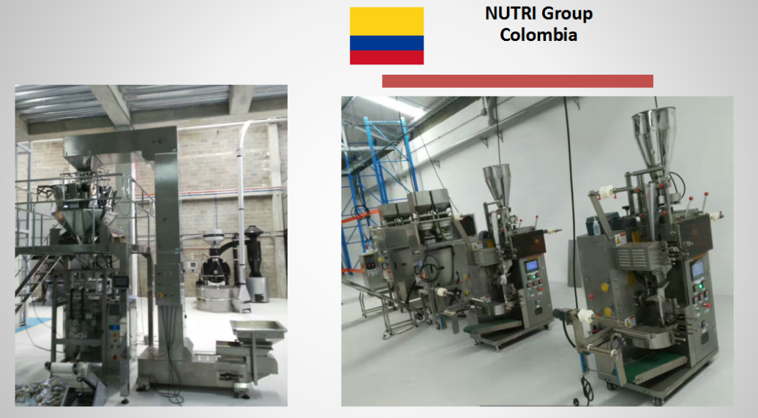
Flex Internatinal Ltd
Nutri Group
Gold state Assembly
Midea
TCL
......

