XK- CCA
XK- CCA Wood Protection product is a concentrated waterborne wood preservative for exterior and interior wood protection against soft rot moulds, borers and termites，wood destroying fungi.
Items | Indicators
Outward | Brown liquid
effective pH range | 1-2
Active ingredients | Copper, arsenic, chromium compounds
Effective components(%) | 50±1 or 60 ± 1
Storage | Dark, cool, ventilated
Physical and chemical indicators:
Performance characteristics
1,CCA wood preservatives are internationally used,effectively protecting against all kinds of wood rot,fungi,termites and water-borne insects.
2,Our wood preservatives have excellent adhesion,which won’t be washed off in rain or damp climates.
3,After CCA treatment,wood surfaces can still be treated with other adhesives,coatings,paint,etc.
Package: 300Kg/ drum
Transportation:land and shipping(our factory is only 2 hours drive to the harbour in Shanghai,which effectively cut the cost of transportation).
USAGE:
There are three kinds of wood treatment technics of CCA preservative: vacuum/pressure treatment, soaking treatment, and coating treatment. The vacuum/pressure treatment is recommended when condition permitted.
Preservative material dipping processing chart:
- The vacuum pump removes air from jar (about 1 atmospheric pressure)
- Fill protection liquid into the jar
3.Pressurize and make protection liquid infiltrate sufficiently (about 15 atmospheric pressure)
4.Discharge protection liquid and vacuumize, to remove unnecessary protection liquid (about 1 atmospheric pressure)

The tool of ACQ treatment
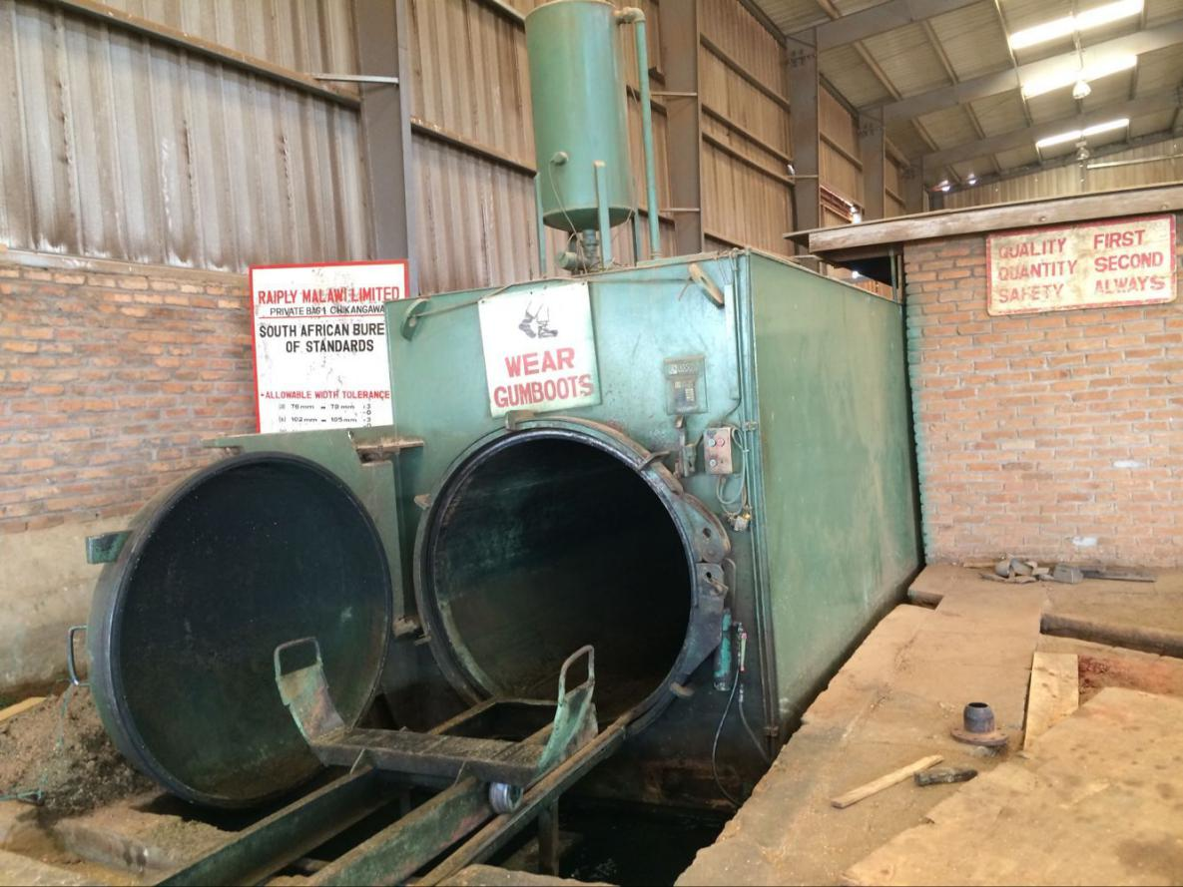
Sample
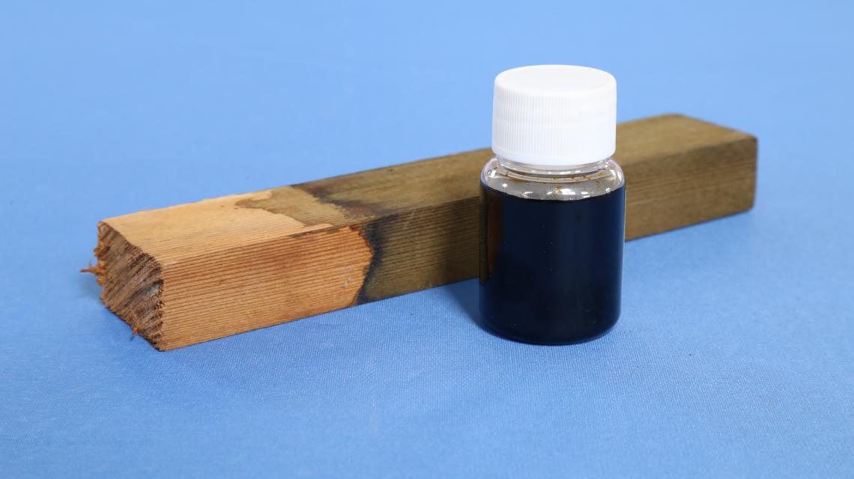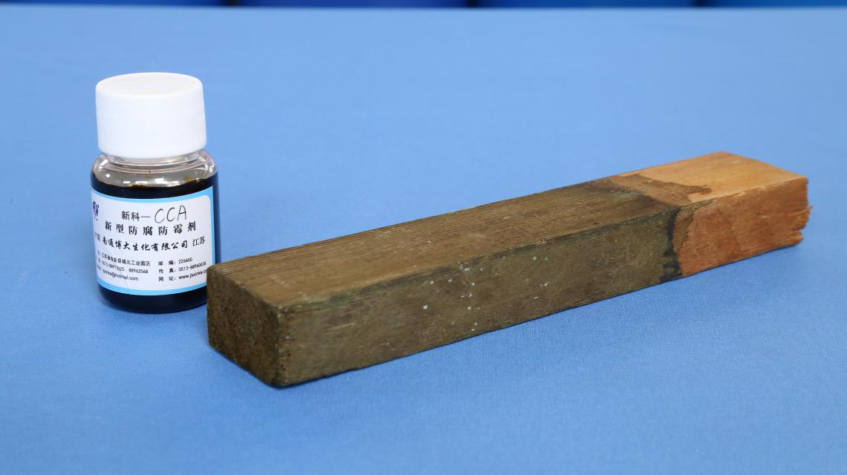
The wood after treatment
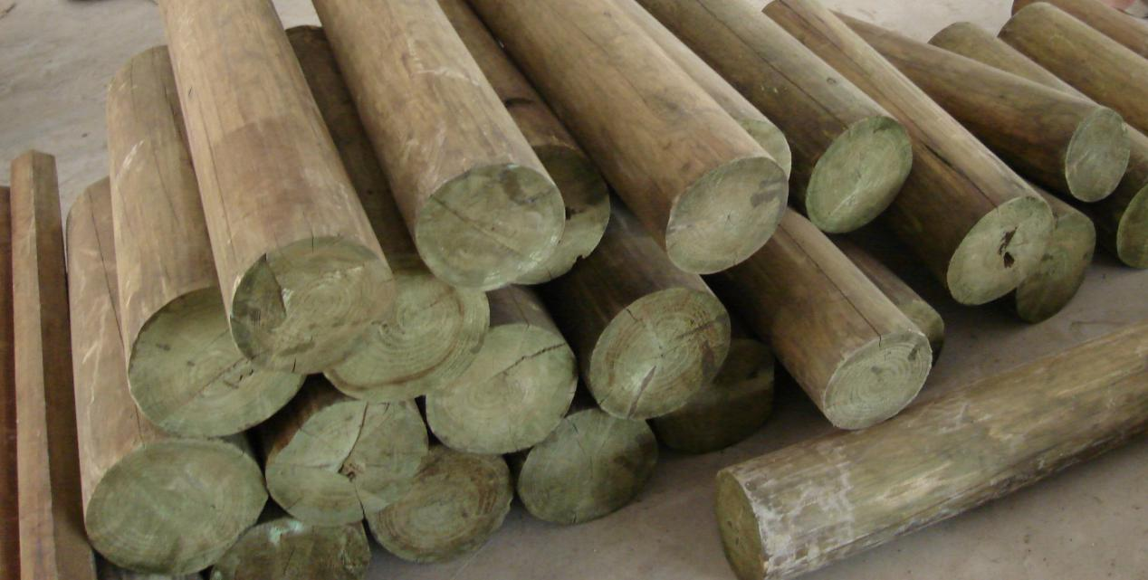
ATTENTIONS:
- Do not inhale spray mist.Wear full protective clothing.
- After use and accidental skin contact, please wash with soap and water .
-Do not drink, eat or smoke while mixing or before clothing changed, face and hands washed.
- Dispose of water where it will not contaminate food,grazing,rivers or dams.
- Prevent contamination of drinking water, food, foodstuffs, and eating utensils.
- Do not re-use container for any other conditions.

WARNINGS:
- Handle with extreme care. Poisonous by contact, swallowing or when inhaled.
- Store under lock and key and away from food and foodstuffs.
- Keep out of reach of children,animals and uninformed persons.
- Treated wood must not be used or despatched until at least 24 hours after treatment.
- Toxic to human, fish,bees and other wildlife animals.
- Can’t discharge residue into rivers or dams.
- In case of poisoning, call a doctor and give this label available to him/ her.
- Do not store alongside combustible materials.

SYMPTOMS OF HUMAN POISONING:
Burning pain in stomach and oesophagus, vomiting, nausea, watery or bloody diarrhoea, dehydration with muscular cramps, intensive thirst, feeble pulse, occasional convulsions, cold clammy skin, coma.

FIRST AID TREATMENT:
Remove person from source of contamination. Remove contaminated clothing and rinse contaminated body area thoroughly with plenty of water and soap. Flush contamination out of eyes with clean water for 15 min. If swallowed and still conscious,induce vomiting by tickling the back part of throat,give copious quantities of water and induce vomiting again.Continue procedure until vomit fluid is clear and free from smell of poison, Hospitalize as soon as possible after vomiting. Administer artificial respiration and/ or closed cheat cardiac massage if necessary. Do not apply direct mouth to mouth respiration if poison was swallowed. Never give anything by mouth to an unconscious person.

NOTE TO PHYSICIAN:
The decision as to whether the severity of poisoning administration of any antidote and actual dose required should be made by qualified medical personnel. Give Dimercaprol 3 mg/kg (or 0.3 ml/kg) every 4 hours for 2 days and then 2 mg/kg every 2 hours for a total of 10 days. Dimercaprol is available as a 10%solution in oil for intramuscular administration. Next, give Penicillamine, up to 100 mg/ kg/day (maximum 1g/day) divided into 4 doses for no longer than 1 week. If a longer administration period is warranted, dosage should not exceed 40 mg/kg per day. Give the drug orally half an hour before meals.
Test reports:our own test reports can be provided,also we can provide the thirld party ones.

