链条输送机规格Chain conveyor specification：
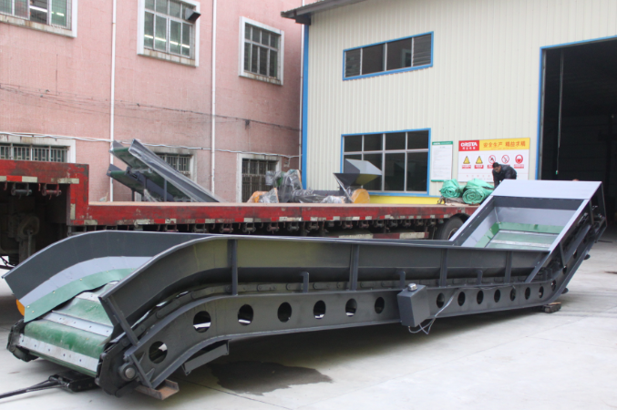
规格(Model)：W1000*8000
外形尺寸(Overall size)：L8500*W1500*H3000
内宽尺寸(Inner width)：1000mm
主电机(Main motor power)：7.5kw-4
边板厚度(Sideboard thickness)：3mm
皮带厚度(Belt thickness)：5mm厚PVC
机架材料(Base frame material)：250#工字钢 joist steel
转速(Rotary speed)：25r/min
机重(Machine weight)：4吨左右 about 4ton
价格(Price)：85000.00(RMB)

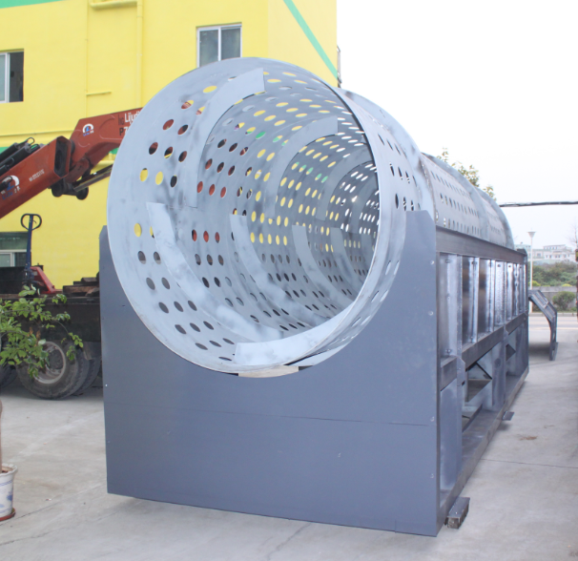
滚桶筛规格Trommel screen specification：
规格(Size)：¢1000*5000
外形尺寸(Overall size)：L5200*W1000*H2500mm
主电机(Main motor power)：7.5kw-4
筒身厚度(screen thickness)：6mm
筛孔尺寸(Screen size)：40mm（可根据客户要求订做the scree size is customized）
皮带厚度Belt thickness：5mm厚PVC 5mm thickness PVC
机架材料(Base frame material)：140#槽钢和200#工字钢 140# U-steel and 200# joist steel
转速(Rotary speed)：25r/min
机重(Machine weight)：3吨左右 about 3ton
价格Price：185000.00(RMB)

电控箱(Electrical control cabinet)：
外形尺寸(Overall size)：800*400*1600
配置功能(Remarks)：配好两机变频器，配过载保护，配备超载延时启Equipped with two frequency converters, with overload protection, and overload delay start
价格(Price)：6000.00(RMB)

1、以上设备价格为出厂价不含税不含运费 The above machines are EXW price and tax is not inclusive.
2、交期(Leading time)：35天 days
3、付款方式(Payment terms)：签订合同预付40%，出货前付清余款。 The 40% payment by T/T on a contract, the rest 60% payment should be paid before loading.
4、整机保修一年，人为损坏除外Warranty period: One year,man made damage is exclusive.
5、电器配件保修6个月 The electrical parts are guaranteed for 6 months
6、异电压异频率加3个点 The cost will increase 3% if different voltage and frequency motor
7、如需开票加13个点，开出来为13%的增值发票

The value will add 13% if you want to open 13% value-added tax special invoice.

