Chain conveyor specification：
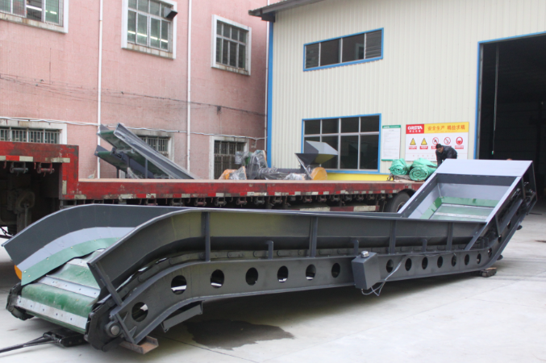
Model：W1000*8000
Overall size：L8500*W1500*H3000
Inner width：1000mm
Main motor power：7.5kw-4
Sideboard thickness：3mm
Belt thickness：5mm厚PVC
Base frame material：250# joist steel
Rotary speed)：25r/min
Machine weight)：about 4ton
Price：85000.00(RMB)

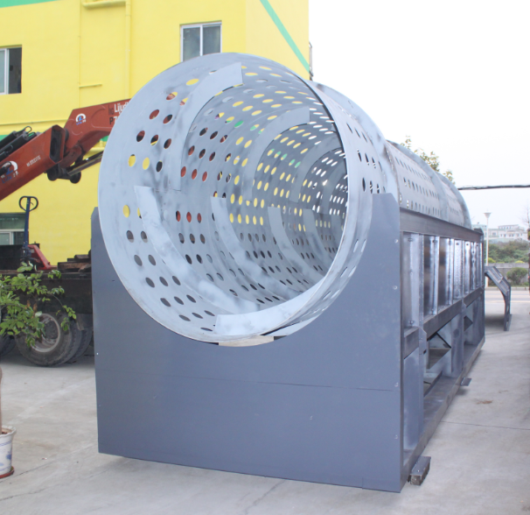
Trommel screen specification：
Size：¢1000*5000
Overall size：L5200*W1000*H2500mm
Main motor power：7.5kw-4
screen thickness)：6mm
Screen size)：40mm (the scree size is customized）
Belt thickness：PVC 5mm thickness PVC
Base frame material： 140# U-steel and 200# joist steel
Rotary speed：25r/min
Machine weight： about 3ton
Price：185000.00(RMB)

Electrical control cabinet)：
Overall size)：800*400*1600
Remarks：Equipped with two frequency converters, with overload protection, and overload delay start
Price：6000.00(RMB)

1、The above machines are EXW price and tax is not inclusive.
2、Leading time：35 days
3、Payment terms： The 40% payment by T/T on a contract, the rest 60% payment should be paid before loading.
4、Warranty period: One year,man made damage is exclusive.
5、 The electrical parts are guaranteed for 6 months
6、 The cost will increase 3% if different voltage and frequency motor
7、The value will add 13% if you want to open 13% value-added tax special invoice.

