I:QUOTATION LIST
To | Mr TCHOFFO JEAN BAPTISTE  Tel: +237 99934721  Fax:  Email:jtchoffo@yahoo.com
Date | 09th, Nov, 2012
From: Molly Lee
Tel: +86-371-67668558
Mob: +86-13676960829
Fax: 86-371-67662768
Email: hjsales23@hongjigroup.com
Google Talk: mollylcm@gmail.com
MSN: mollylcm@hotmail.com
Skype: mollylcm
⑴
Description | Model | Qty | Unit EXW-Price
Hopper | Build by yourself.
Vibrating feeder | ZSW-960x3800 | 1set | USD9355
Jaw crusher | PEF600x900 | 1set | USD30645
Belt conveyor | B800x20m | 1set | USD4840
Impact crusher | PF-1214 | 1set | USD40323
Belt conveyor | B800x20m | 1set | USD4840
Belt conveyor | B650x22m | 1set | USD4268
Vibrating screen | 3YK1860 | 1set | USD15484
Belt conveyor | B500*20m | 1set | USD3220
Belt conveyor | B500*20m | 1set | USD3220
Belt conveyor | B500*20m | 1set | USD3220
Total Amount EXW-Price |  |  | USD119415

II:SEPECIFICATIONS
Reference of technical data with above machines
Model | ZSW-960x3800 | 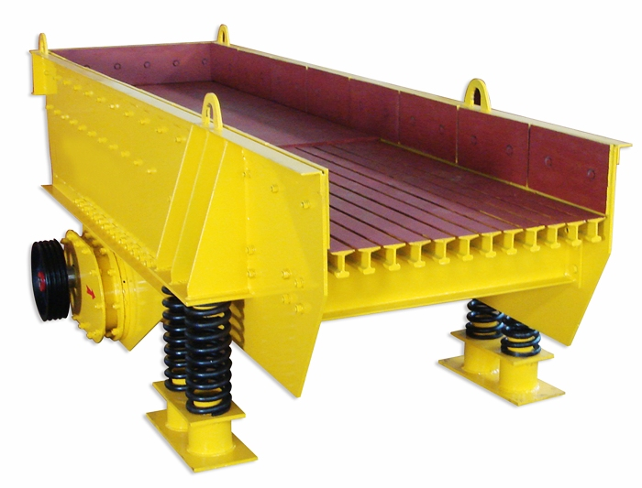
Feed chute size(mm) | 960*3800
Max.feeding size(mm) | 500
Handling capacity(t/h) | 90-200
Power(kw) | 11
Weight(kg) | 3980
Overall Dimension(mm) | 3882*2224*2121

Model | PEF600×900 | 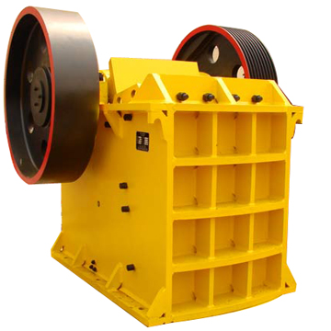
Power(kw) | 75
Max feed size(mm) | 480
Adjustment scopes(mm) | 75-200
Production capacity(m³/h) | 40-120
Rotating speed of main shaft(r/min) | 255
Overall dimensions (1×w×h)(mm) | 2792×2168×2250
Weight(kg) | 17600

Belt Width(mm) | 500 | 650 | 800 | 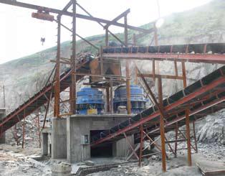
Belt Length (m) /Power (kw) | ≤12/3 | ≤12/4 | ≤6/4
Belt Length (m) /Power (kw) | 12∽20/  4∽5.5 | 12∽20/5.5 | 6∽15/5.5
Belt Length (m) /Power (kw) | 20∽30/ 5.5∽7.5 | 20∽30/  7.5∽11 | 15∽30/  7.5∽15
Belt Speed  (m/s) | 1.3∽1.6 | 1.3∽1.6 | 1.3∽1.6
Capacity(t/h) | 40∽80 | 131∽323 | 278∽546

Model | PF-1214 | 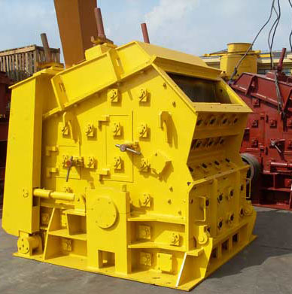
Specification(mm) | Φ-1250×1400
Feeding opening size(mm) | 400×1430
Max.feeding size(mm) | 400
Capacity(t/h) | 130-180
Power(kw) | 160-200

Model | 3YK1860 | 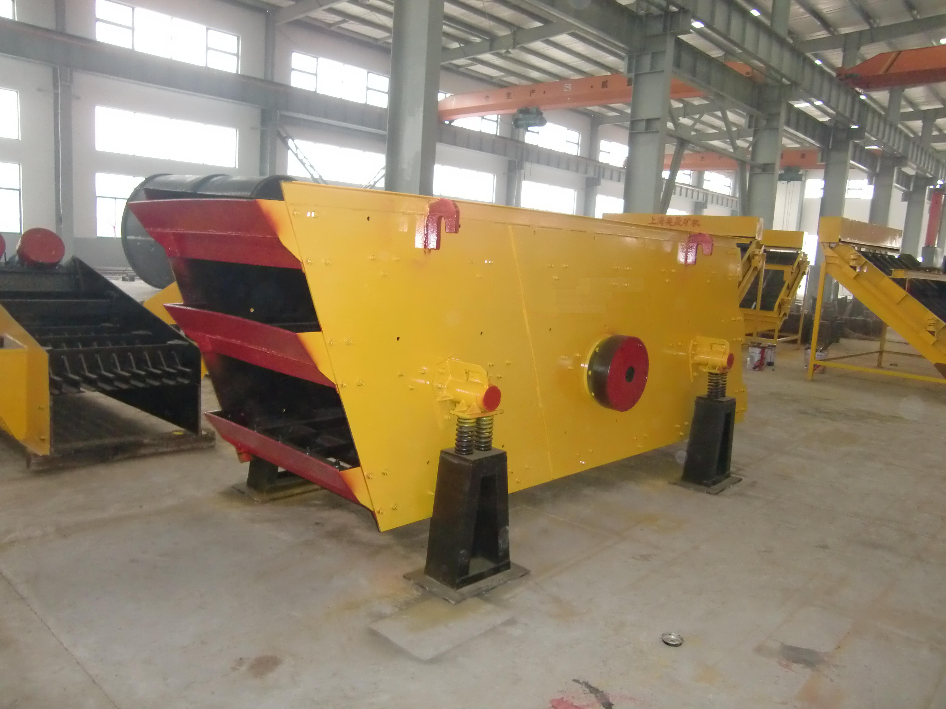
Feed chute size(mm) | 3
Max.feeding size(mm) | 5-200
Handling capacity(t/h) | ≤400
Power(kw) | 250-600
Weight(kg) | 22
Overall Dimension(mm) | 9200
Ⅲ Commercial Terms
1. Delivery time: 30days after receiving the prepayment.
2. Payment terms:Prepayment: 30% of the total amount to be paid within 5 working days after signing the contract by TT, the 70% of the total amount to be paid by TT after inspection & before delivery.
3. Guarantee: 100% brand new when leaving the factory. we guarantee quality of the machines for a period of one year from the trail run finish(exclude easily damageable parts). But the expense of going abroad of technical engineers should be paid by buyer.
4. Installation: If you require the installation service from us. We will send one technical engineer to your site to guide installation, take trail run and train the workers. Expenses should be paid by the buyer, including the visa, round-trip tickets, insurance, hotel, food and 80 dollars salary per day.
5. Packing: The goods would be processed to be rustproof and moisture proof before delivery. The small parts are packed into wooden box.
6. We will supply foundation drawings after signing contract. 7. Period of validity: This quotation is available in 60 days since issued.

