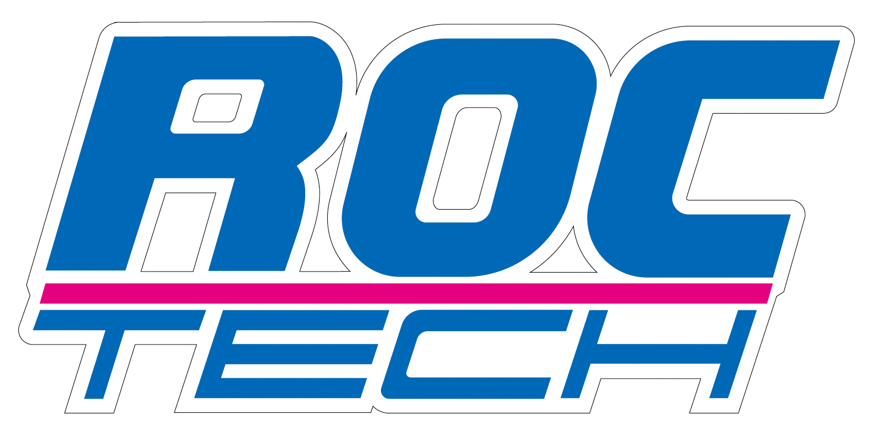

ROCTECH MACHINERY CO., LTD.

Professional supplier for CNC Routers, CNC Laser machines

HIGH PRECISION, HIGHER SPEED, FAST SERVICE

www.roc-tech.com
c_gao@roc-tech.com

Nov., 20, 2012

From: Roctech Machinery Co., Ltd
To: Mr. Cesar Lozano

For CNC Machining RC1325 the brand and the photos as follow:

- The 4.5 KW HSD spindle is original from Italy
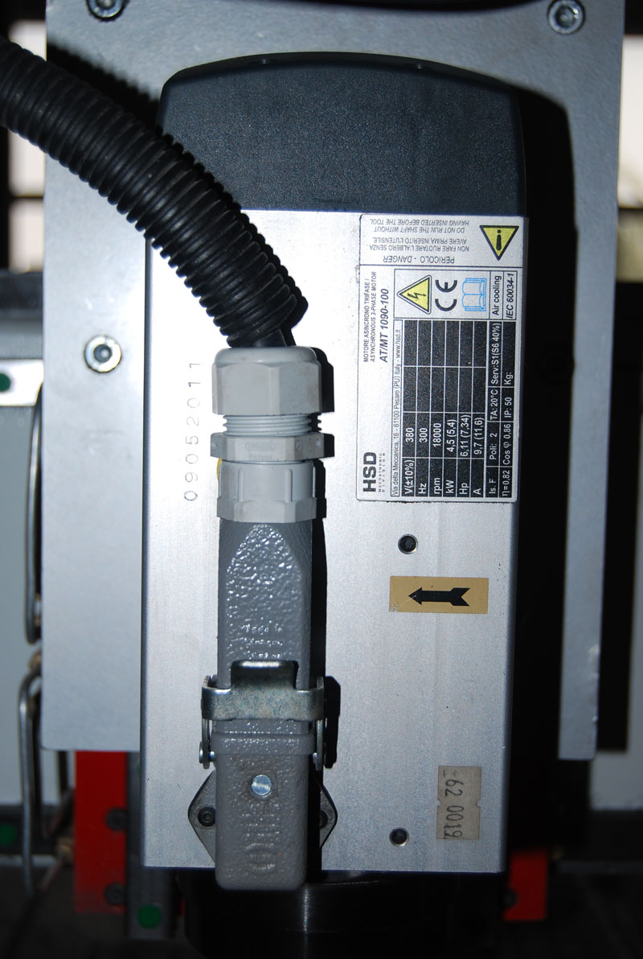

- The 5.5KW Delta inverter is original from Taiwan, the 24V Schneider contactor is original from France.
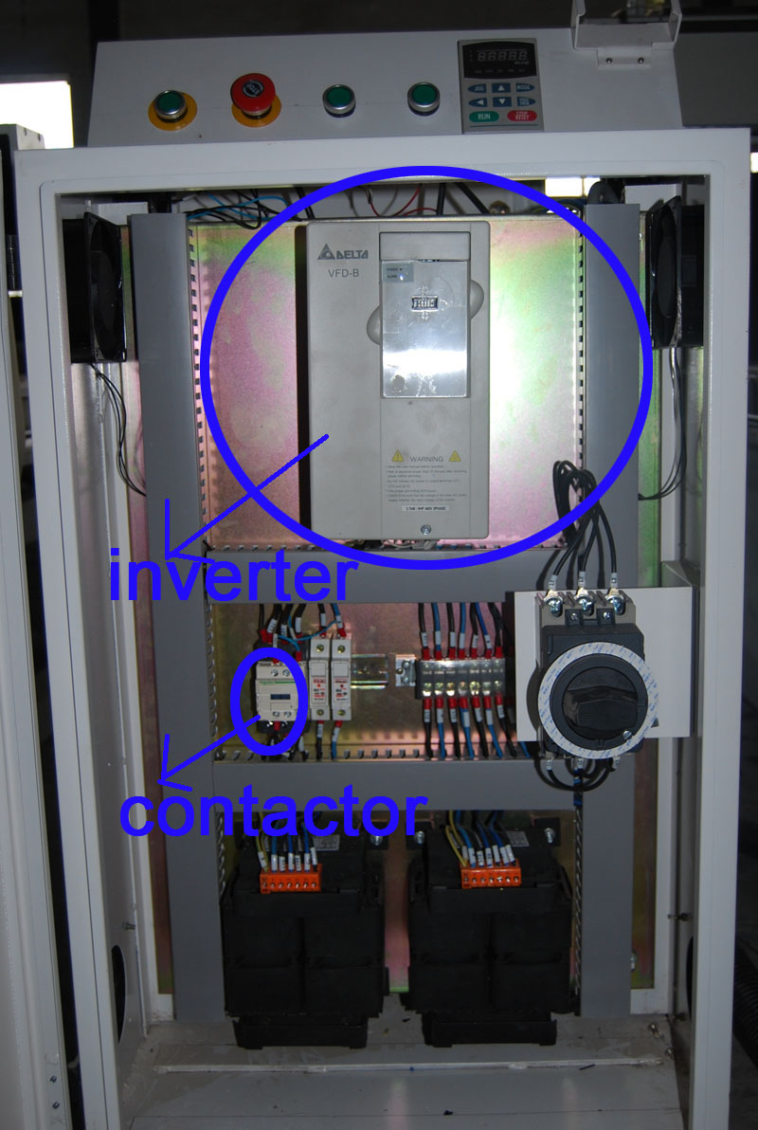

- The Omron limit sensor is original from Janpan.
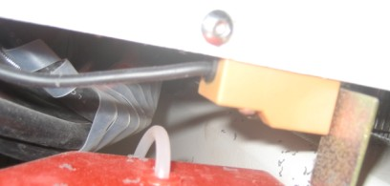

4.Taiwan TBI 2510 ball screw
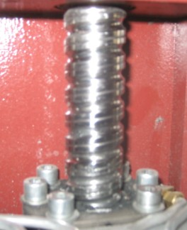

5.118 Big stepper motors
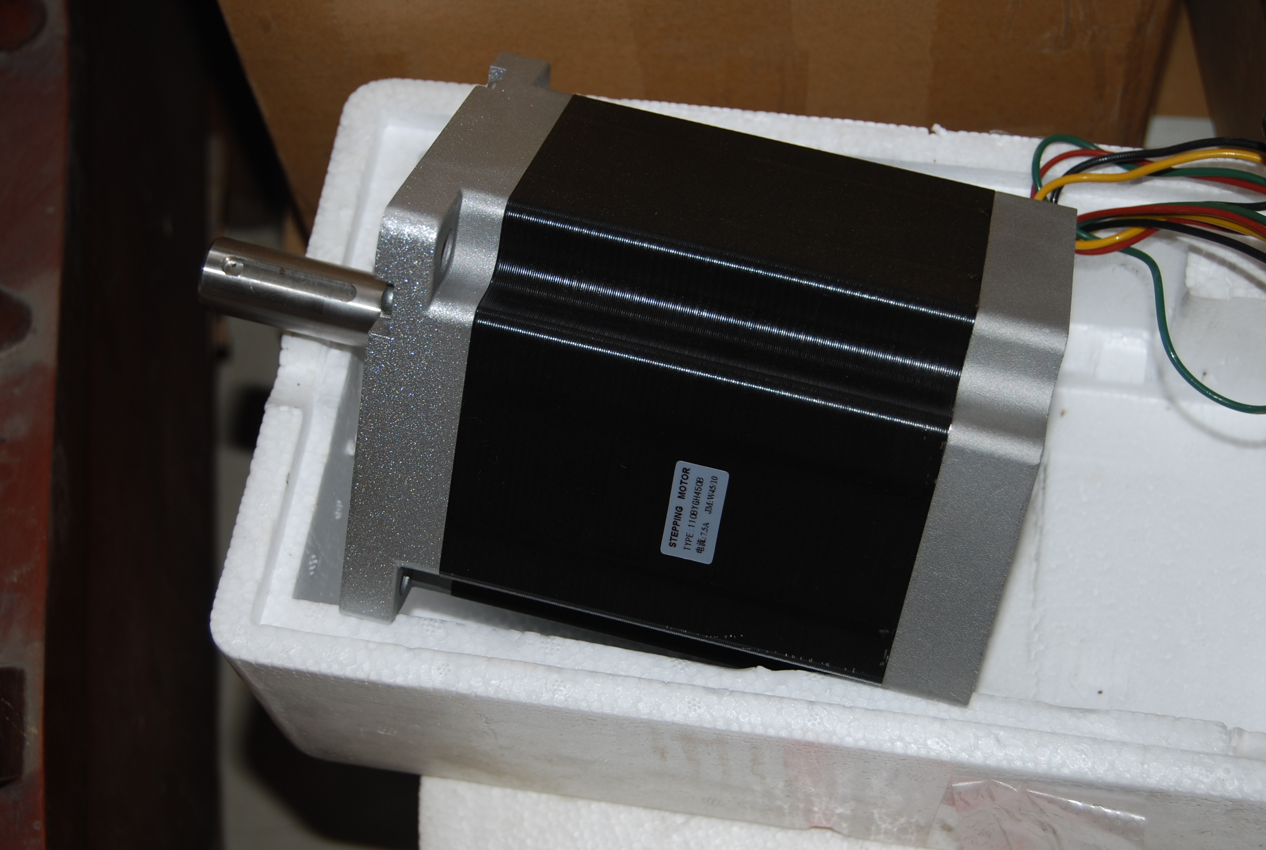

6. Strong side board
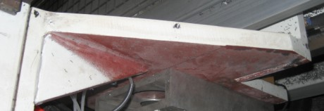

7. Hiwin linear and block, original from Taiwan.
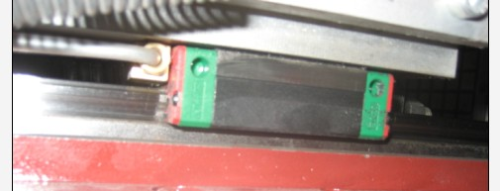

8. DSP control system with high-quality from Beijing, China.
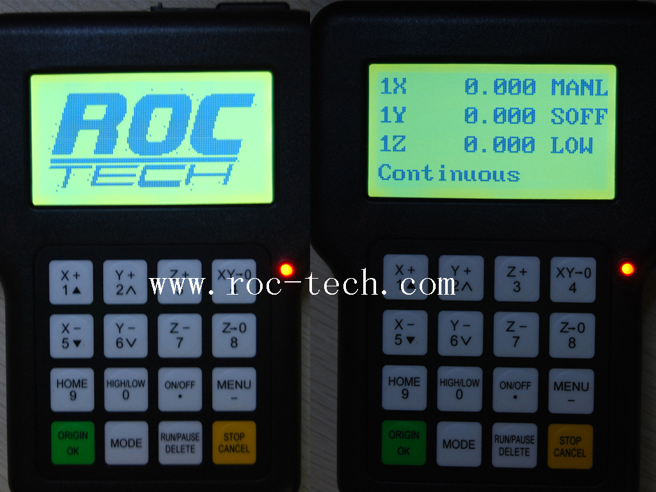

9. Specification of CNC Machining RC1325:
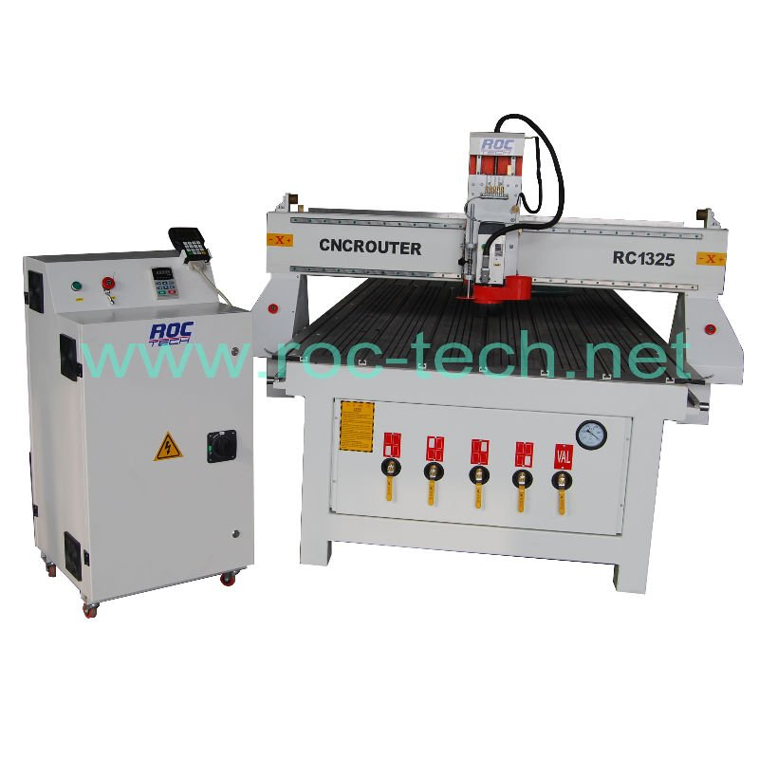
CNC ROUTER RC1325
Basic machine with 1300x2500x200mm
4.5 kw HSD spindle
5.5 kw Delta inverter
Steel tube structure
DSP control system
Stepper driving motor
Original Type3 software
ArtCAM software
T-slot and vacuum combined table
Lubrication
Becker Germany Vcauum system(including hoses, valves and Becker 5.5kw Pump)
Dust collector(including collector motor, two bag type, hoses, bracket and dust hood on spindle)

Model Number: CNC Router RC1325
CIF Manzanillo price: 15,300.00 USD
Delivery Time: After T/T payment in advance, about 21days

Option:
1.Yaskawa servo system (including Drivers, 850w
motors, and break, and special DSP) 4 sets, 4000 USD extra


