

ROCTECH MACHINERY CO., LTD.

Professional supplier for CNC Routers, CNC Laser machines

HIGH PRECISION, HIGHER SPEED, FAST SERVICE

www.roc-tech.com
l_liu@roc-tech.com

Nov. 21, 2012

From: Roctech Machinery Co., Ltd
To: Mr. Ricardo Saborio Monge

For CNC Machining RC0609 the brand and the photos are as follows:

1. The1.5kw domestic water cooling spindle
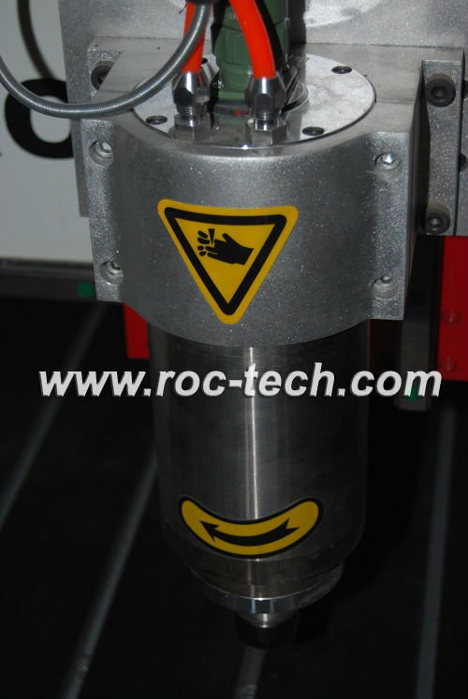
2. The Omron limit sensor is original from Japan.
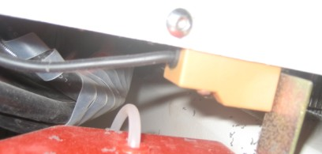

3. Taiwan TBI ball screw: x and z axis are 1605, Y is 2510
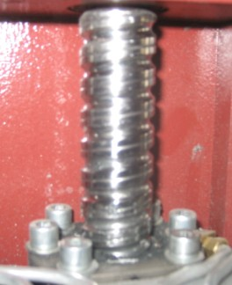
4. 118 big stepper motor for y axis and 85B stepper motor for x, z axis
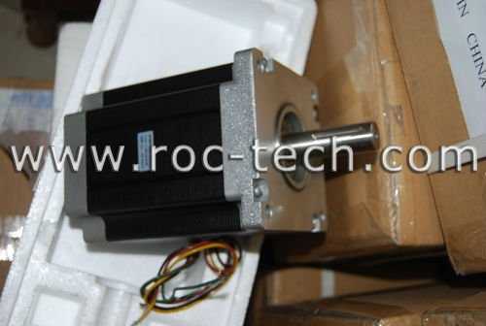
5. 16mm Hiwin linear for y axis and block original from Taiwan.
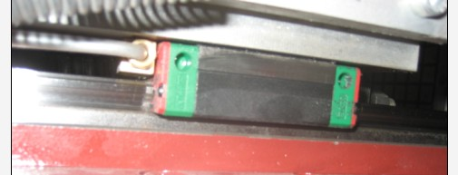

6. DSP control system with high-quality from Beijing, China.

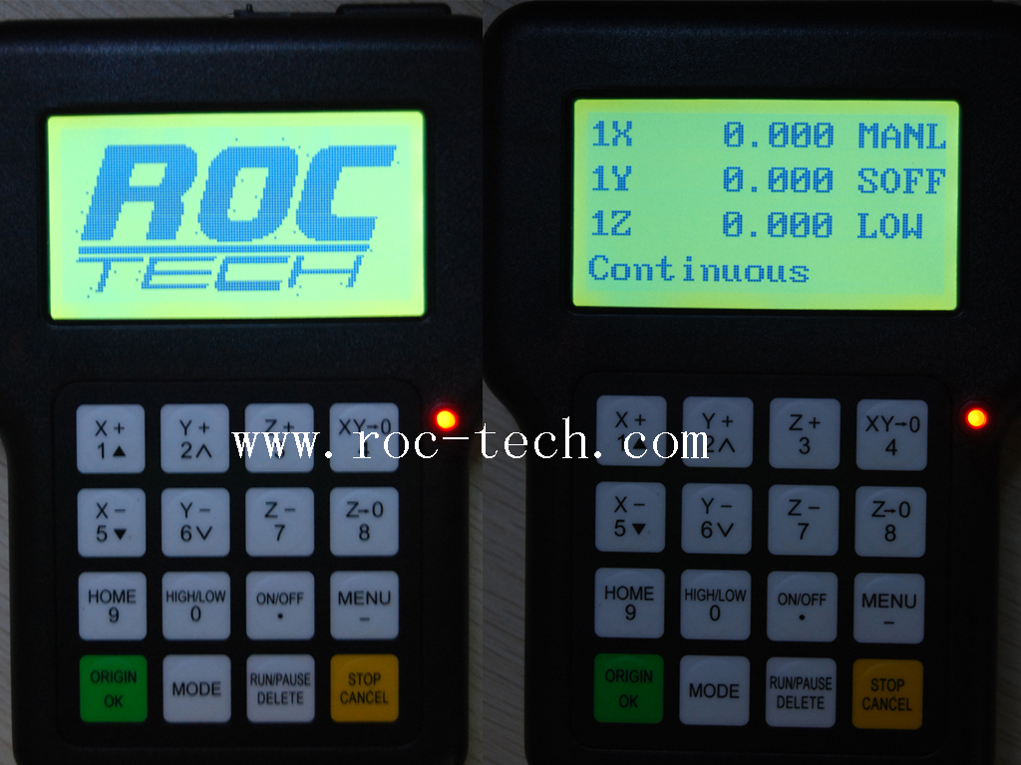

7. Specification of CNC Machining RC0609:
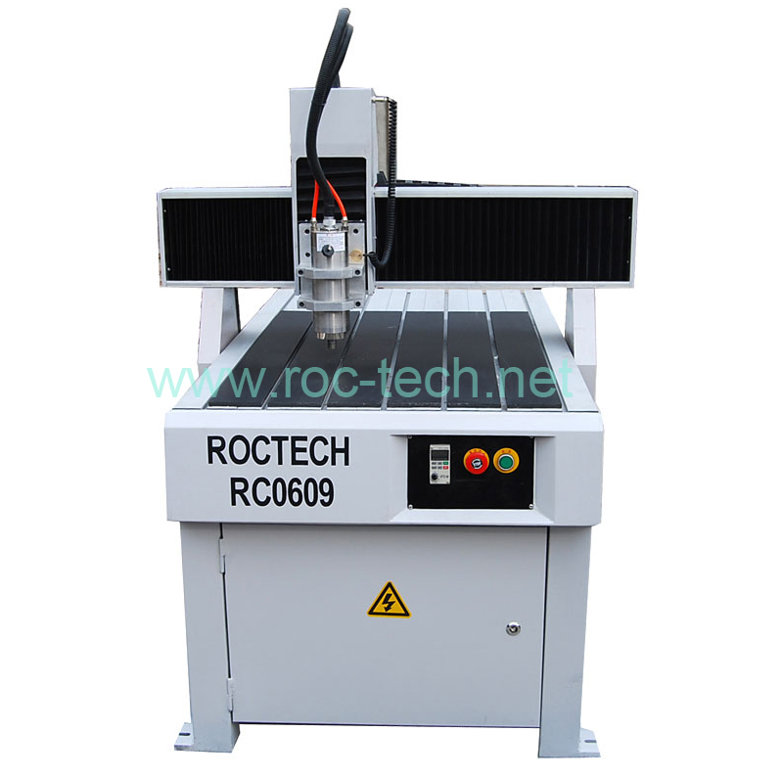

CNC Router RC0609
Travel area: 600x900x120mm
Y structure: Taiwan TBI Ball screw and Hiwin linear
X, Z structure: Taiwan TBI Ball screw and Round linear
1.5kw water coolant spindle
1.5Kw Delta inverter
Stepper motors
Water pump
DSP control system
Original Type3 software
T-slot table

Model Number: CNC Router RC0609
FOB Tianjin port price: 3800 USD
Delivery Time: After T/T payment in advance, about 15 days

