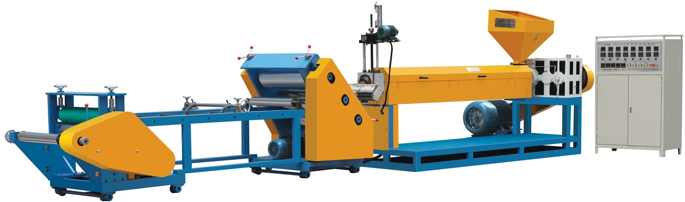
ZHP-670B Single Layer Plastic Sheet Extruder

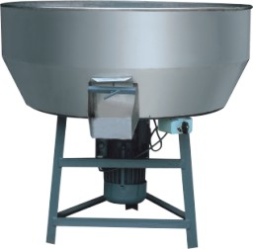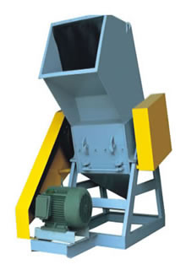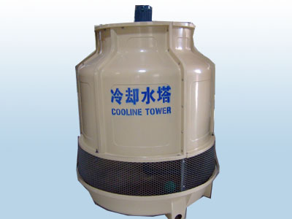
XJ-2 Mixing Machine FS-650 Crushing Machine ZHLS-10 Cooling Tower
Item | Description of Goods | Quantity | Unit Price  (USD) | Amount  (USD)
1. | ZHP-670B Plastic Sheet Extruder | 1 set | 22000.00 | 22000.00
2. | XJ-2 Mixing Machine | 1 set | 500.00 | 500.00
3. | FS-650 Crushing Machine | 1 set | 3000.00 | 3000.00
4. | ZHLS-10 Cooling Tower | 1 set | 800.00 | 800.00
FOB Ningbo, China TOTAL: |  |  |  | 26300.00
Quotations:

TOTAL: SAY FOB NINGBO CHINA U.S. DOLLARS TWENTY SIX THOUSAND THREE HUNDRED ONLY!

FEATURES:
MODEL | ZHP-670B Single Player Sheet Extruder
Hard gear, Strong torque, low noise | Full frequency conversion control (Danfoss)
Screw material : 38 crMoAL  Nitrogen treatment: 0.4 - 0.7mm | Roller Hard chromium plating 0.08-0.18mm  Hardness: HRC58-62 Surface roughness: ≥Ra
5 Heating zones of the screw | 3 Heating zones of the die head
Motor screen changer system | Energy-saving Die head
Individual 45° Three roller control system | CHINA Chint Electric
PID Adjusting Memory & Antijam Digital
Temp. Control

MODEL | ZHP-670B Single Player Sheet Extruder
WIDTH OF DIE HEAD | 700mm
MATERIAL | PP.PE
WIDTH OF SHEET | 680mm
THREE ROLLER SIZE | Ф350*700mm*3
THICKNESS OF SHEET | PP.PE:0.3-2.5mm
SCREW SIZE | Ф110 1:32
TOTAL POWER | 110kw
WORKING POWER | 65kw
SPEED | 15-20m/min
CAPACITY | 150kg/h
DIMENSION | 12*1.5*2.2m
WEIGHT | 5200kg
Generations:

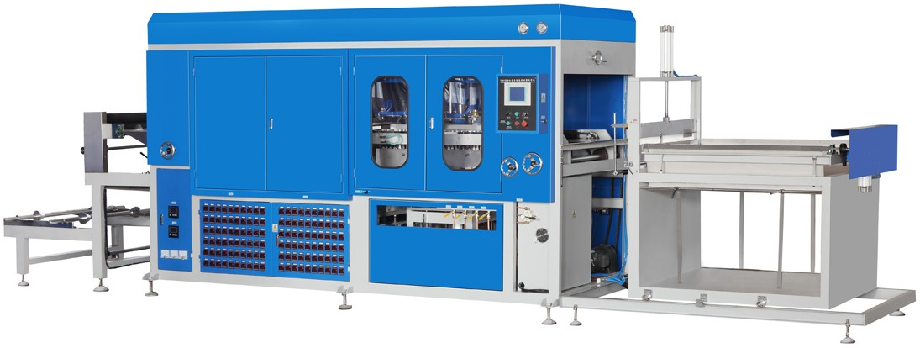

ZHXS-1200/700 Vacuum Forming Machine

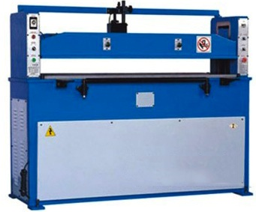
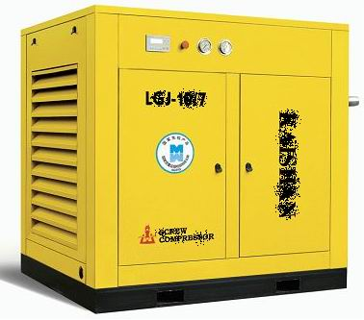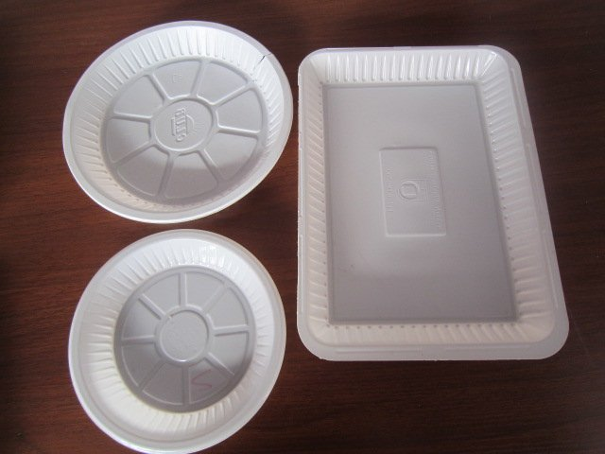

Air Compressor Egg Tray Sample ZHLP-30 Hydraulic Punching Machine
Quotations:
Item | Description of Goods | Quantity | Unit Price  (USD) | Amount  (USD)
1. | ZHXS-1200/700Vacuum Forming Machine | 1 set | 28000.00 | 28000.00
2. | ZHLP-30 Hydraulic Punching Machine | 1 set | 6000.00 | 6000.00
3. | Air Compressor | 1 set | 5000.00 | 5000.00
4. | Mould | 1 set | 3800.00 | 3800.00
FOB Ningbo, China TOTAL: |  |  |  | 42800.00

TOTAL: SAY FOB NINGBO CHINA U.S. DOLLARS FORTY TWO THOUSAND EIGHT HUNDRED ONLY!

Generations of ZHXS-1200/700 Vacuum Forming Machine:
Suitable Sheet(mm) | PVC PS PET PP | Expansion PSP
Suitable Sheet(mm) | Width 500-700  Thickness 0.1-1.2 | Width 500-700  Thickness 1-3.5
Feeding Length (mm) | 600-950 Stepless adjustment
Max.MouldingDepth (mm) | Negative mould 200 positive mould 200
Speed (mould/min) | 3-8 times/min
Power Supply | AC380/220V 51kw (Max)
Air Consumptions | ≧1.5M³/mim(External air supply)
Working Pressure | ≧0.6Mpa
Dimensions(mm) | 7500×2000×2250
Weight(kg) | 3000 kg

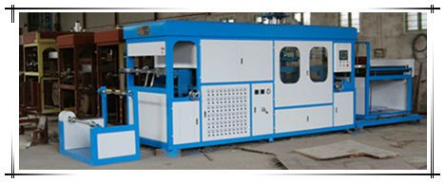

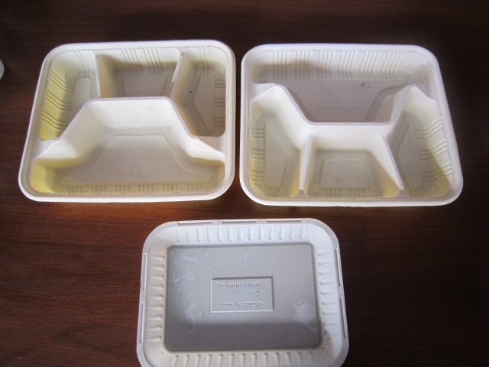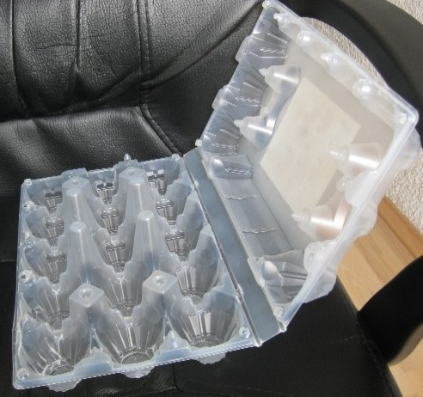

MODEL: ZHJY-6B CUP PRINTING MACHINE

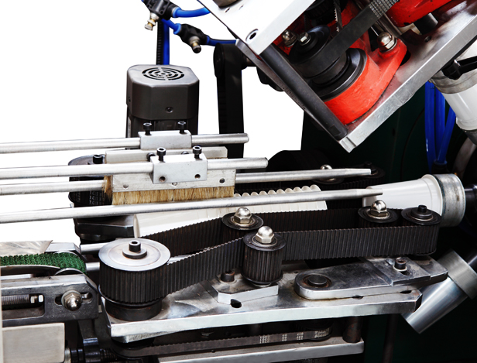
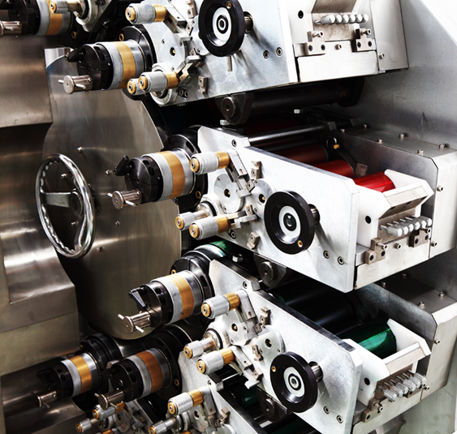
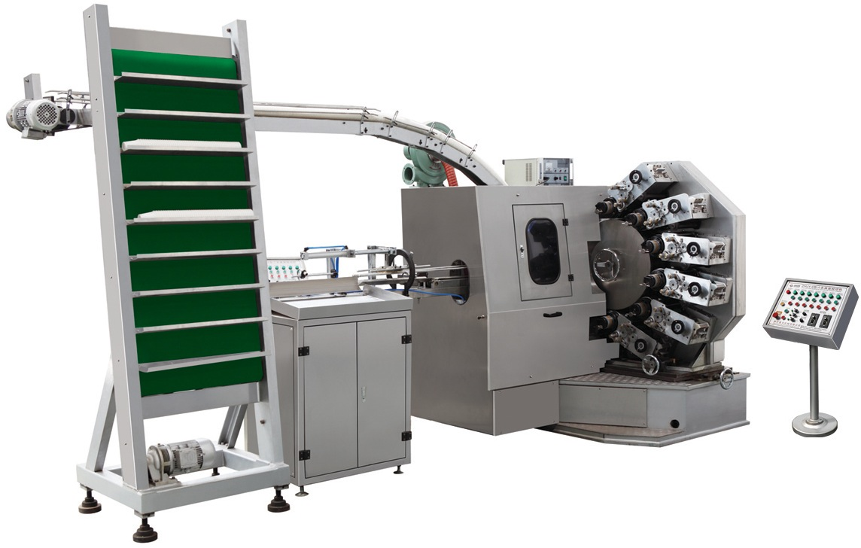

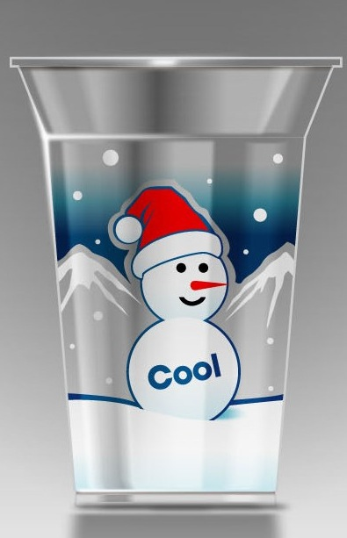
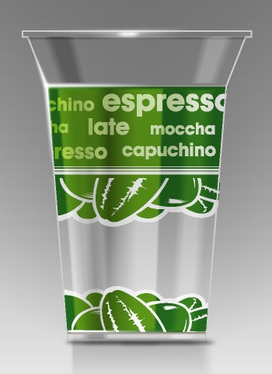
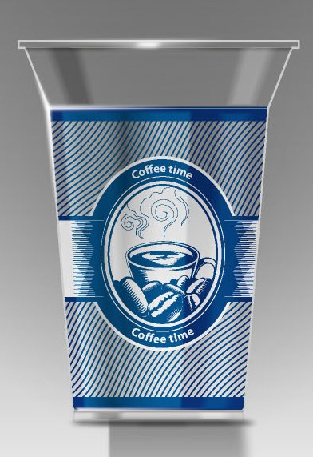
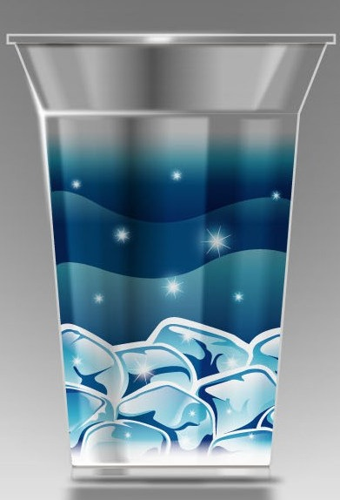

Item | Description of Goods | Quantity | Unit Price  (USD) | Amount  (USD)
1. | ZHJY-6B Cup Printing Machine | 1 set | 60000.00 | 60000.00
FOB Ningbo, China TOTAL: |  |  |  | 60000.00
Quotations:

TOTAL: SAY FOB NINGBO CHINA U.S. DOLLARS SIXTY THOUSAND ONLY!

Features:
Well proven color heads, based on decades of manufacturing experience.
Six color heads each provided with eight distribution rollers.
Sharp print results with two form rollers on each color head.
Easy access to product handling areas and print areas.
Optimum product feeding with separate screw feeder motor.
Graphic operation panel for easy machine-control.
Belt feeder with pressure control.
Corona pretreatment with easily adjustable electrodes.
Quick change mandrel disc assembly.
Mandrel rotation control for all around pretreatment and curing.
High powered ‘Curing on Mandrel’ UV-lamp system with stand-by mode.
Counting & stacking with packing table.

Specification：
MODEL | ZHJY-6B
Min./max. Product height: | 30-180mm
Min./max. Rim diameter: | 40-140mm
Max. Printing height: | 120mm
Min./max. Taper: | 0-12°
Printing Speed | 5000-12000pcs/hour
Total power: | 18kw
Weight: | 4 ton
Dimension: | 5000*2400*2500mm

