H-beam Combination Work Station
H型钢组焊矫一体机
机器型号Machine model: ZHJ
报价编号Offer refer:130322EC
摆布图Lay-out:
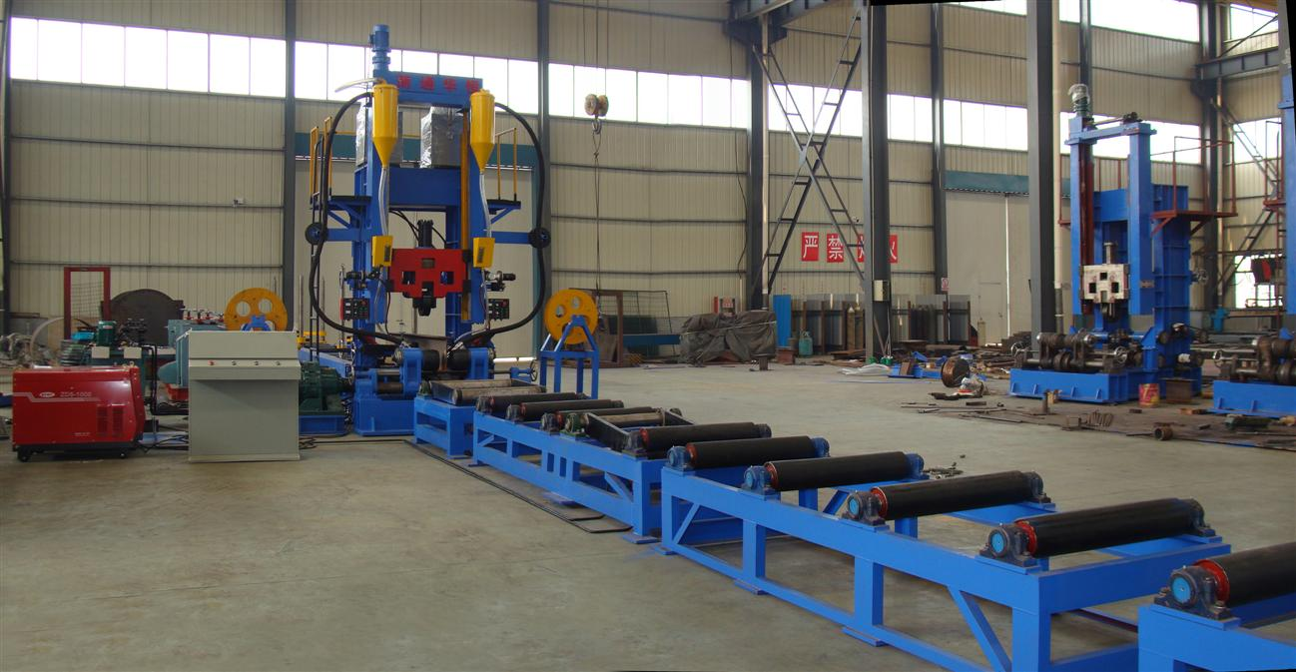

- 机器包装尺寸Machine packing dimension: 11800mm×2130mm×2300mm
- 总毛重Total G.W: Approx 21000 kg
- 建议集装箱Suggest container: 40'HC

可加工H型钢规格H-beam dimensions:
- 翼缘板宽度Flange width: 200-800mm
- 翼缘板厚度Flange thickness: 8-40mm
- 腹板高度Web height: 300-2000mm
- 腹板厚度Web thickness: 6-30mm
- 工件长度H-beam length: 6000-15000mm

机器参数Machine parameter
- 焊接方式Welding type: 自动双边埋弧焊automatic double-side submerged-arc welding
- 定位方式Positioning type: 导向丝杠guide screw
- 控制方式Speed control type: 深圳汇川交流变频器Shenzhen Inovance Ac frequency inverter
- 焊接角度Welding angel: 45度可调45 degree (adjustable)
- 生产速度Line speed: 400-1000mm/min
- 焊机型号Welder power model: 成都福田ZD5-1000埋弧焊机Chendu FOT ZD5-1000 submerged arc welder
- 电压Voltage: 380 V/50 Hz
- 总功率Total power: 150kW
- 安装空间Installation space: 35000mm×3000mm×5000mm

供应范围Supply Scope
- 主机Frame assembly.
- 电控系统Electric control system: electric cabinet, etc.
- 组立机构Assembly device
- 抬升装置1号Hold device 1#
- 出料输送辊道Out-put conveyor (包含抬升装置2号Included hold device 2#)
- 液压系统Hydraulic system
- 提升装置Lifting device
- 焊丝送丝机构Welding wire feeding device
- 工作平台Work platform
- 梯子Staircase
- 焊机Welder power
- 焊剂回收机Flux recovery

技术文件Technical Document
- 操作手册Machine operation manual
- 安装图纸Installation drawing
- 电气原理图Electrical circuit diagram
- 发货清单Supply list
- 合格证Qualified certificate

价格Price：USD73,580 (FOB Shanghai, China)
交货期Production lead time：within 60 days
付款方式Payment：30%T/T in advance, 70%T/T before shipment

