HZT-15 AccessoriesSolar module power：17V/53WSizeLamp Height：3500mmAccessoriesSolar module power：18V/49WItem no  USD928.00  12V/65AH AGM Lead Acid Battery  Lamp power：12V/7W×2  Switch control：Light open, time close  Work time：8hrs/day  Rainy days：4days  Material：Plastic powdered steel  USD982.00  12V/65AH AGM Lead Acid Battery  Lamp power：12V/13W  Switch control：Light open, time close  Work time：8hrs/day  Rainy days：4days | Picture | Specifications（It’s available according to customer’s need） | FOB Xingang, China
 | Picture | Size | Lamp Height：3500mm  Material：Plastic powdered steel
HZT-17 | 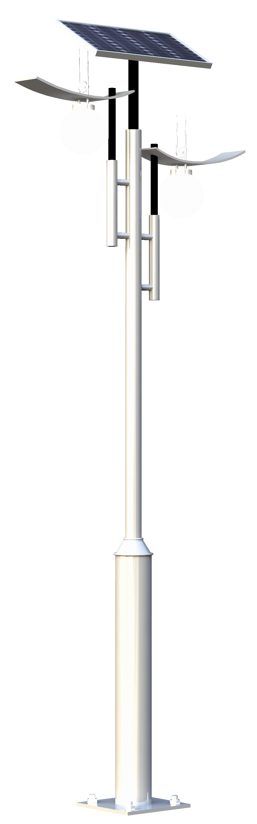 | Accessories | Solar module power：17V/53W  Lamp power：12V/7W×2  Switch control：Light open, time close  Work time：8hrs/day  Rainy days：4days | USD956.00  12V/65AH AGM Lead Acid Battery
HZT-17 |  | Size | Lamp Height：3500mm  Material：Plastic powdered steel | USD956.00  12V/65AH AGM Lead Acid Battery
HZT-18 | 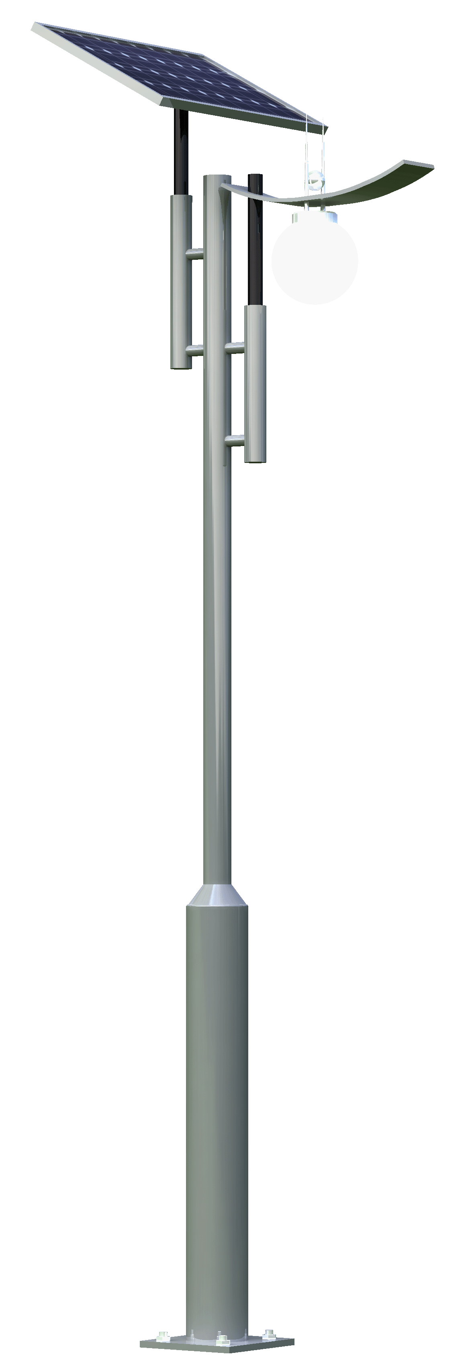 | Accessories | Solar module power：18V/49W  Lamp power：12V/13W  Switch control：Light open, time close  Work time：8hrs/day  Rainy days：4days | USD878.00  12V/65AH AGM Lead Acid Battery
HZT-18 |  | Size | Lamp Height：3500mm  Material：Plastic powdered steel | USD878.00  12V/65AH AGM Lead Acid Battery
HZT-19 |  | Accessories | Solar module power： 17V/53W  Lamp power： 12V/7W×2  Switch control：Light open, time close  Work time：8hrs/day  Rainy days：4days | USD998.00  12V/65AH AGM Lead Acid Battery
HZT-19 |  | Size | Lamp Height：3500mm  Material：Plastic powdered steel | USD998.00  12V/65AH AGM Lead Acid Battery

Item noPictureSpecifications（It’s available according to customer’s need）FOB Xingang, China
FOBTianJinHZT-20AccessoriesSolar module power：18V/49W
Lamp power：12V/13W
Switch control：Light open, time close
Work time：8hrs/day
Rainy days：4days
USD906.00

12V/65AH AGM Lead Acid BatterySizeLamp Height：3500mm
Material：Plastic powdered steelHZT-44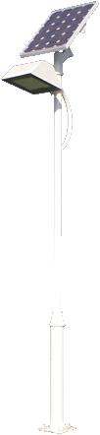AccessoriesSolar module power：18V/27W
Lamp power：LED 12V/6W
Switch control：Light open, time close
Work time：8hrs/day
Rainy days：4days
阴雨天数：4天
USD689.00

12V/38AH AGM Lead Acid BatterySizeLamp Height：3500mm
Material：Plastic powdered steelHZT-45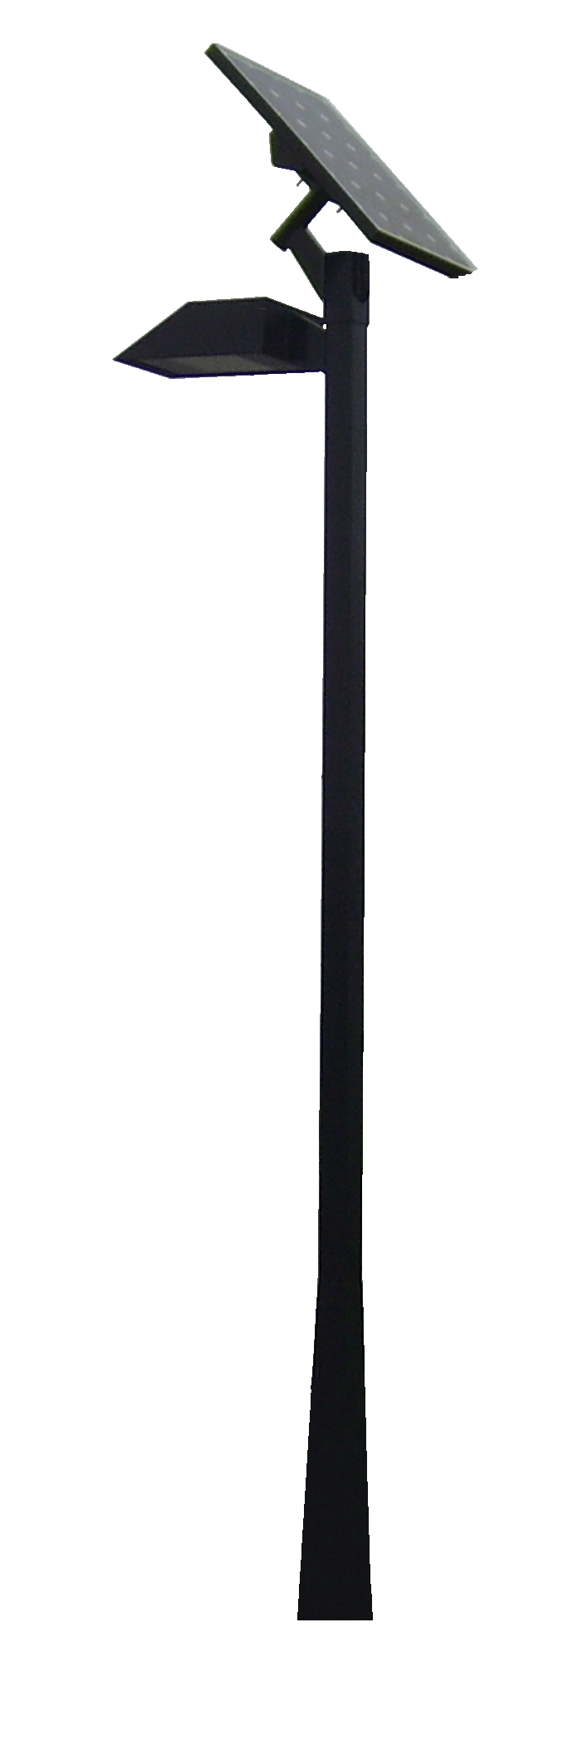AccessoriesSolar module power：18V/27W
Lamp power： LED12V/6W
Switch control：Light open, time close
Work time：8hrs/day
Rainy days：4days
USD698.00

12V/38AH AGM Lead Acid BatterySizeLamp Height：3500mm
Material：Plastic powdered steelHZT-46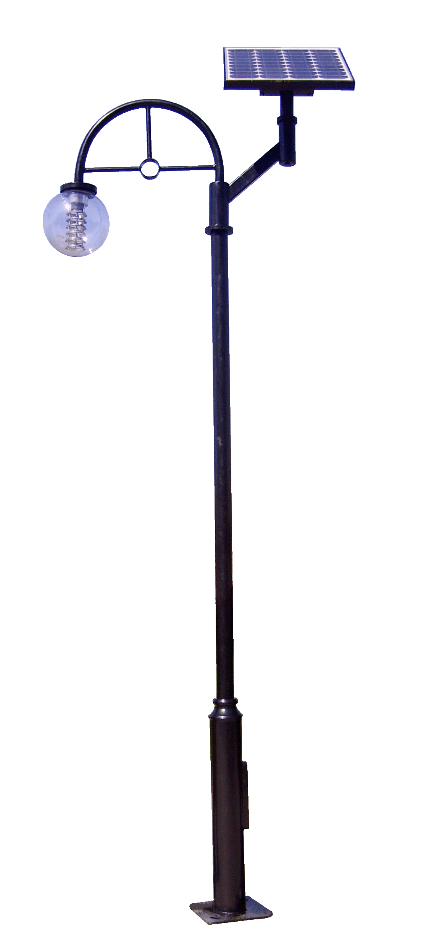AccessoriesSolar module power：18V/49W
Lamp power： 12V/13W
Switch control：Light open, time close
Work time：8hrs/day
Rainy days：4days
USD866.00

12V/65AH AGM Lead Acid BatterySizeLamp Height：3500mm
Material：Plastic powdered steelHZT-47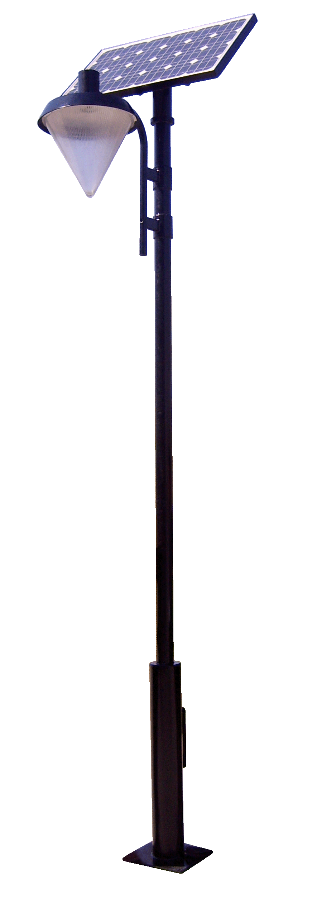AccessoriesSolar module power：18V/49W
Lamp power： 12V/13W
Switch control：Light open, time close
Work time：8hrs/day
Rainy days：4daysUSD898.00

12V/65AH AGM Lead Acid BatterySizeLamp Height：3500mm
Material：Plastic powdered steelHZT-48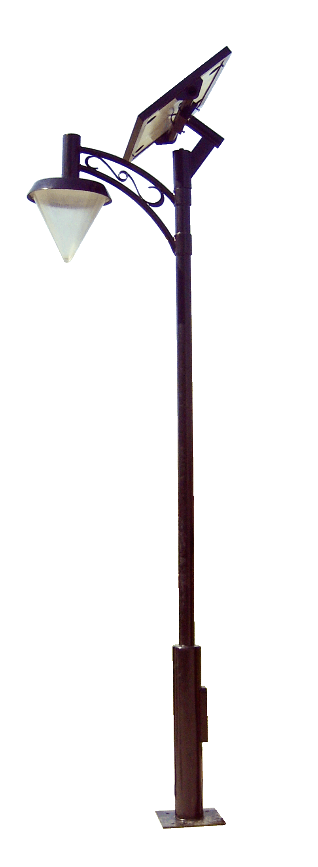AccessoriesSolar module power：18V/49W
Lamp power： 12V/13W
Switch control：Light open, time close
Work time：8hrs/day
Rainy days：4daysUSD907.00

12V/65AH AGM Lead Acid BatterySizeLamp Height：3500mm
Material：Plastic powdered steel

