Landscaping Grass

TYPE 1: Legend Grass (Oasis)
YARN: Tencate Oval8800
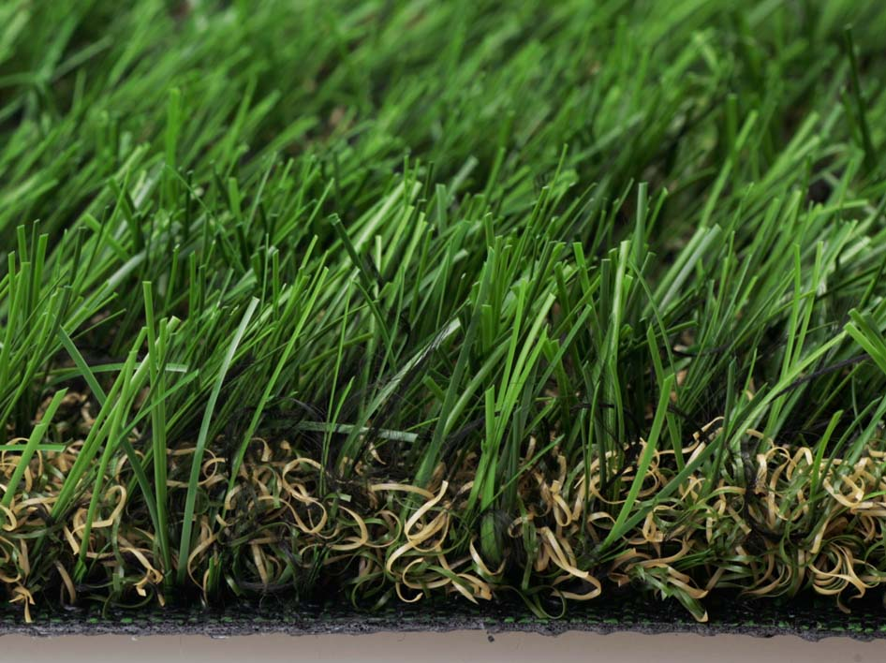
DTEX: PE8800+PP4400
COLOR: Straight (field green and lime green)
+ thatch (yellow and green)
Or (coffee and lime green)
PILE HEIGHT: 30-45mm
GUAGE: 3/8”
STITCH RATE: 14-18stitches/10cm
DENSITY: 14700-18900stitches/square meter
WARRANTY: 10 years

TYPE 8: MagicGrass3
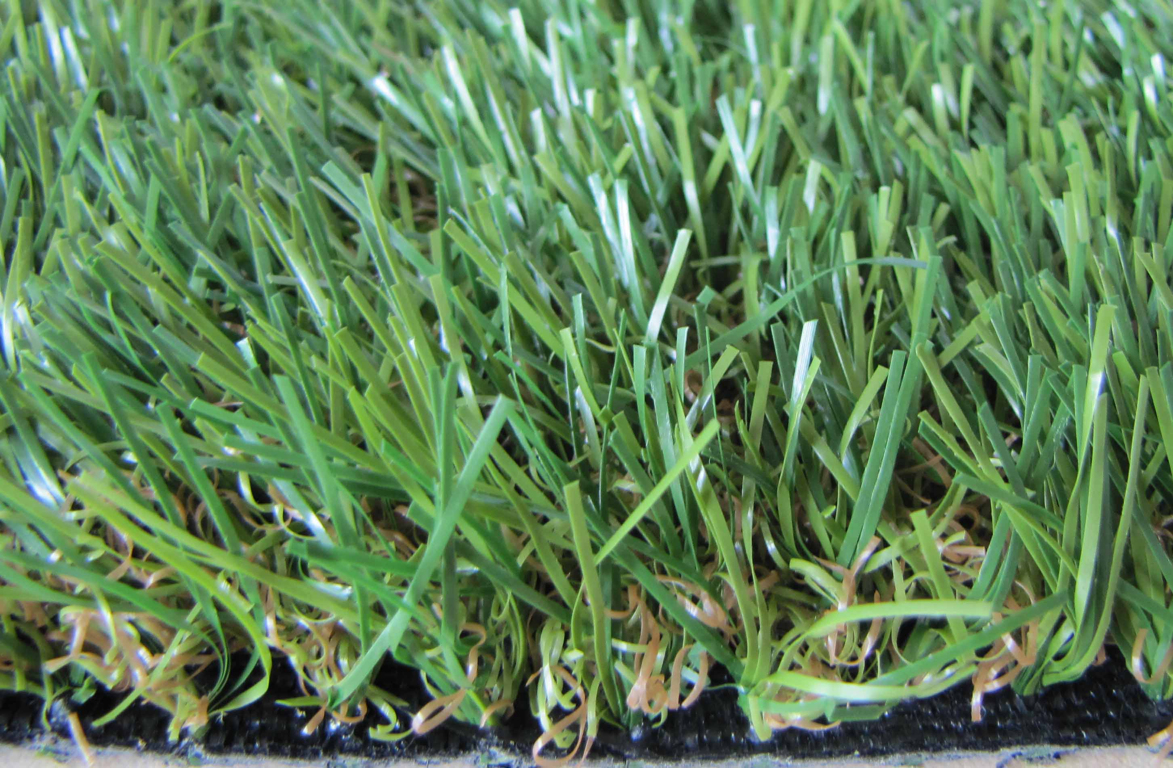
YARN: Four-tones color grass
DTEX: PE&PP12000
COLOR: Straight (field green and lime green)
+thatch (coffee and lime green)
PILE HEIGHT: 20-40mm
GUAGE: 3/8”
STITCH RATE: 14-18stitches/10cm
DENSITY: 14700-18900 stitches/square meter
WARRANTY: 7 years

TYPE 9: MagicGrass4
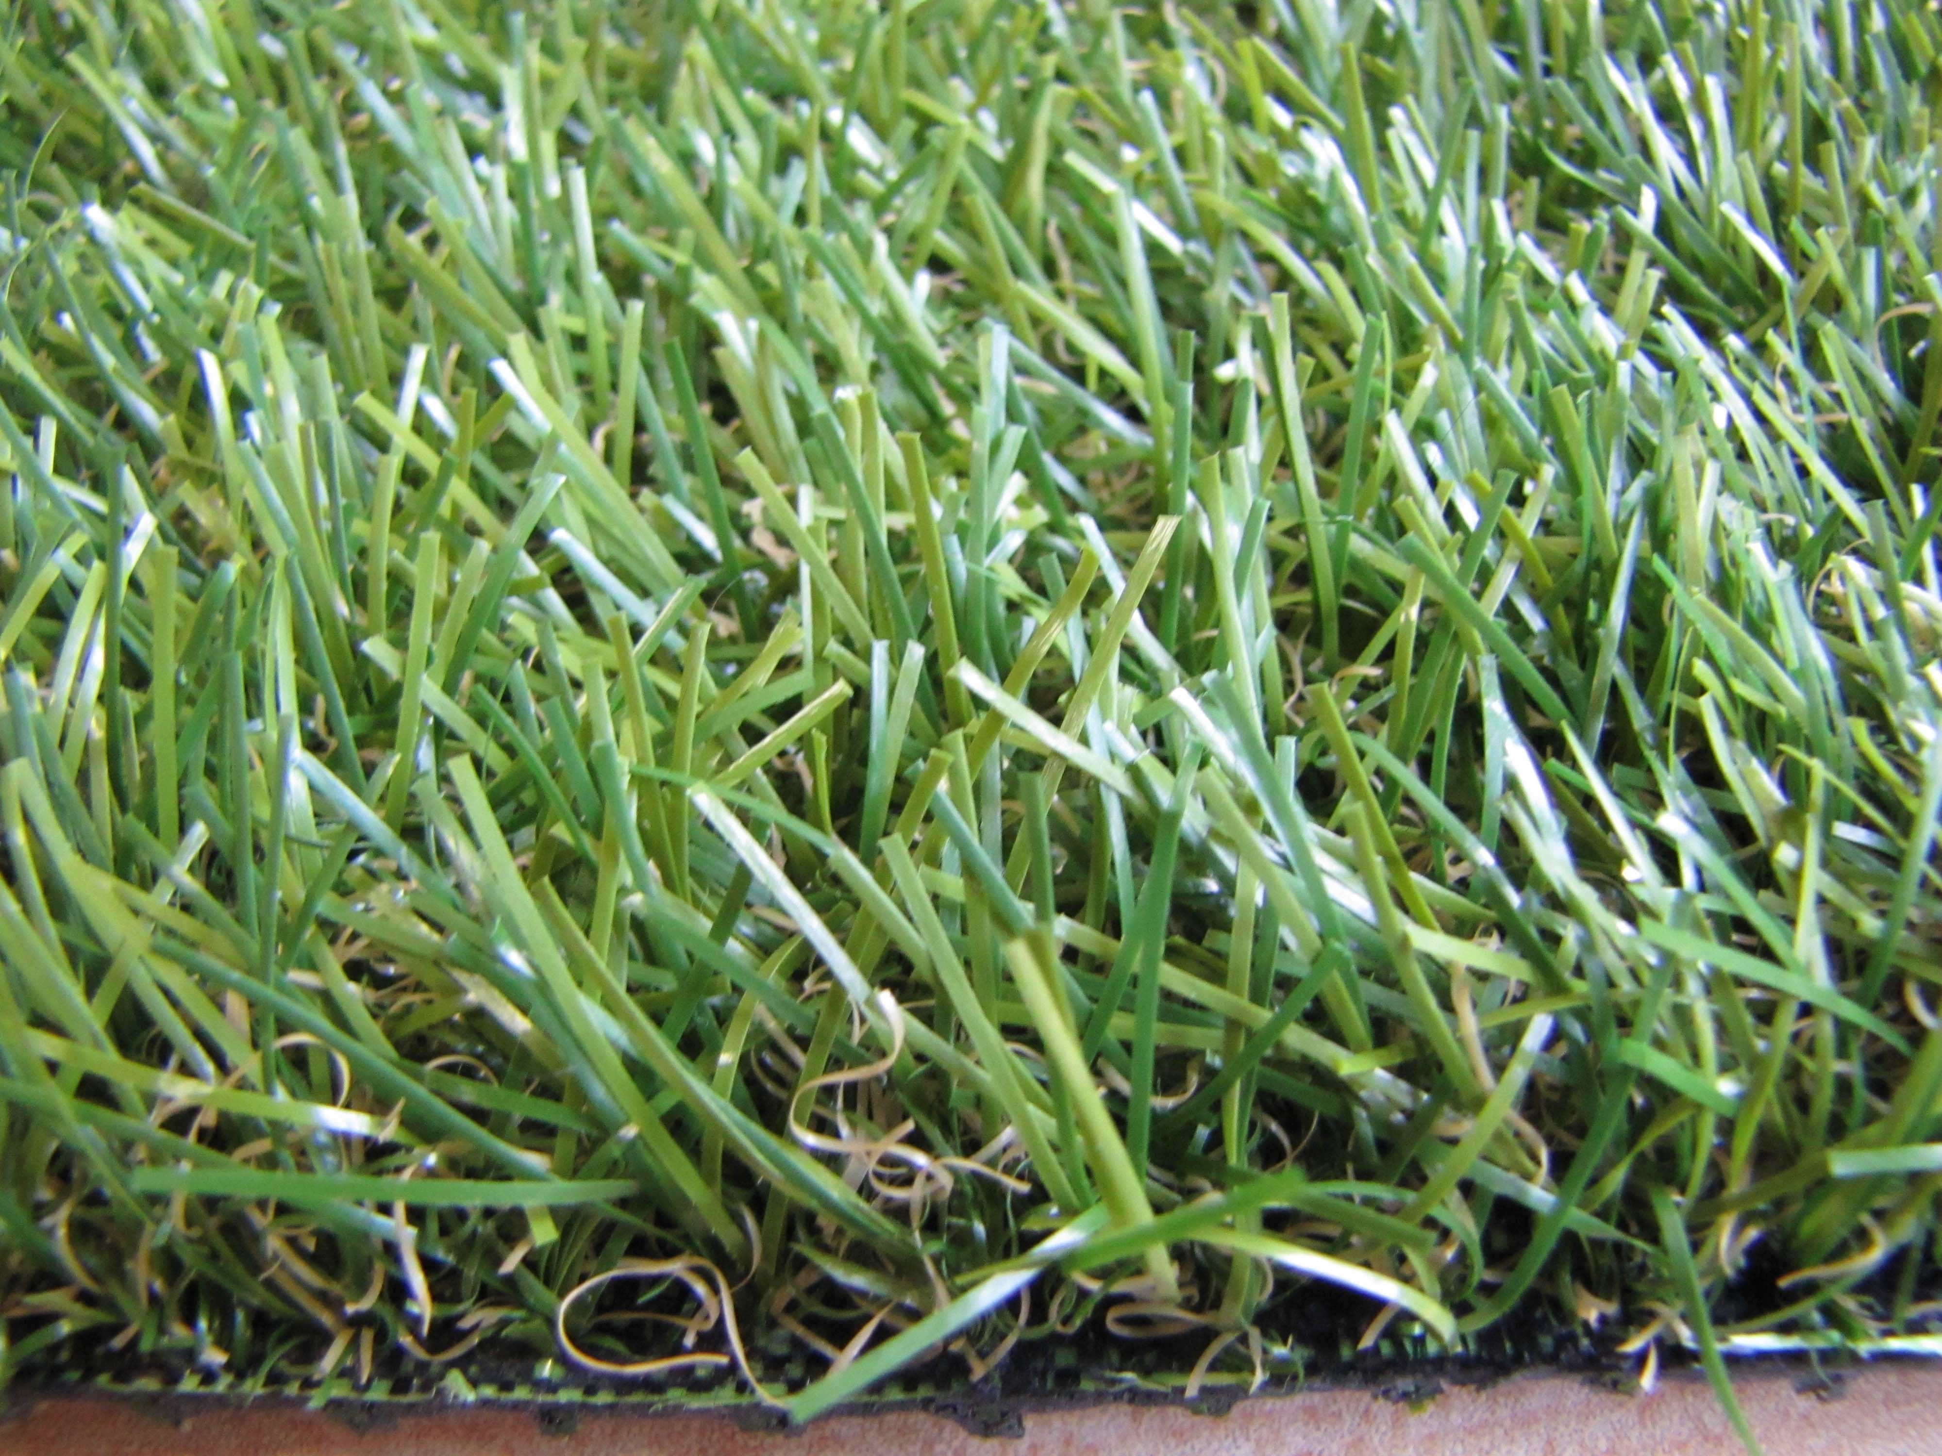
YARN: Four-tones color grass
DTEX: PE&PP10500
COLOR: Straight (field green and lime green)
+thatch (yellow and green)
PILE HEIGHT: 20-40mm
GUAGE: 3/8”
STITCH RATE: 14-18stitches/10cm
DENSITY: 14700-18900 stitches/square meter
WARRANTY: 7 years

