WAW Microcomputer controlled electro-hydraulic servo stranded wire universal testing machine

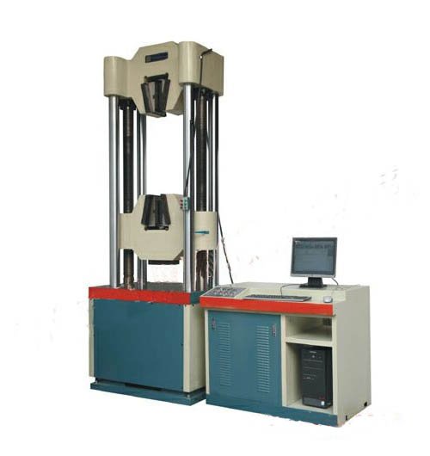

Description
This machine is used to do tension test of steel stranded wire, it also can perform tension, compression, bending, shear test for metal and non-metal materials. Oil cylinder placed underneath, can adjust testing space freely, with automatic hydraulic clamp system, adjustable columns on the main frame structure. Use high-quality imported electronic parts and components for circuit making, the operating software is based on Windows.

Features
1. 2 upright posts, hard chrome-plated, easy installation of hydraulic jaw, tension fracture position in the middle of specimen.
2. With high quality parts, imported motor, thick steel column, plates and beam
3. Non-corrosion column and screw poles to ensure long time application
4. Steady working

Main Technical Data

Testing range: 0-1000KN, 0-600KN
Error:<±1%
Max. tension distance:1000mm
Piston distance: 250mm
Working voltage: AC380V, 3phases
Power of oil pump motor: 2.0KW, 1.5KW

