STCBR-1

Tester Operation Manual

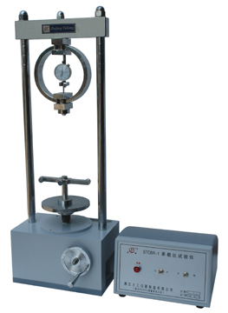

- Application
The apparatus is suitable for doing CBR test (bearing-ratio test) for the soil, the base course and the sub-base materials after making the specimen in the prescriptive cylinder.
- Main Technical Parameter
- Capacity: 30KN
- Standard penetration speed: 1mm/min
- Testing range: 30KN
- Size of the cylinder: ￠152 x 170mm
- Size of the penetration rod: ￠50x 100mm
- Surcharge weight (split): total 8 sets (outside diameter: 150mm, inside diameter: 52mm), 125g per set, divided into two semicircle along the diameter.
- Electricity supply: AC220V, 50Hz

- Structure Drawing
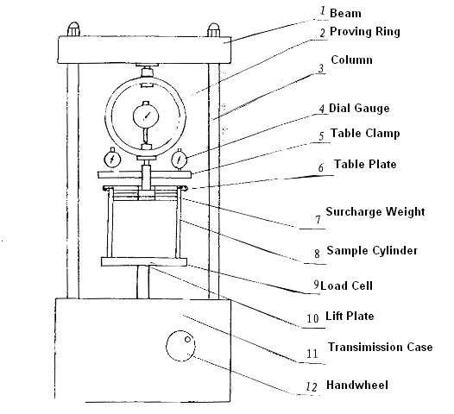

- Operation Method
- Turn on the electricity supply switch to start the apparatus. Check the working situation of the apparatus and the handle. Push the handle in to do electric operation. Pull out the handle to do manual operation.
- Prepare the specimens according to CBR Test Method JTJ057-85.
- Measure the immersion swell increment:
- Put the immersion swelled specimen on the swell plate with adjustable rod. Load enough surcharge weights on the swell plate to make the pressure on the specimens equal to the pressure of the pavement on the material level.
- Put the cylinder and the swell plate together into the bath (without water). Pull tight the mould with pulling rod. Install the dial gauge and read out the initial reading.
- Put water into the bath to make the water naturally enter in the top and bottom of the specimens. In immersion processing, the water surface in the bath should keep about 25mm above the top of the specimens. Usually immerse the specimens for 96 hours.
- Read out the reading on the dial gauge after immersion and calculate the immersion swell increment as following:
Immersion swell increment= height changes after immersion÷original height of the specimen (120mm)x100%
- Take out the specimens from the bath and pour out the water on the top of the specimen. Settle it for 15 minutes to make it draining water. Then download the additional surcharges weight, the swell plate, the base and the filter paper. Scale the weight to calculate the changes of the humidity and density of the specimens.
- Penetration Test
- Put the specimens after immersion test on the lift plate. Adjust the penetration rod towards the proving ring. Put a certain quantity of surcharge weights besides the penetration rod.
- Add 15KN load with hand-wheel on the penetration rod. Then adjust the proving ring and the dial gauge (measuring deformation) into the zero position.
- Add load and press in the hand-wheel. Keep record of the penetration capacity at some readings on the dynamic dial gauge. Pay attention to the penetration capacity as per 2.5mm. At this time, there should be more that 8 readings. The total penetration capacity should be more than 7mm.
- Calculate and draw the pressure-penetration capacity diagrams. Calculate the bearing-ratio when the penetration capacity is 2.5mm and 5.0mm.
Bearing-ratio=Unit pressure÷(7.0 or 10.5)x100%
- Maintenance
- Clean the apparatus after finish the test
- Change the new lubricating oil into the transmission case after use for 1 year. Maintain regularly later.

- Packing List
- Main frame: 1 unit
- proving ring (with 1 unit of dial gauge): 1 unit
- control cabinet: 1 unit
- penetration rod: 1 unit
- CBR Part : 3 Pcs
- manual: 1 piece
- Certification: 1 piece
- Immersion swell accessories (need to order): 1 set

- surcharge weights: 8sets
- table clamp: 1 unit
- sample cylinder: 1 unit
- guard ring: 1 unit
- base: 1 unit
- swell plate: 1 unit
- dial gauge: (prepared by user)

Production Conformity Certificate

The production has already passed check. The quality is conformity.

Model | STCBR-1
Production | CBR Testing Apparatus
Serial No.
Checker | 003
Shanghai Civil l& Road Instrument CO., LTD.
Zhejiang Tugong Instrument CO., LTD.
ISO9001 Certified!

