
无锡贝瑞斯机械设备有限公司
WUXI BALANCE MACHINERY EQUIPMENT CO., LTD
Add: Baolu Road, Qianzhou Industrial Zone, Huishan District, Wuxi City, Jiangsu Province, China
Tel: 0086-510-83115339 Fax: 0086-510-83113616 Mobile: 0086-158-616-98920
Skype: platform_balance MSN: platform_balance@hotmail.com
Email: angela@cnplatform.com Web: www.cnplatform.com
Contact: Angela Wang

QUOTATION
To: Mr. K.viswanathan Quote No.: 13BRS010525
Suspended Platform Components
Voltage: 440V, 3 Phases, 50Hz
Product | Configuration | Picture | QTY | EX WORK PRICE (USD)
 |  |  |  | Unit Price  (USD) | Total Price  (USD)
Suspension Cage | Aluminum Alloy platform  7.5mtrs long | 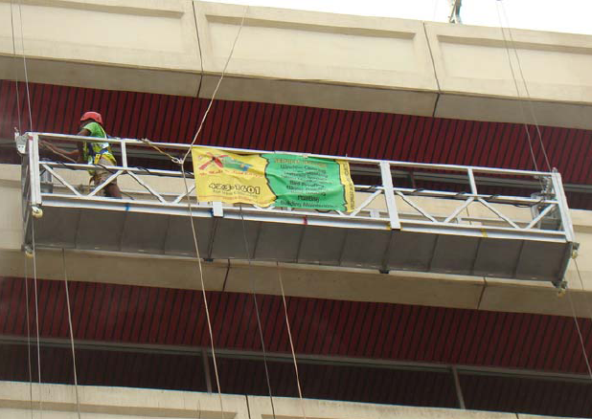 | 1 Set
Suspension Mechanism | Steel with hot galvanization | 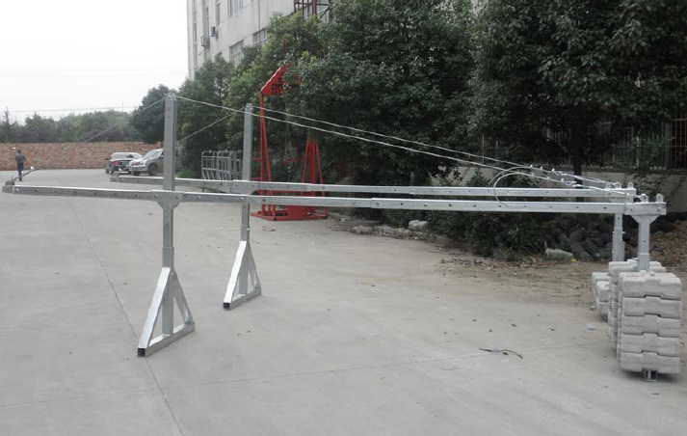 | 1 Set
Hoist | Model: LTD8  Motor Power: 1.8kw  Rated Lifting Capacity: 8 KN | 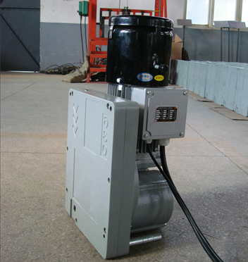 | 2 Pcs
Safety Lock | LSF30 Anti-tilting Type (30Kn) | 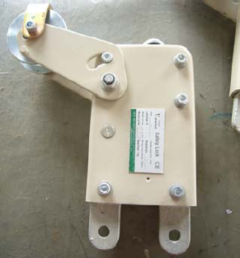 | 2 Pcs
Electric box | Component brand: Schneider | 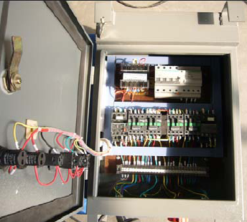 | 1 Pcs
Steel wire rope | 9.1 mm  100mtrs/pcs  Brand: Fasten | 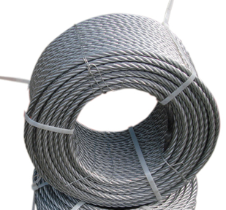 | 4 Pcs
Power cable | 3*2.5+2*1.5mm²  Brand: Wuxi Cable Factory | 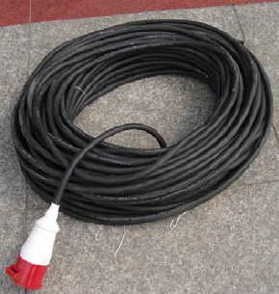 | 1 Pcs
Counter  weight | 25kg/pcs  1 Set = 40 Pcs  Cement type | 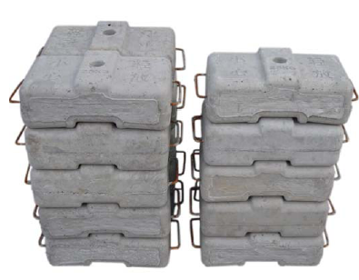 | 1 Set
Other | Other accessories  Like Wall roller, casters, accessories |  | 1 Set
If buy a whole set, the price is favorable
EX WORK price = US$ 6,130
FOB SHANGHAI PORT, CHINA ------ US$ 6,375
CIF CHENNAI PORT, INDIA ------ US$ 6,470

Summary:
- Terms of validity: 1 month
- Payment: USD 100% paid in advance by T/T.
- Time of Delivery: 10-15 working days after receipt of the payment.
- Warranty: 1 year.

