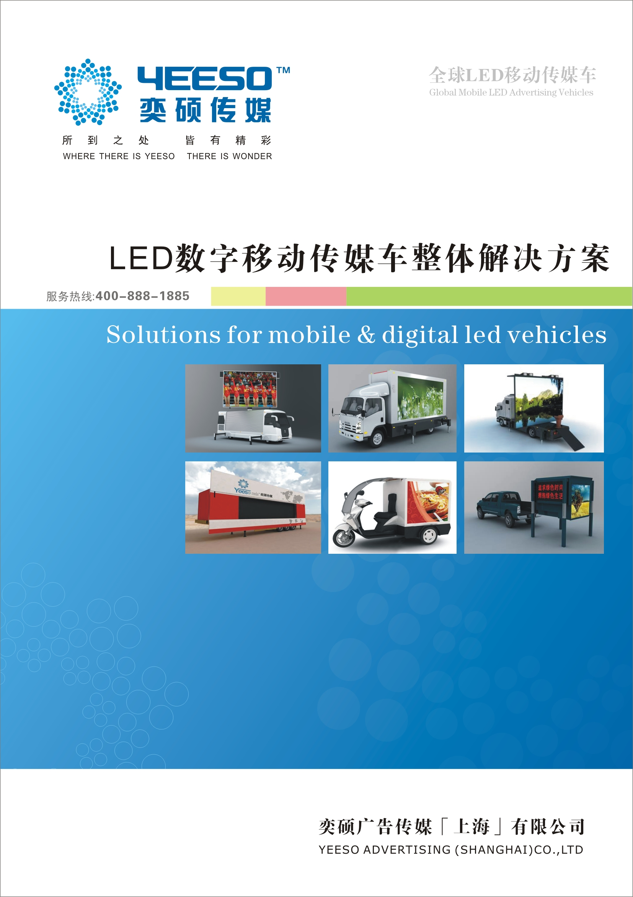
A. Parameters
Specification | YES-MINI-3
Light Box
External dimension | 1150mm×960mm×1700mm | Picture size |  | 900mm×1200mm
Light tube quantity | 7 | Power of light box |  | 200W
Power
Input voltage | Direct current 24V |  | Output voltage | 24V
Current flow | 200AH |  | Power dissipation | Can use 8 hours
Multimedia System
Player | MP3, FM | Speaker |  | Peak power: 15W
B. Rendering shows
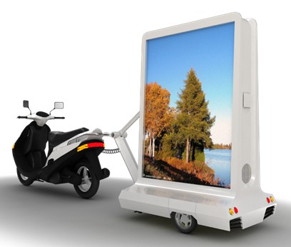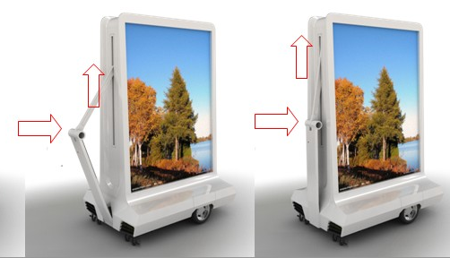

C. Quotation: 1800USD/Unit FOB Shanghai (without motor)

Remark:
MOQ:8UNITS
- Warranty: 12 months
- Container loading: 8units/20"GP, 18units/40"GP
- Payment term: 50% T/T in advance, balance 50% T/T should be paid before shipment
- The above quotation validity: 30days.
- Manufacturing time: 40 days.
- Renderings only as a reference to the actual exterior dimensions.



