I. GENERAL INTRODUCTION

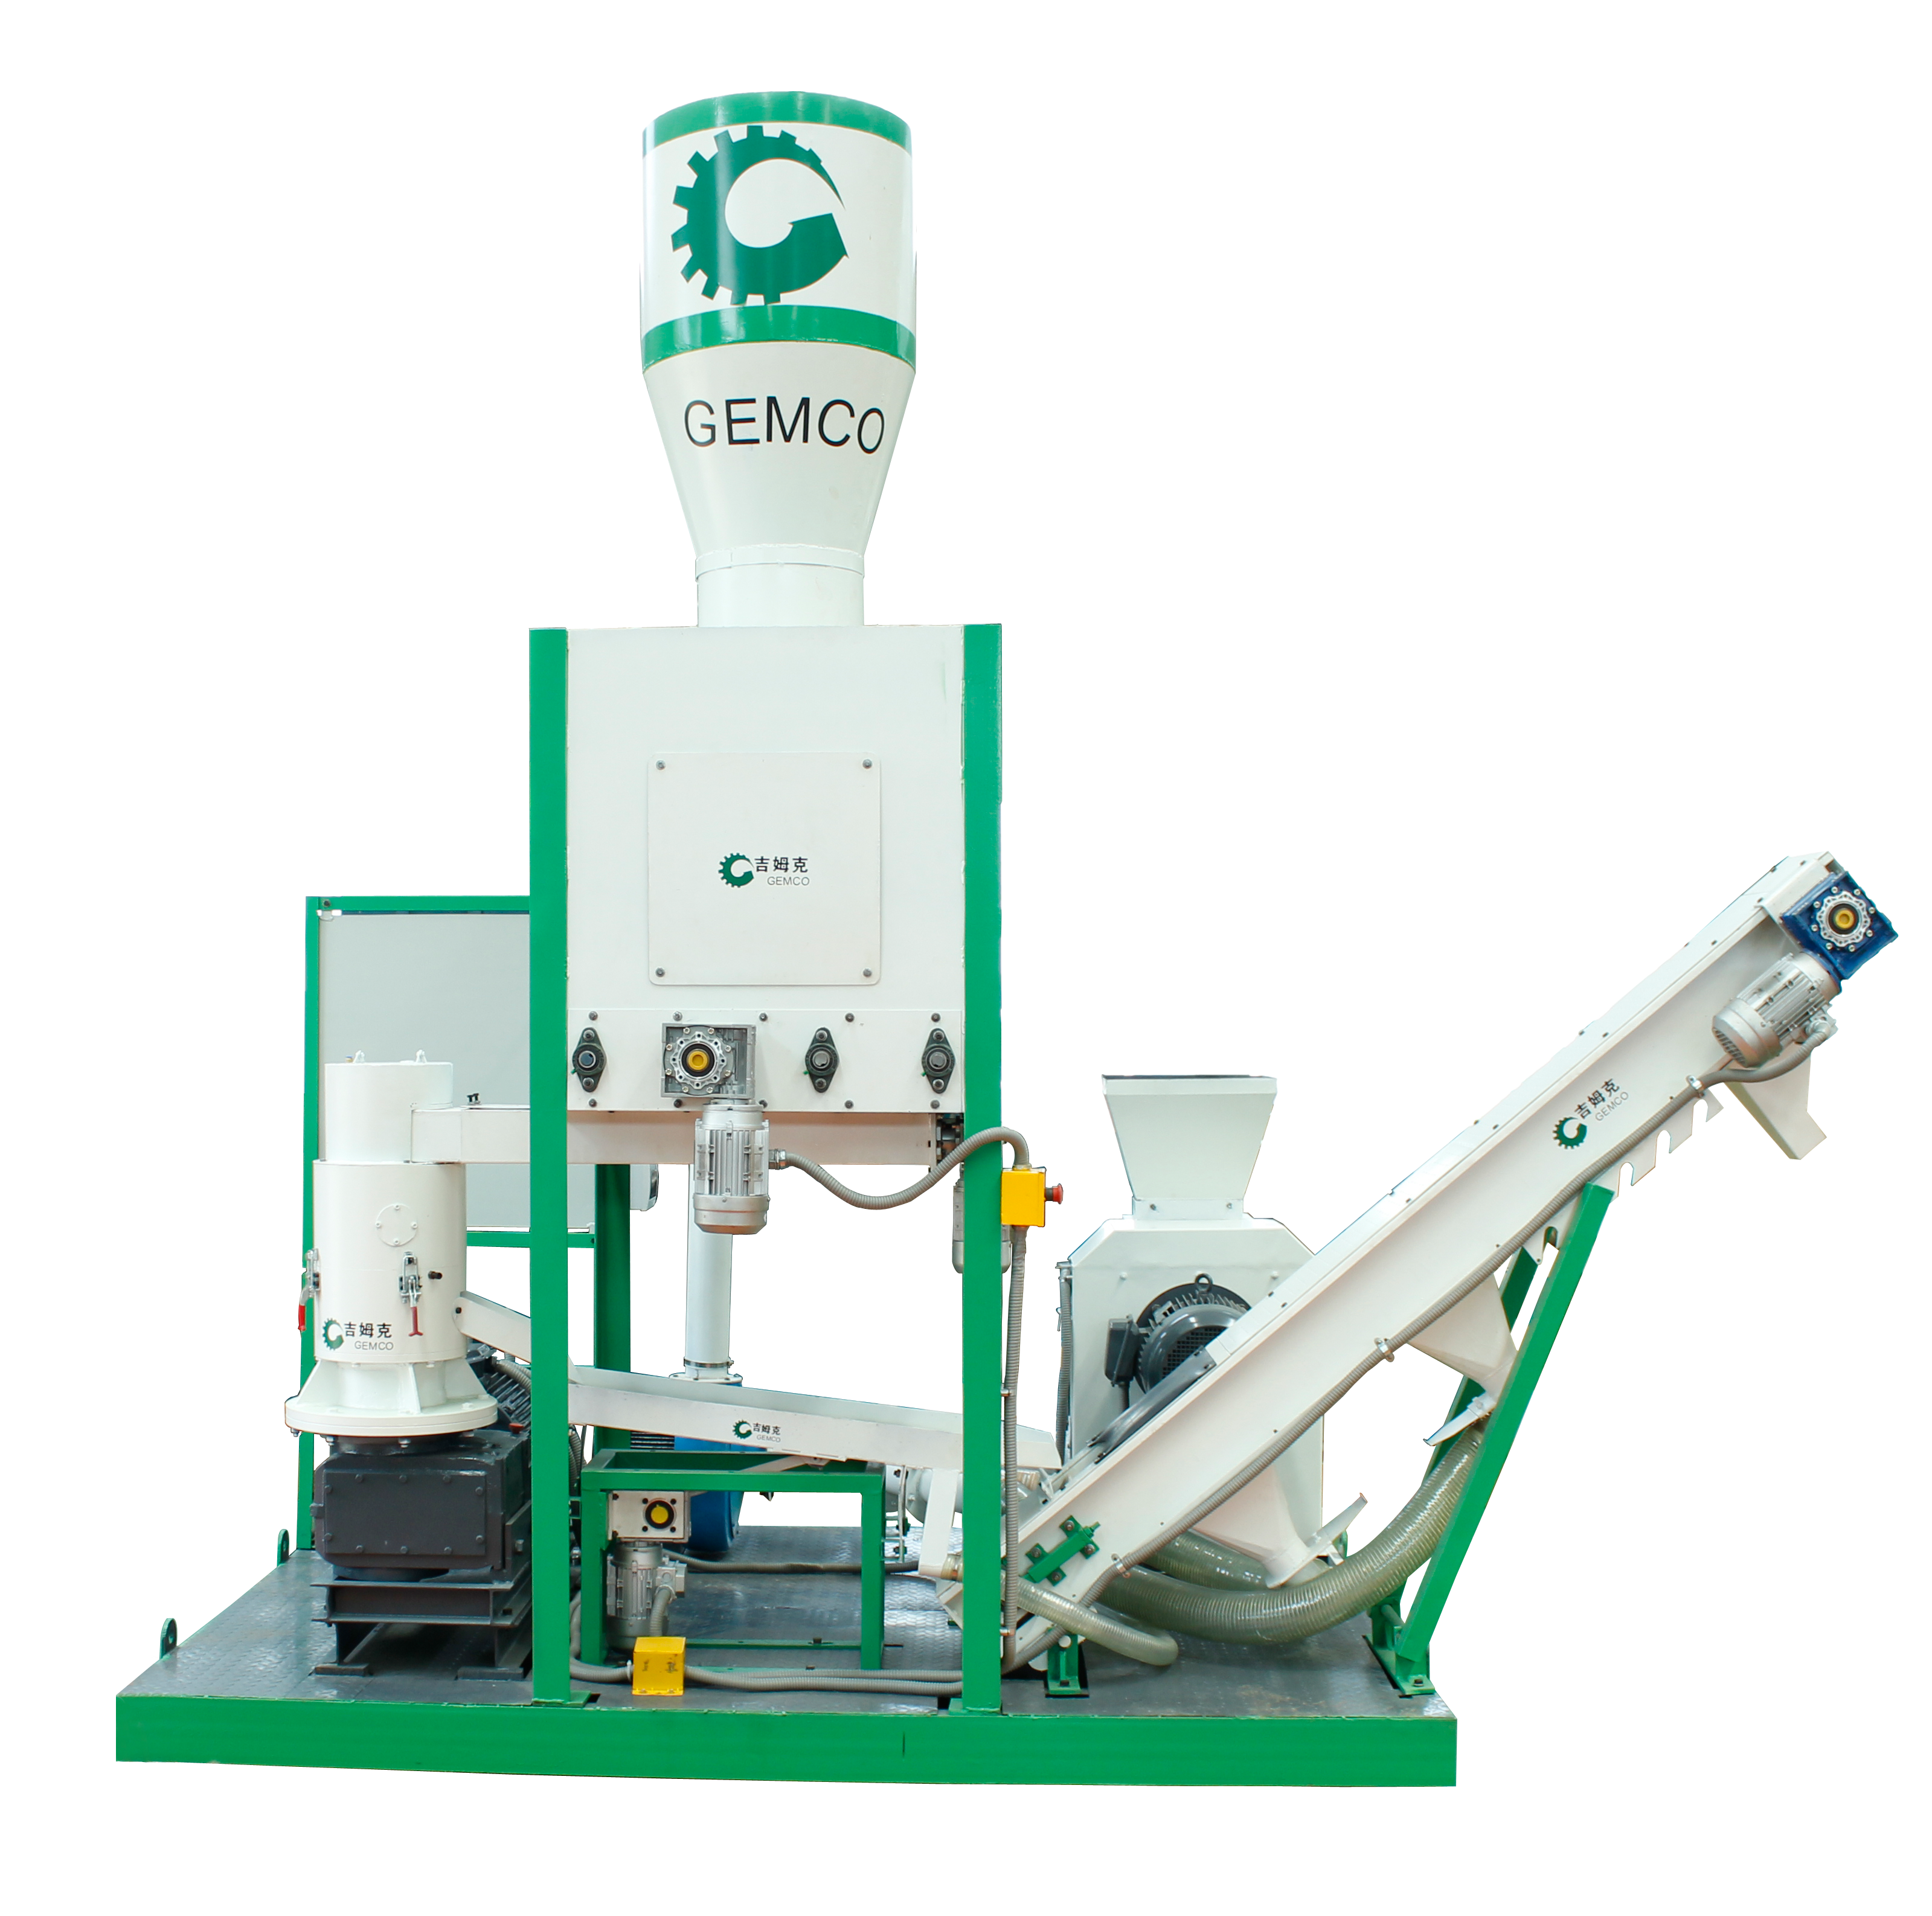This MPL 300 small moveable multifunctional
complete pellet plant is specially designed for pelletizing production. It has a high efficiency
on energy pellets and animal feed pellets
making, enjoying a wide application rage for the raw materials.
With the delicate structure design, the
necessary processing equipments are arranged
in one piece of complete plant, primarily
consisting of hammer mill, cyclone separator,
bin, screw conveyor, pellet mill, vibrating
screen, scraper conveyor, electric cabinet, and
foundation frame. The pellet plant integrates
the processing functions of crushing,
pelletizing, cooling, transporting, etc into one
complete plant, improving working efficiency
remarkably and lowering your pellets
production costs.

One operator can manage the operation of this whole
plant by simple adjusting the operation buttons,
lowering your labor cost efficiently.

Patented pelletizing technology guarantees a flexible
applicability, satisfying customers with different requirements.

SPECIFICATION

No. | Item | Unit | Content
1 | Raw Material |  | Wood, Saw Dust, Straw, Peanut Shell, Etc
2 | Pellet Size | Mm | Diameter 4-12
3 | Density | T/M3 | 0.6-1.2
4 | Capacity | Kg/H | Wood | 250-350
 |  |  | Feed | 350-500
5 | Power | Kw | 41.25
6 | Dimension | Mm | 1960*3500*3500

ii. flowchart

2.1. Crushing Section
It's with 15 hammer blades, 3 blade sections at equilateral triangle vertex. By changing the different position of the blades, it's suitable for crushing woody or biomass or forage material with size less than 20 mm (diameter), the size of the output crushed material can reach diameter 3-5mm.

2.2. Pneumatic Conveying Unit
This unit includes one 2.2kw air blower, wind pipeline and cyclone separator. It will transport the crushed material into bin for mixing and storage. It's connected with vibrating screen and bucket conveyor with semitransparent soft pipes to cool the pellets, and collect the powder and dust.

2.3. Material Mixing, Storage Bin
It's with 1m³ volume, its shell is made of 2.5 mm steel plate. There are two portholes on both sides for monitoring and observation. Four paddle type mixers is driven by one 0.75KW motor. The highest material level for this bin is at 800mm from the bottom.

2.4. Screw Conveyer
The input port for mixed material is at the bottom of the bin. It's 112mm in diameter, 1023 mm long. It is to feed the mixed material into the pellet mill, and is driven by frequency conversion speed controlled motor, 0.18 KW, frequency conversion range is 30~60 Hz.

2.5. Pelletizing Section
This pellet machine makes 0.4 ton wood pellets per hour by using pure sawdust. The water adding system is connected and available to adjust the moisture content of the mixed material. We can make 6, 8 mm pellets (diam.). One tank is available for adjusting the moisture content of the crushed material.

2.6. Vibrating Sieve
It is with 3.5*3.5mm Mesh, with 0.37KW power. The size of the mesh can be changed according to your requirements. One φ45mm soft pipes is connect to collect the powder and dust.

2 .7.Scraper Conveyor
It's driven by chain, the scraper size is at 145mm. The size for single section is 2436*437*484 mm. The length and height of this conveyor can be extended by adding and connecting one extra section. There are five positioning joints at the end of the conveyor, you can adjust the height and angle of the conveyor easily. Two φ100mm soft pipes is connect to cool the pellets.
III. FEATURES

1. One 20’ container is enough for all.
Lowering the maximum height of the complete plant, this makes encasement and shipment much easier.

2. Easy and safe to operate.

2.1 Four strong magnetic separating blocks to remove the iron impurities to prevent the damage

2.2 Two safety locks on both sides of the shell. The position switch is installed on the right side of the shell beside the safety lock.

2.3 All the wires are protected by steel layer embedded soft pipe.

2.4 Only need one worker to control and operate the whole plant, lowering your labor cost efficiently.

2.5 Two emergency stops are adopted.

3. Considerate design with dust proof
3.1 Powerful pneumatic conveying system is highly efficient, uses the minimum power with perfect performance in crushed material transportation, powder collection at vibrating sieve, pellet cooling at scraper conveyor and dust control.

3.2 Control Board for Frequency Conversion Speed Controlled Motors, with dust prevention.

3.3 Pelletizing chamber is covered, preventing the dust swirl in the air.

3.4 Five positioning joints at the end of the conveyor, you can adjust the height and angle of the conveyor easily.

4. All electric components are High Quality and Original Schneider Electric Brand

5. Conditions:
Ⅰ- Delivery time: 55 days when received your prepayment
Ⅱ- Quality Guarantee Terms: Quality guarantee term is for one year.
III - Electricity situation
All of the machines listed above are matched Chinese Standard electricity situation: 380 Volts, 50Hz, 3 phases.
IV - Operator: 3 worker are needed.
One for the material loading;
One for Controlling;
One for packing the pellets.

