Quotation
Of
Compulsory Asphalt Batching Plant

QUOTED BY: Mr.Martin Wu
Quotation Date: Apr. 1st, 2013

Уважаемые дамы и господа :

Спасибо за Ваш запрос. Мы рады представить следующее предложение.

1. Рамки коммерческого предложения
Рамки коммерческого предложения асфальтобетоносмесительной установки QLB60 указаны в приложении. Ввиду научно-технического прогресса, мы оставляем за собой право обновления.

2. Срок поставки
Товары будут готовы к отгрузке в течение 30 рабочих дней с завода в г. QuanZhou после технического подтверждения и получения обязательного заказа и предоплаты. Дата подтверждается после получения заказа.

3. Цена

4. Установка
Продавец должен отправить инженеров для установки. Все расходы на проживание и питание инженеров за границу (включая расходы на проезд за границу) несет на себя покупатель. Более того, покупатель должен платить инженерам зарплату 60USD в день.

5. Условия платежа
30% предоплата T/T, 70% оплачивается T/T, когда товар готов к отгрузке.

6. Срок действия
Данное предложение действует в течение 30 дней с даты предложения указанного на сопроводительном письме.

Appendix I: QLB60 Compulsory Asphalt Batching Plant Main parameters
60Model | QLB(Y)-60
≤7.5kgFuel Coal Consumption(Kg/t)≤15kgFinished Products Temperature(℃）120-160Toal Power (Kw)Capacity（t/h) | 195
±0.2%Cement Accuracy±0.3%Asphalt Contrast±0.3%Constant Temperature Accuracy(℃）±5Aggregate AccuracyFuel Oil Consumption(Kg/t) | ±0.5%
Bitumen Accuracy

Appendix II: QLB60 Compulsory Asphalt Batching Plant Specification

opening device6setweighting hopper1setAggregate Feeding Systemaggregate hopper5.5m³3pcNO. | Name | Configuration | Specification | QTY | Unit | Manufacturers | Image
roller φ3201pctension device1setcleaner1setflat beltB650*17900*101pcShandong Laizhouelectric roller JBT7.5-1.25-400*6501setJiangsu1
weighing sensorCST2000Kg4pcTranscell2Burning System (Two sets)burner2pccentrifugal fan9-19No5.6A right180°2setFujian East Asia blowerfan motorY160M1-2；N=11kw2setJiangsu dazhongdiesel oil gear pumpGC-322setFujian QuanzhoumotorY100L1-4；N=2.2kW2setJiangsu dazhongfire-resistant brick |  | cylinder | QGB-ES80*200-L3 | 6 | pc | Airtac
windlassBWY27-29-7.5kw2setJiangsufeeding hopper2pc5Hot Aggregate lifting systemHot Aggregate lifting hopper1.1M³1setAggregate lifting rack1setwindlassBWY27-29-7.5kw1setJiangsu2setXinghuaautoigniter PQCI-30A2setChangsha xinxing3Drying Roller System(Two sets)drying roller2setbig gear loop2pcdecelerate caseZQ350-8.23-12setJiangsumotorY160M-4；N=11kW2setJiangsu dazhongseal loop4setframe2set4Cold Aggregate lifting system(Two sets)Cold Aggregate lifting hopper1.1M³2setAggregate lifting rack2set |  | finished material storage hopper | 9ton | 1 | set
De-dust Systemcyclone de-dust device1set |  | rack |  | 1 | set
De-dust Systemcyclone de-dust device1set |  | De-dust pipe |  | 1 | set
De-dust Systemcyclone de-dust device1set |  | motor | Y180L-4；N=22kW | 1 | set | Jiangsu dazhong
Discharge hopper1setMixer cover1set8Powder Weighing Systemscrew conveyerLSY219-6M1pc7 |  | cylinder | QGB-EZ125×250-L3 | 2 | pc | Airtac
 |  | cycloid needle wheel decelerate device | XLDY7.5-5-9 | 1 | set | Jiangsu
sensorCST250Kg1pcTranscellcylinderQGB-ES80×250-L31pcAirtac9Asphalt Weighing Systembitumen weighing tank and frame1set |  | powder hopper and frame |  | 1 | set
 |  | sensor | CST250Kg | 1 | pc | Transcell
 |  | Cylinder | QGB-ES80×160-L3 |  | pc | Airtac | 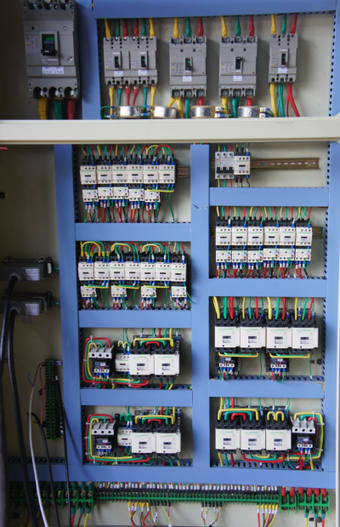
 |  | gear bitumen pump | CLB100 | 1 | set | Xinjin
 |  | motor | Y112M-4,N=4kW | 1 | set | Jiangsu dazhong
 |  | revolving plug valve | X44W-16C,Φ40 | 1 | set
10 | Frame | mainframe |  | 2 | set
10 | Frame | platform、railing |  | 1 | set
10 | Frame | Traction frame |  | 2 | set
10 | Frame | Front axle | 7.50-20 | 1 | set
10 | Frame | Rear axle | 8.25-12 | 2 | set
10 | Frame | supporting leg |  | 12 | pc
11 | Electronic Control System | control room |  | 1 | pc
11 | Electronic Control System | 1P air condition |  | 1 | set | Domestic brand
11 | Electronic Control System | control platform | include computer system | 1 | pc
11 | Electronic Control System | touch screen | eview | 1 | set | Taiwan
11 | Electronic Control System | switch |  | 6 | pc | OMRON
11 | Electronic Control System | connect cable |  | 1 | set
12 | Pneumatic System | air compressor | W-0.9/7-E；N=7.5kW | 1 | set | Fujian jianyang
12 | Pneumatic System | pneumatic system central parts |  | 1 | set
12 | Pneumatic System | FRL Combination | QFLJWA-L15 | 1 | pc | Airtac
12 | Pneumatic System | electromagnetic valve | Q25DC-L15 | 7 | pc | Airtac
13 | Coal grinding equipment | Coal grinding mill | MPF600 | 1 | set | Fuzhou huayi
13 | Coal grinding equipment | Motor | N=22kw | 1 | set | Fujian mindong
13 | Coal grinding equipment | Coal handling pipe |  | 1 | pc
13 | Coal grinding equipment | Control cabinet |  | 1 | pc

EXCLUSIONS

a) Civil works, but provide loading drawing.
b) Any power source.
c) Link cables between generating set and our motor control panel and essential services panel.
d) Any item not definitely specified.

