**LED floor display P6.4 cabinet size :512mm *512mm**

**The front of cabinet:**

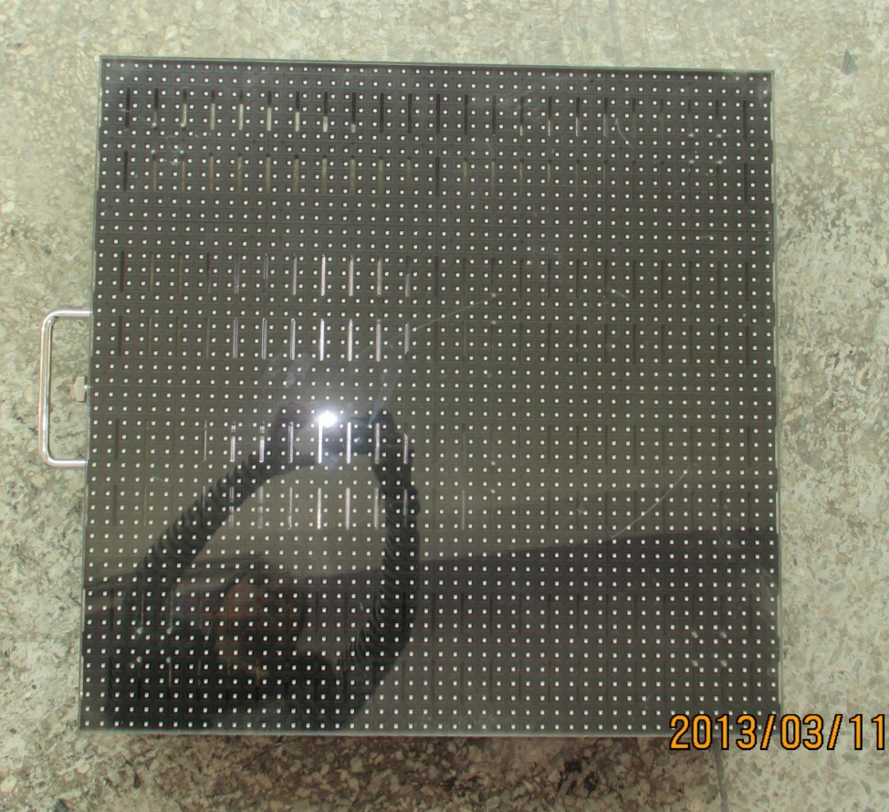

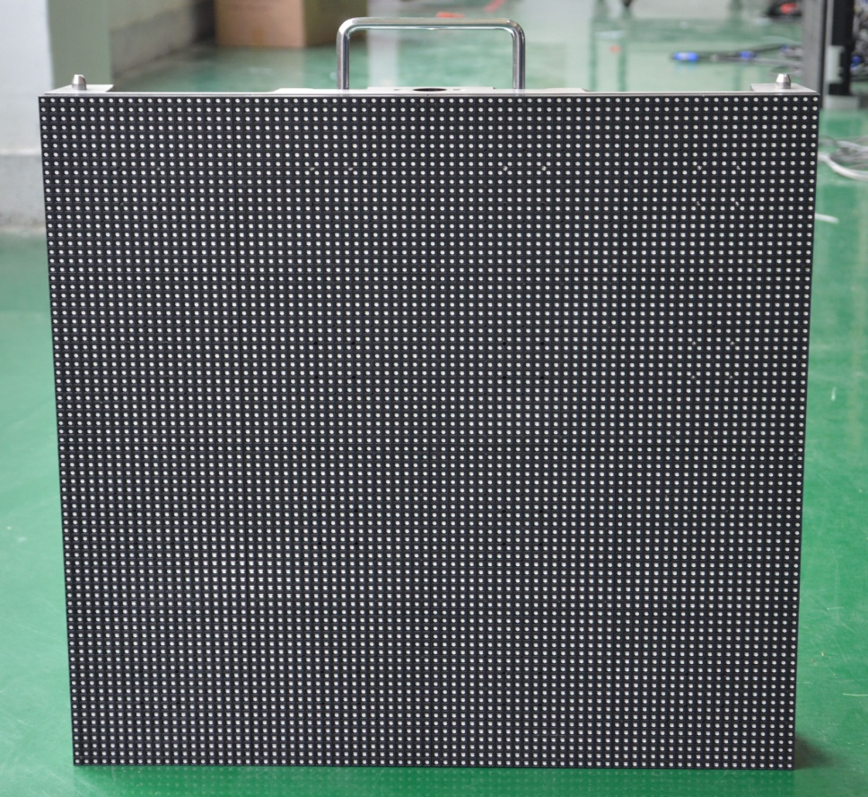

**The cabinet of housing needs to be covered a pcs Acrylic glass**

**The back of cabinet:**

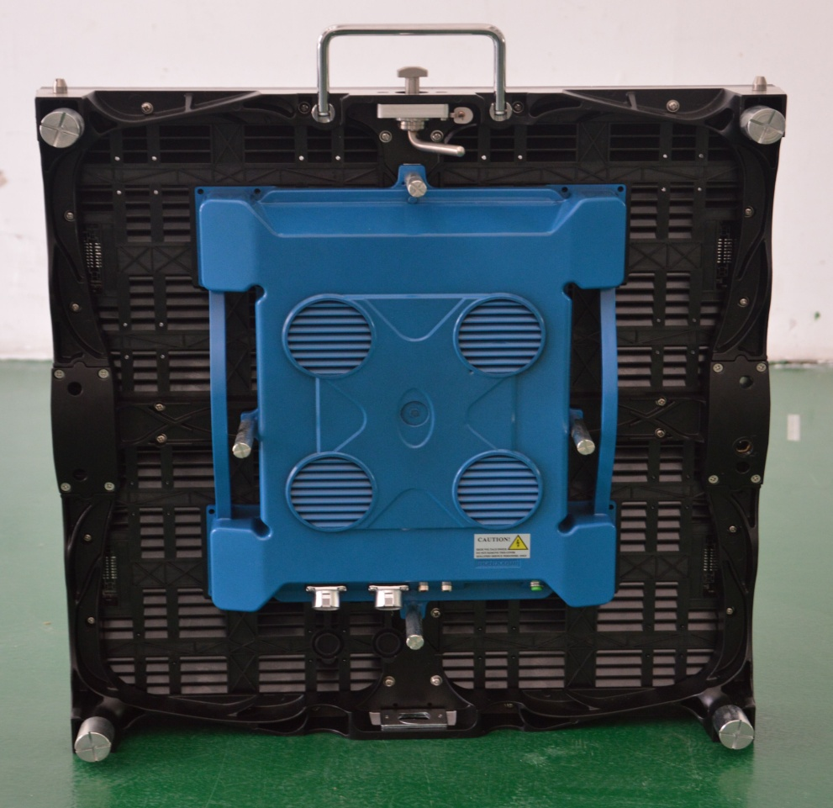

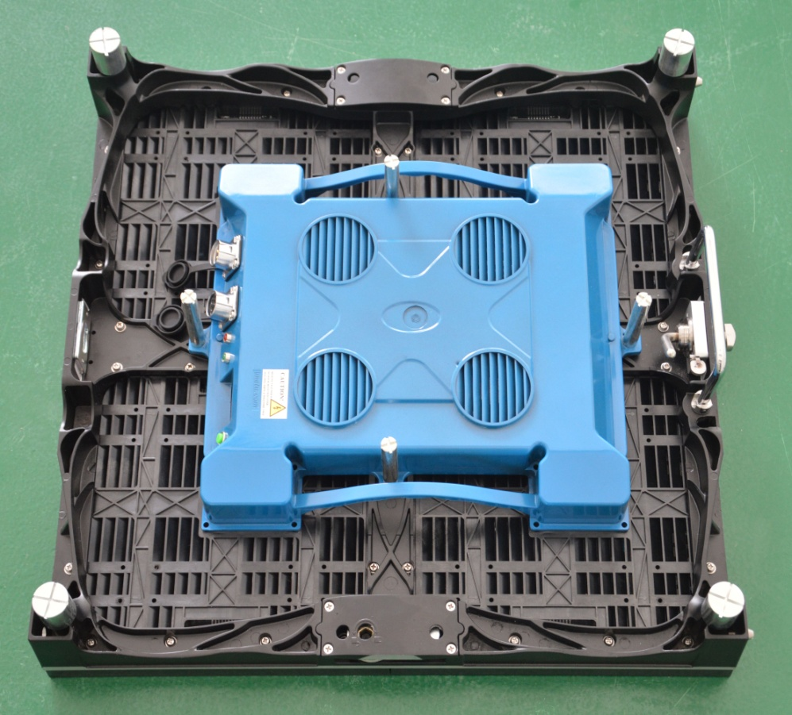

**Cabinets of connection:**

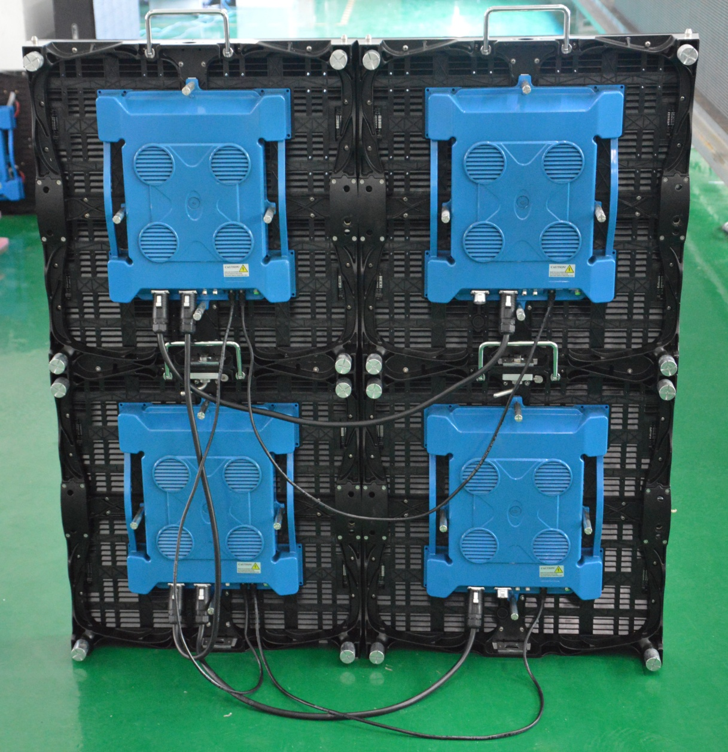

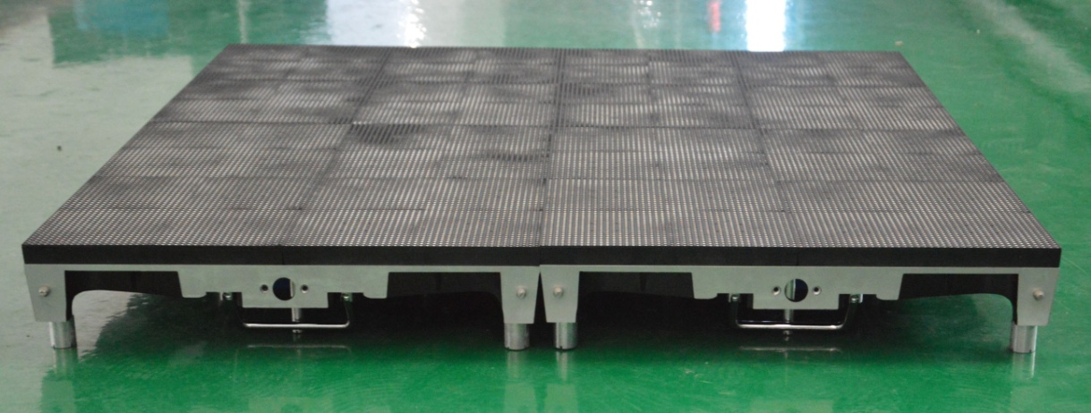

**Each cabinet of housing needs to be covered a pcs Acrylic glass**

**LED screen of aging :**

