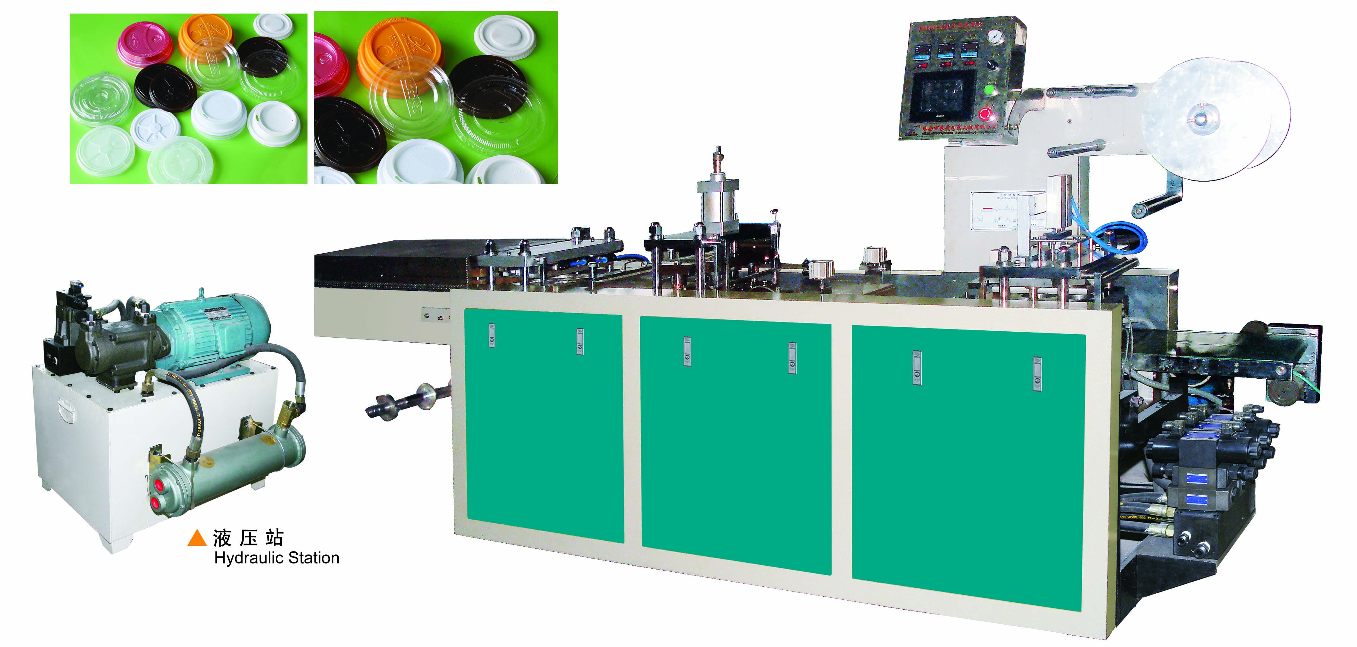
DHBGJ-350L Automatic Cover Forming Machine
Technical Parameter:
Punching Frequency | 20-35time/min
Max Forming Depth | 50mm
Max. Forming Area | 260mm*340mm
Air-compressor | <0.2m³/min
Pressure | 0.4-0.7MPa
Power | 20Kw
Overall Dimension | 4000*750*1700mm
Weight | 1000Kg

Characteristic:
It’s a new type one that combines advantages of several types of main forming machines and also brings to more improvement and innovation.
With easy operation, calm running, convenient maintenance and stable function.
It can produce PVC, PS, PET etc. all kinds of covers.

