YZF 406

Quotation: USD57500(EXWORK)
Delivery time: 30 workdays
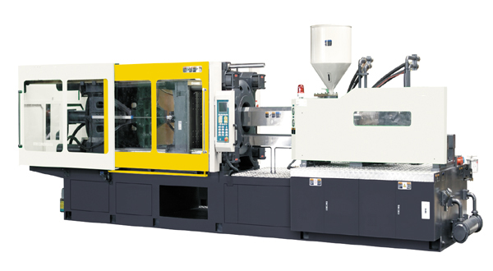

Main specification of YZF406 |  | Screw A | Screw B | Screw C
Injection Unit
Screw Diameter | mm | 70 | 75 | 80
Screw L/D Ratio | L/D | 21.4 | 20 | 18.8
Shot Volume (theoretical) | CM³ | 1423 | 1634 | 1859
Injection Weight (PS) | g | 1295 | 1487 | 1692
 | oz | 45.6 | 52.4 | 59.6
Injection Rate | g/s | 366 | 395 | 446
Plasticizing Capacity | g/s | 60 | 65 | 70
Injection Pressure | MPa | 199 | 173 | 152
Screw Speed | rpm | 160
Clamping Unit
Clamp Force | KN | 4060
Toggle Stroke | mm | 700
Max. Mould Height | mm | 800
Min. Mould Height | mm | 280
Space Between Tie Bars (W×H) | mm | 720×720
Ejector Force | KN | 110
Ejector Stroke | mm | 160
Ejector Numbers | n | 13
Others
Max Pump Pressure | MPa | 16
Pump Motor Power | kW | 37
Heater Power | kW | 20.73
Machine Dimension (L×W×H) | m | 7.57×1.96×2.41
Machine Weight | t | 14.2
Oil tank capacity | L | 687

