LCF-1530A CNC CO₂ Laser Cutting Machine
LCF-1530A 数控激光切割机

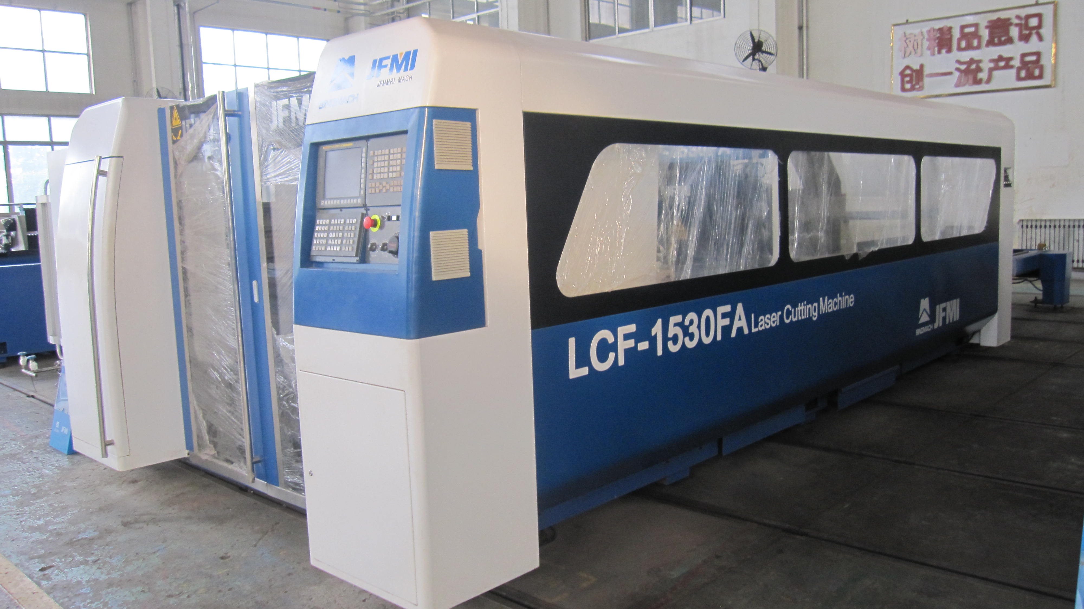

Jinan Foundry and Metalforming Machinery Research Institute Co., Ltd.
2013/11

1. Technical Parameters
 | Items项目 | Parameter参数 | Unit单位 | Remark备注
 | Max. cutting range 最大加工范围 | 3030×1520 | mm
 | X axis stroke X轴行程 | 3030 | mm
 | Y axis stroke Y轴行程 | 1520 | mm
 | Z axis stroke Z轴行程 | 120 | mm
 | W axis stroke W轴行程 | 14 | mm | Automatic focusing自动调焦
 | X、Y axis positioning accuracy  X/Y 轴定位精度 | ±0.05 | mm/m
 | X、Y axis reposition accuracy  X/Y轴重复定位精度 | 0.025 | mm
 | X、Y Max. cutting speed  X/Y轴的最大切割速度 | 145 | m/min
 | Worktable Max. loading capacity  工作台最大载重 | 1000 | kg
 | Floor space（L x W）  占地面积（长*宽） | 9500×3200 | mm
 | Main machine weight主要机械重量  （not include laser generator不包括激光发生器） | 12 | t
2. Main Configuration主要配置
 | Items项目 | Manufacturer制造商
1 | CNC system FAGAR8070 数控系统 FAGAR8070 | Japan日本 FANUC
2 | AC digital servo motor 交流数字伺服电机FAGAR8070 | Japan 日本FANUC
3 | AC digital servo driving system 交流数字伺服驱动系统 | Japan日本 FANUC
4 | Laser generator C2000 激光发生器C2000 | Japan 日本FANUC
5 | Z axis following capacitance-type sensor  Z轴电容式传感器 | Germany 德国PRECITEC
6 | Automatic programming software 自动编程软件 | English 英国RADAN
7 | Transducer变频器 | Imported进口
8 | Precision rack and gear 精密齿条和齿轮 | Germany德国 Herion
9 | Precision ball screw 精密滚珠丝杠 | Taiwan 台湾HIWIN
10 | Precision ball linear guideway 精密滚珠直线导轨 | Japan日本 THK
11 | Automatic focusing axis 自动调焦轴 | Design by ourselves自己设计
12 | Precision reducer 精密减速器 | Germany德国 Stober
13 | Laser cutting head 激光切割头 | Design by ourselves自己设计
14 | Air circuit system components 气路系统组件 | Japan日本 SMC
15 | Outside light path glass 外部光路玻璃 | USA美国 II-VI
16 | f8.75" focus glass f8.75"调焦玻璃 | USA美国 II-VI
17 | Hydraulic cylinder 液压油缸 | Japan日本 SMC
18 | Hydraulic unit elements 液压单元元件 | Design by oursleves自己设计
Auxiliary Support Equipment
 | Water Cooling Unit | China中国 DVT LSJR
 | Voltage-stabilized source | China中国 SBW
 | Screw type air compressor(optional) | Atlas Copco BLT-10A
 | Cooling dryer and Filter | Germany 德国PARKER SPL012
 | Centrifugal fan（for dusting device） | China famous brand中国著名品牌
 | Dust collector(optional) 收尘器 （可选） | Imported进口

3. Spare Parts备件（not include parts installed on equipment不包括安装在设备上的备件）
 | Items项目 | Quantity数量 | Remark备注
 | Cutting head切割头 (importer from USA美国进口)  ￠2.0，￠2.3，￠2.5 | Each 5pcs, 每种5件  total 15pcs总计15件 | Free supply along with equipment随机提供
 | Ceramic body陶瓷体 | 1pc | Free supply along with equipment随机提供
 | Focus glass调焦玻璃 | 1pc | Free supply along with equipment随机提供
 | Socket head wrench套筒扳手 | 1set | Free supply along with equipment随机提供
 | Screw driver螺丝刀（cross, plain十字的，普通的）medium中等的 | Each 1pc每种1件 | Free supply along with equipment随机提供
 | Open spanner 开口扳手 | 1set | Free supply along with equipment随机提供
 | Raw tape空白带 | 1coil | Free supply along with equipment随机提供
 | 704 silicone rubber 704 硅橡胶 | 1drum | Free supply along with equipment随机提供
 | Approaching switch, relay 接近开关，继电器 | Each 2pcs每种2件 | Free supply along with equipment随机提供

Price价格
To be discussed after Technical Approval 技术验收后商讨
Payment付款
30% by T/T in advance, 70% balance by T/T before shipment
预付30% T/T，发货前70% T/T
Documents before delivery发货前文件
a. Purchase order with all requirements带有所有要求的采购订单
b. 100% payment 100%付款
Delivery time发货时间
Within three months after payment settled 付全款后的三个月内
Installation and Training安装和培训
Free installation and training 免费安装培训
All rest relevant expense is for buyer’s account excludes air ticket除机票外的所有其他相关费用由买方承担
Warranty质保期
Free for one year一年免费


