1 Non-Pressurized Solar Water Heater
Item No. | Specification | Vacuum Tube |  |  | Capacity | Inner Tank |  | The Size of Packing | Gross Weight | Price (FOB Tianjin) | The Quanity of 40`Container
 |  | Diameter | Length | No.s |  | Material | Thickness | mm
HMSD Series (21⁰,33°, 42°, 50°)
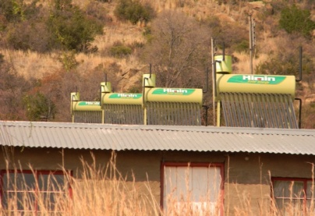 | Q-B-J-1-125/1.47/0.05-1 | Φ58MM | 1800MM | 12 | 120L | SUS304 | 0.5mm | 1105×1621×1870 | 43KGS | USD158/PC | 88PCS
 | Q-B-J-1-145/1.72/0.05-1 | Φ58MM | 1800MM | 14 | 140L | SUS304 | 0.5mm | 1255×1621×1870 | 47KGS | USD169/PC | 80PCS
 | Q-B-J-1-165/1.97/0.05-1 | Φ58MM | 1800MM | 16 | 160L | SUS304 | 0.5mm | 1405×1621×1870 | 51KGS | USD190/PC | 67PCS
 | Q-B-J-1-185/2.22/0.05-1 | Φ58MM | 1800MM | 18 | 180L | SUS304 | 0.5mm | 1555×1621×1870 | 55KGS | USD203/PC | 67PCS
 | Q-B-J-1-205/2.48/0.05-1 | Φ58MM | 1800MM | 20 | 200L | SUS304 | 0.5mm | 1705×1621×1870 | 65KGS | USD257/PC | 60PCS
 | Q-B-J-1-245/2.98/0.05-1 | Φ58MM | 1800MM | 24 | 240L | SUS304 | 0.5mm | 2005×1621×1870 | 69KGS | USD274/PC | 60PCS
 | Q-B-J-1-285/3.48/0.05-1 | Φ58MM | 1800MM | 28 | 280L | SUS304 | 0.5mm | 2305×1621×1870 | 79KGS | USD300/PC | 60PCS

2 Non Pressure Collectors
The technological data and price of Himin Low pressurized solar collectors
Model | Collecting area(㎡) | Total area(㎡) | Gross Weight(including water)KG | Size | Tubes  Length*diameter  MM | FOB Tianjin port USD | Quantity in 20’s container | Quantity in 40’s container | Quantity in 40HQ container
JPS-30TX21-50° | 5.4 | 6.27 | 256 | 2930*1551*1833 | 2100*58 | 359 | 70 | 140 | 160
JPS-30TX21-33° | 5.4 | 6.27 | 256 | 2930*1965*1367 |  | 363 | 70 | 240 | 160
JPS-30TX21-15° | 5.4 | 6.27 | 245 | 2930*2223*757 |  | 353 | 70 | 140 | 160
JPS-30TT21-00° | 5.4 | 6.27 | 230 | 2930*2390 |  | 288 | 70 | 140 | 160
JPH-50TX18-33⁰ | 7.6 | 8.6 | 389 | 3680*1970*1526 | 1800*58 | 455 | 54 | 108 | 132
JPH-50TX18-00⁰ | 15.2 | 8.6 | 337 | 3672*2445 |  | 354 | 54 | 108 | 132
JPS-60TX21-50° | 10.8 | 12.54 | 555 | 2930*3082*3645 | 2100*58 | 758 | 42 | 84 | 100
JPS-60TX21-33° | 10.8 | 12.54 | 555 | 2930*3968*2658 |  | 771 | 42 | 84 | 100
JPH-100TX18-33⁰ | 15.2 | 15.8 | 770 | 3.68*4.307*2.949 |  | 993 | 30 | 60 | 68

3 Heat Pipe Collectors

Heat Pipe | Specification | Aperture area | tubes |  | FOBxiangangUSD | Container
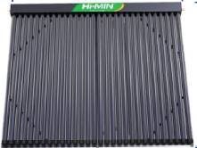 |  |  | number | length*Diamter MM |  | 20' | 40'
 | HRJ7-10/1.8 | 1.22 | 10 | 1800x58 | 203 | 150 | 358
 | HRJ7-15/1.8 | 1.84 | 15 | 1800x58 | 300 | 120 | 285
 | HRJ7-20/1.8 | 2.46 | 20 | 1800x58 | 401 | 92 | 220
 | HRJ7-25/1.8 | 3.08 | 25 | 1800x58 | 502 | 70 | 160
 | HRJ4-30/18 | 3.7 | 30 | 1800x58 | 597 | 64 | 153

