日产20000条编织袋成套生产设备
序号及图片  No. and Picture | 设备名称  Name | 规格型号  Mold | 单价  Unit price | 数量  Qty | 金额  Total  price | 生产能力  (单机)  Unit capacity
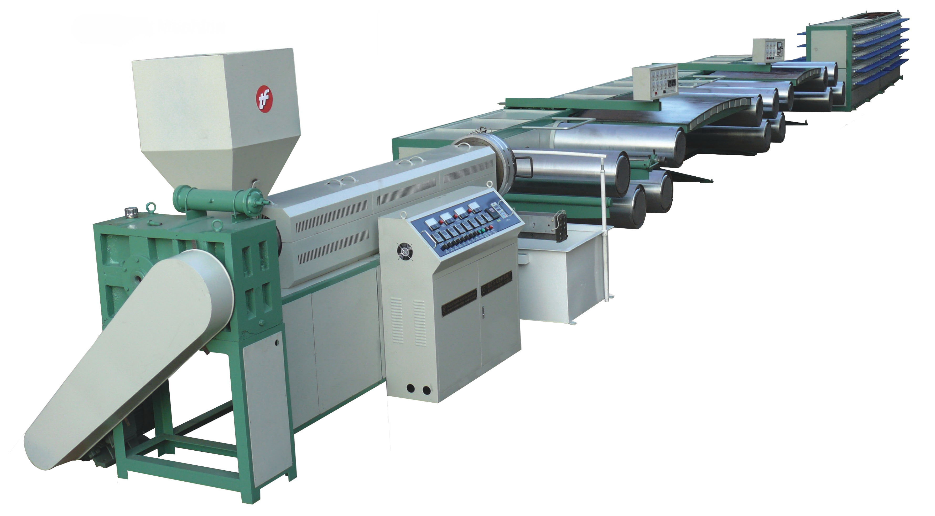 | 塑料扁丝拉丝机  Tape production line | SJ-FS5.5-110/800 | 29000 | 1 | 29000 | 50-100千克/小时  50-100kg/h
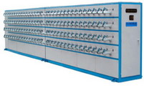 | 组合式收卷机  Winder | S-SJJ-11 | 29000 | 120锭 | 29000
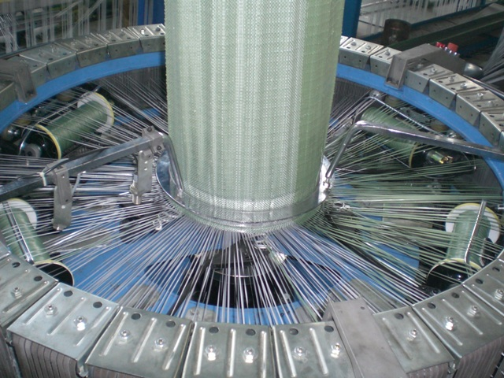 | 六梭圆织机  6 shuttle circular loom | SBY-850X6S | 9000 | 6 | 54000 | 1.8-2.5m/min  3kw
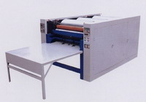 | 三色印刷机  3 color printing machine | S-YDJ-800III | 4000 | 1 | 4000 | 1000-1500pc/h
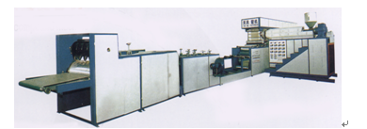 | 复合机  Lamination machine | SJ-FMF800-90I | 29000 | 1 | 29000 | 20-80m/min
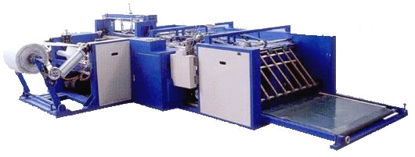 | 自动切缝机  Auto cut & sew machine | QF850 | 26000 | 1 | 26000 | 20-36pc/min  10KW
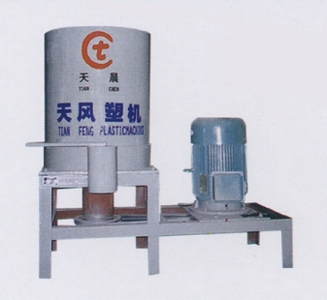 | 烘干搅拌机  Dry machine | SH-30 | 1500 | 2 | 3000 | 150-300 kg/h
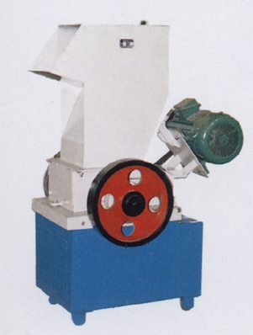 | 粉碎机  Crusher machine | SCP-300 | 1500 | 1 | 1500 | 30-50 kg/h
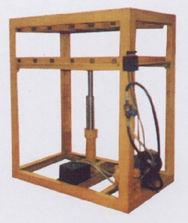 | 液压打包机  Baling machine | DB-100 | 850 | 1 | 850
铜管Bobbin |  | ￠38×230mm | 0.3 | 15000 | 4500
总 计  Total FOB SHANGHAI |  |  | USD 151850

备注： 1. 以上价格为含税FOB SHANGHAI价。
2. 付款方式：T/T （30%定金，余款70%发货前付清）或L/C。
集装箱：3X40FT。
交货期：收到30%定金或信用证2个月交货。
3. 所有产品为全新产品，自设备安装之日起一年内实行质量“三包”、设备使用年限10年以上，如去国外调试客户负责我方工程师食宿和往返机票并支付工程师每人每天60美金的工资
4. 用电：120KW; 用人：12人每班； 厂房：长40米宽20米高5米

Terms and conditions
TERMS OF PAYMENT:
T/T OR IRREVOCABLE L/C AT SIGHT.
BY T/T: 30% DEPOSIT OF TOTAL AMOUNT, THE BLANCE 70% WILL BE PAID BEFORE DELIVERY
BY L/C: 30% DEPOSIT OF TOTAL AMOUNT, THE BLANCE 70% WILL BE PAID BY L/C.
DELIVERY TERM:
2 MONTHS AFTER RECEIPT OF ORIGINAL L/C OR RECEIPT OF T/T DEPOSIT.
DELIVERY PORT:
CHINA MAIN PORT (SHANGHAI).
INSTALLATION:
OUR COMPANY WILL SEND 2-5TECHNICIANS FOR INSTALLATION, ADJUSTMENT, TRAINING FOR CUSTOMER, THE BUYER SHOULD BEAR ALL THE CHARGE SUCH AS ROUND TICKET, ACCOMMODATION, FOOD ETC, AND THEY SHOULD PAY $60/DAY/PERSON DURING THE PERIOD. ALL THE INSTALLATION CHARGE COST WILL BE ISSUE IN THE PROFORMA INVOICE.
GUARANTEE SYSTEM AND MAINTENANCE:
ONE YEAR GUARANTEE FOR THE MACHINES EXCEPT THE SPARE PART, CUSTOMER WILL BE SUGGESTED TO BUY PRODUCTION SPARE PART FROM US YEARLY.
BANK DETAILS FOR INWARD T/T OR L/C OPENING:
- Beneficiary’s Bank: BANK OF COMMUNICATIONS HEFEI BRANCH
2. Bank Address: 38 HUAYUAN STREET, HEFEI, CHINA, 230001
TEL: 86-551-2636976
FAX: 86-551-2637046
3. Bank Swift Code: COMMCNSHHFI
4. Beneficiary A/C: 341399000146300000561
5. Beneficiary: HEFEI TIANFENG PLASTIC MACHINERY CO., LTD

