
No.1, Jing’er Road Feiyun New Area, Ruian City, Zhejiang Province, China
Tel: 86-577-65026938 Fax: 86-577-65025068 E-mail:31@31000.cn http://www.31000.cn

QUOTATION
DXDS-J350E Catsup four-side sealing & double-line packing machine
Price (FOB NINGBO): USD14500.00 (Validity of the offer: 30 days）
Picture:
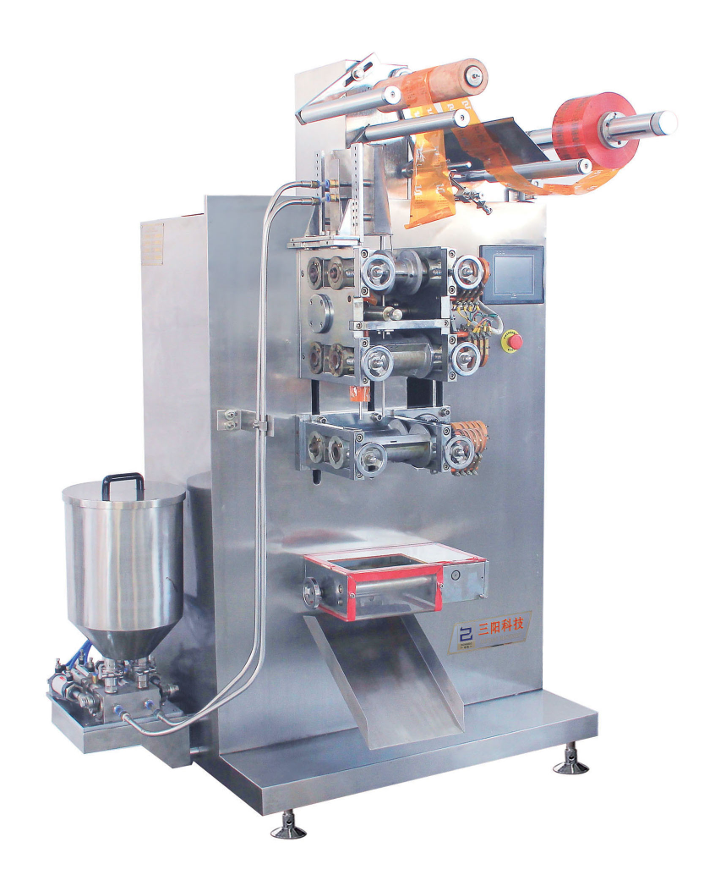
Sample：
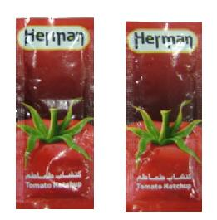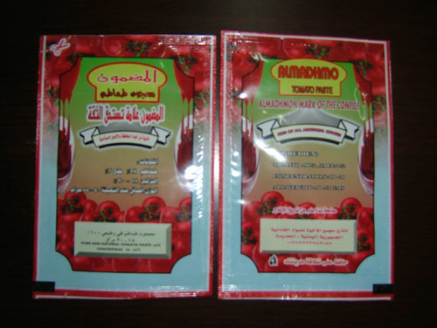
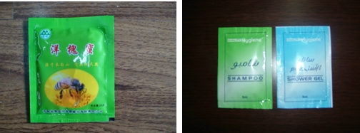

REMARK:
- packing material:____
- pouch size: width:____ mm*Length: ____mm
- Dosage:__ ml
- speed:____times/min (pls give pouch width and length, then we can sure the speed)
- Sealing way: four side sealing
- cutting: Flat cutting, with tear notch
- Printing: machine price already with iron printing without color (free), also can use ink roll printer, but should add usd_400
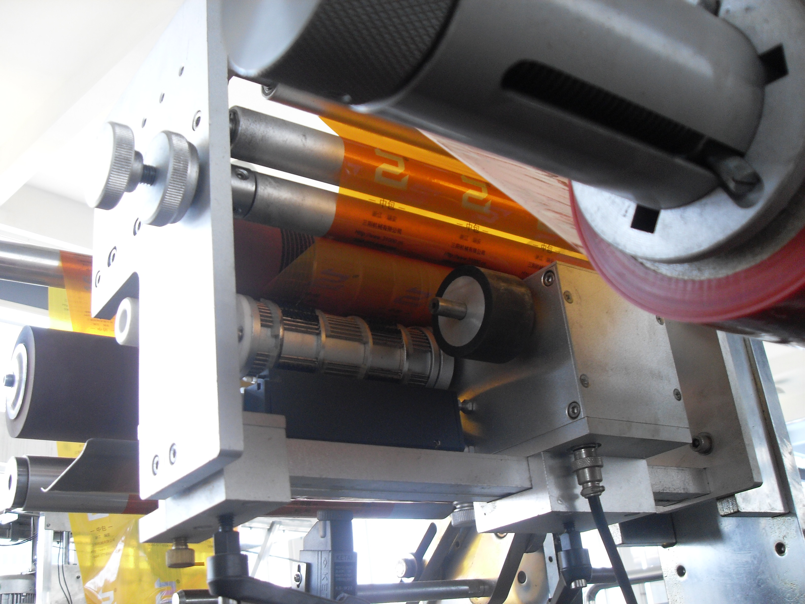
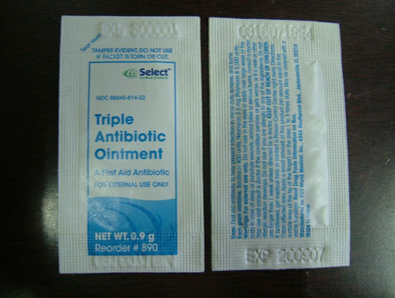
This date is iron printing without color, press it.
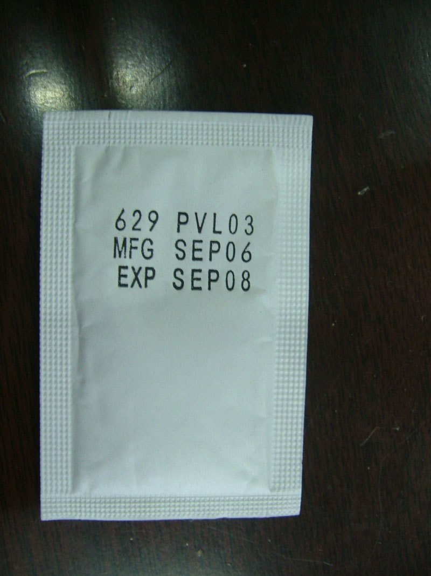
This is use ink roll printer to printing date

- Machine shell adopts AISI 304 Stainless, Material touching parts: AISI 316 stainless steel.
- Export wooden case is suitable to long distance transportation.
- Delivery date:35-45 work days after receipt of 30% deposit
- Payment: 30% deposit by T/T for order, left amount should be send before delivery date.
- Checking: customer should come to factory to check machine with material and film before delivery time.
- Guarantee: guarantee for one year, within this period if spare parts national broken differ from artificial broken, seller supply spare parts with free. Customer should responsible for expenses only
- If need seller send technician for debugging machine, buyer responsible for all fees. Salary: 100USD/DAY.

Alice
Ruian Sanyang Technology Co., Ltd
Adresse: No. 1, Jing'er Road, Feiyun New Area, Rui'an City, Zhejiang Province, China.
Tel: 86-577- 65026938 65025118 Mobile: 86-15857782507
Fax: 86-577-65025068
Site: www.zjpackingmachine.com
E-mail: sales@chinapackagemachinery.com
MSN: jiangru@hotmail.com
Skype: alicejin6

