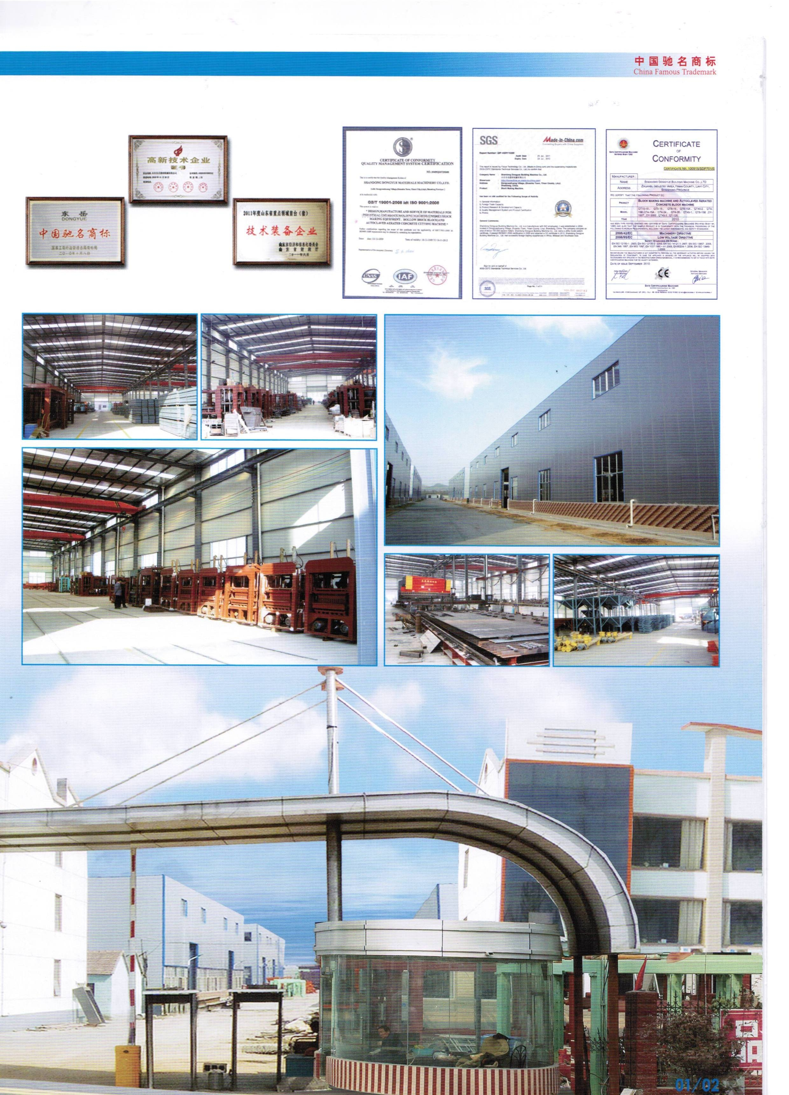

QT4-15C Production Line Price

No |  |  |  | Name |  | Specification |  |  |  | Unit price× Qty. |  | Images
I Batching System
1 | 45 ton cement silo  (for reference not including the total price ) |  |  |  |  |  | Capacity | 45tons |  | Supplied by customer |  | 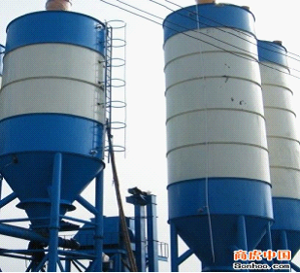
1 |  |  |  |  |  |  | Diameter of tank | 2.2 m
1 |  |  |  |  |  |  | Thickness of tank | 5mm
1 |  |  |  |  |  |  | Total height | 11 m
2 | Screw Conveyor  (for reference not including the total price ) |  |  |  |  |  | Diameter (mm) | 219 mm |  | 2200×1 Set |  | 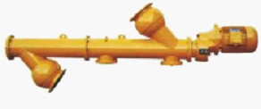
2 |  |  |  |  |  |  | Wall thickness(mm) | 8mm
2 |  |  |  |  |  |  | Handling Capacity (m³/h) | 34tm³/h
2 |  |  |  |  |  |  | Power (kw) | 5.5 kw
3 | Cement Scale  (for reference not including the total price ) |  |  |  |  |  | Volume of Weighing Hopper | 0.4m³ |  | 1300×1 Set |  | 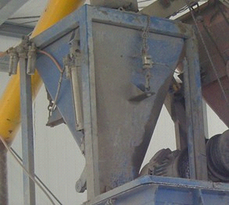
3 |  |  |  |  |  |  | Batching Precision | ±1％
3 |  |  |  |  |  |  | Max. Metage of Powder Material | 500kg
3 |  |  |  |  |  |  | Max. Metage of Water Scale | 180kg
4 | Concrete Batching Machine |  |  |  |  |  | Cubage of weighing hopper | 1.2 m³ |  | 7900×1 Set |  | 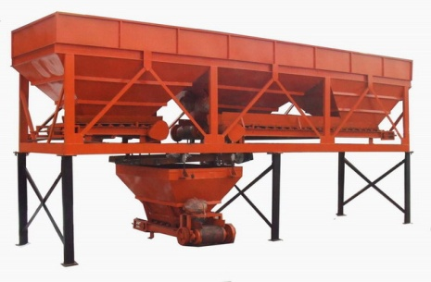
4 |  |  |  |  |  |  | Cubage of reserve hopper | 3×3m³
4 |  |  |  |  |  |  | Productivity | 60m³/h
4 |  |  |  |  |  |  | Max. metage | 2000 kg
4 |  |  |  |  |  |  | Batching category | 3
4 |  |  |  |  |  |  | Dimension（L×W×H)mm | 8390×2000×2800
5 | JS500  concrete mixer |  |  |  |  |  | Input Capacity | 800L |  | 6600×1 set |  | 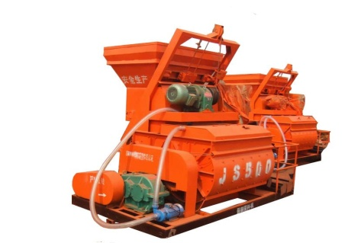
5 |  |  |  |  |  |  | output Capacity | 500L
5 |  |  |  |  |  |  | Productivity | ≥25m3/h
5 |  |  |  |  |  |  | Max. raw diameter material | 80/60 mm
5 |  |  |  |  |  |  | Roating speed of stirring shaft | 2*8r/min
5 |  |  |  |  |  |  | Dimension ((L×W×H)mm | 3030×2300×2800mm
5 |  |  |  |  |  |  | power | 24.75KW
5 |  |  |  |  |  |  | Weight | 4000kg
6 | Belt conveyor |  |  |  |  |  | Length | 6 m |  | 1500x1 set |  | 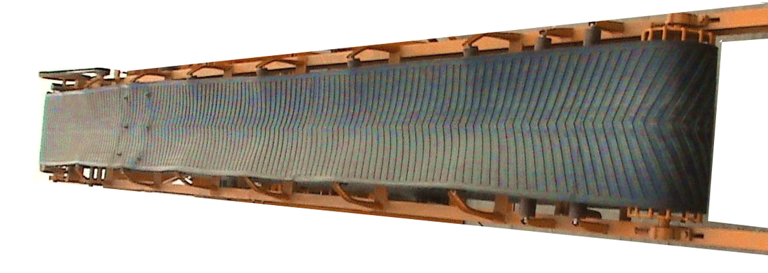
6 |  |  |  |  |  |  | Width | 50 cm
6 |  |  |  |  |  |  | Power | 1.1kw
Ⅱ、Forming Section
7 |  | Block making machine |  |  |  | Block Making Machine |  | 1pices |  | 19800×1 Set | 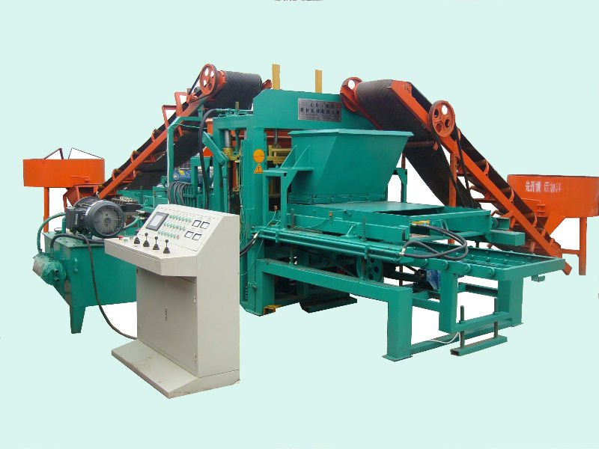
 |  |  |  |  |  | Hydraulic Unit |  | 1 piece |  | 19800×1 Set
 |  |  |  |  |  | PLC Control Unit |  | 1 piece |  | 19800×1 Set
 |  |  |  |  |  | Pallets Feeder |  | 1 piece |  | 19800×1 Set
 |  |  |  |  |  | Block sweeper |  | 1 piece |  | 19800×1 Set
 |  |  |  |  |  | Spare parts and tools |  | 1 piece |  | 19800×1 Set
 |  |  |  |  |  | mould |  | 1set |  | 19800×1 Set
Ⅲ.Transferring Section
8 |  | Transferring equipment |  |  | Automatic Blocks Stacker |  |  | 1 sets | 4500×1set |  | 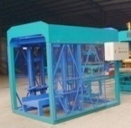
 |  |  |  |  | Manual Hydraulic Cart |  |  | 2 pieces
Total Price FOB Qingdao :40300USD
Container: Equipment No.4~8 requires 2×40 feet container (40HQ)
IV.Optional Accessories
9 |  |  | Color feeding part |  | Color feeding machine |  |  | 1 piece | 4500x1 set |  | Optional ( for paver with color making)
 |  |  |  |  | Color mixer(1.2m diameter) |  |  | 1 piece
 |  |  |  |  | Color belt conveyor |  |  | 1 piece
10 |  |  | Pallet |  | PVC pallet/Bamboo pallet |  |  | (1010x550x25mm) | 1200 pcs. |  | 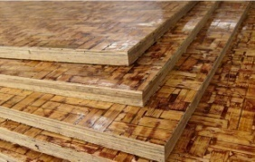
11 |  |  | Extra mould |  | Block mould |  |  | 1set | 2200 |  | (Including hollow block,solid block)
 |  |  |  |  | Paver mould |  |  | 1 set | 2400 |  | (Including all kinds of paver,interlock,curbstone)

QT4-15C Host machine parameter
Dimension of host machine | 3800×1800×2550mm | Host machine power | 19.2 KW
Mould area | 400×800mm | Vibration force | 40KN
Mould period | 15-25S | Mixer model | JQ500/JS500
The size of the pallet | 1010×550×25mm | General water Consumption | 4T/every day
Weight of the host machine | 4.6T | Voltage | 380V/220V/415V

Block and paver general capacity

Size(LxWxH) | Pcs/Mould | Pcs/ Hr | Pcs/ 8 Hr
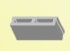400X100X200 | 8 | 1440 | 11520
400X150X200 | 6 | 1080 | 8640
400X200X200 | 4 | 720 | 5760
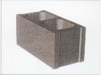400X250X200 | 3 | 540 | 4320
230x110x70 | 24 | 4320 | 34560
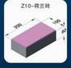200X100X60 | 16 | 2880 | 23040
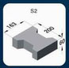200X163X60 | 8 | 1440 | 11520
Can make all kind of hollow and solid and paver block

Main Raw Material

Stress and Strength : 10-15Mpa(to increase the strength, it will need to change the mix design)

No | NAME | Proportional ration | Sample
1 | cement | 10% | 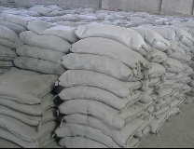
2 | sand | 30% | 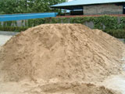
3 | Crushed stone | 60% | 

