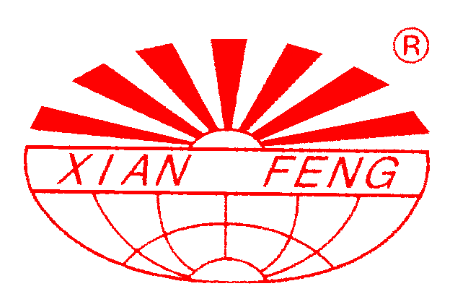

PROJECT

FOR

FL-300 FLUID BED GRANULATOR
&
GFG-300 Fluidizing Dryer

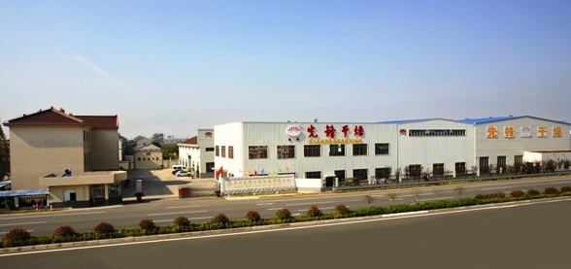

BY

Jiangsu Xianfeng Drying Engineering Co., Ltd
China
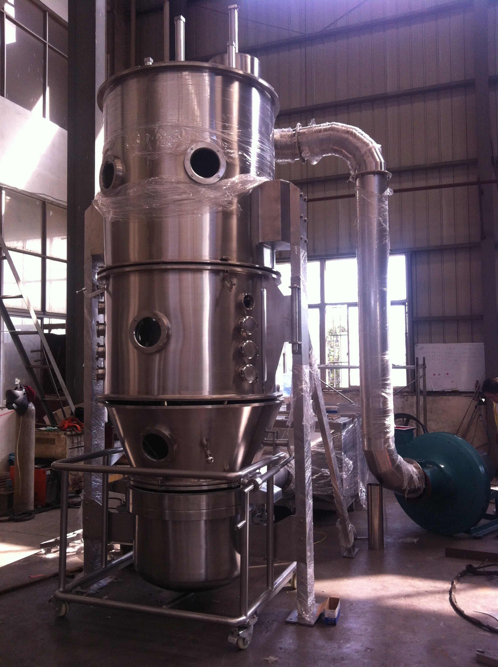
Fluid bed granulator

FL-300 Fluid bed granulator
Technical Parameters：
Item | Unit | parameter
Diameter of container | mm | 1600
Container volume | L | 1000
Capacity | Kg/batch | 150-350
Power of fan | kW | 30
Electrical heater | kW | 90
Amount of compressed air | M³/min | 2.0
Compressed air pressure | MPa | 0.6

Detailed parts：
Name | Spec | Material and type | Manufacturer
Main machine system | filtering chamber(Top chamber)： dust remove and filter system with shaking cylinder, | SUS304 Flange δ=16  Main machine δ=3mm  Granulating system include peristaltic pump, spray dryer | Xianfeng
Main machine system | Middle chamber SUS304  With spray nozzle(two fluid), peristaltic pump |  | Xianfeng
Main machine system | One trolley: SUS304 |  | Xianfeng
Main machine system | Top-lift section：2 air cylinder and ballonet air-sealing |  | Xianfeng
Main machine system | Inlet air chamber ：with inlet air adjust air flap , inlet-air filter and heater, drainage |  | Xianfeng
Main machine system | Support: stainless steel SUS304 |  | Xianfeng
Main machine system | Seal ：silicon rubber |  | Xianfeng
Main machine system | Temp point ：inlet one ，outlet one |  | Xianfeng
Air heater and inlet air filter system | Electrical heater | 90 kW | Xianfeng
Air heater and inlet air filter system | Cover | SUS304 | Xianfeng
Air heater and inlet air filter system | Primary ,middle filter and HEPA | Screen 、non-woven fabrics， | Xianfeng
Inlet air and  exhaust air system | Draught fan (separated installed with main machine) | （1）manual operation wind volume；  （2）Motor power 30 Kw | Buy from market
Inlet air and  exhaust air system | Silencer | noise≤80 decibel, Carbon steel | Xianfeng
Inlet air and  exhaust air system | Inlet air duct with inlet air flap | SUS304 δ=2 mm | Xianfeng
Inlet air and  exhaust air system | Exhaust duct | SUS304 δ=1.5mm
Inlet air and  exhaust air system | Outlet air duct | duct：carbon steel δ=1.5mm | Xianfeng
Control system | Control cabinet | Stainless Steel | Xianfeng
Control system | Main electrical parts | Electric relay ,air switch and so on | Siemens
Control system | Indicating instrument | Ampere meter, voltmeter, temp sensor | Buy from market
Control system | Pneumatic element | cylinder、manifold block 、barometer | Buy from market
Control system | PLC |  | Siemens
Control system | Touch screen |  | Siemens
Bag filter |  | With antistatic fibre, uniformity release static electricity，no spark appear ，safety in production | Xianfeng
Viewing window | Toughened glass | Observe inside material condition | Xianfeng
Spare Parts
No | Name | Type | Unit | Qty
1 | Sealing strip |  | set | 1
2 | Compressed air tube | Ф10 | meter | 10

FLUIDIZED BED DRYER

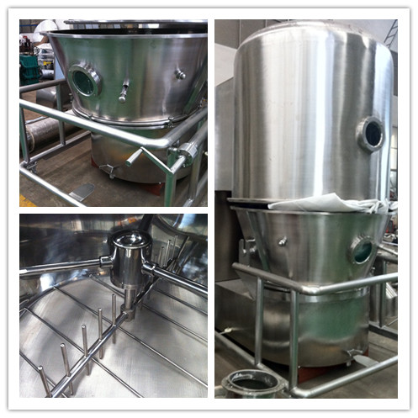

GFG-300 FLUIDIZED BED DRYER
Technical Parameters：
Item | Unit | parameter
Feeding capacity | kg/batch | 200-300
Fan power | KW | 30
Consumption of steam | kg/h | 400
Consumption of compressed air | M³/min | 0.9
Equipment list：
name | details | Material and instruction | Manufacturer
Main frame system | Filter room: has the filters and the explosion release | SUS304  It fits for different kinds of powder and granule drying. | Xianfeng
Main frame system | Middle room: has view glass |  | Xianfeng
Main frame system | One trolley: material flow in fluid-bed with stir motor |  | Xianfeng
Main frame system | Lifting: double cylinder and air cell pressure |  | Xianfeng
Main frame system | Air inlet room; it has water exit, adjustment air valve |  | Xianfeng
Main frame system | Main tower support: cover with Sus304 |  | Xianfeng
Main frame system | Main tower airproof: Silicon rubber |  | Xianfeng
Main frame system | Temperature test: air inlet and air outlet |  | Xianfeng
Air Heating system | Gas furnace |  | Xianfeng
Air Filtrating system | Initial and middle efficient filter | Sieve screen, none woven fabric | Xianfeng
Air Filtrating system | Shell | SUS304 | Xianfeng
Air Filtrating system | Sub-high efficient filter | Three grade filter, meet 300000 level. | Xianfeng
Air exhaust system | Suction fan | (1) hand adjustment air valve  (2) engine power 30 Kw | Buy from market
Air exhaust system | silencer | Carbon painted, make sure the fan is closed off. noise≤80db(A) | Xianfeng
Air exhaust system | Air pipe | Pipes: sus304 | Xianfeng
Air exhaust system | Dust exhaust pipe | Pipes: sus304  Flange: sus304 | Xianfeng
Air exhaust system | Air exhaust pipe | Pipes: carbon steel  Flange: carbon steel | Xianfeng
Control system | Tank | Carbon steel plastic painted
Control system | Operation system | Touch screen control | SIEMENS
Control system | program | PLC
Control system | Electrical element | Touch, relay, button, air switch | SIEMENS
Control system | Indication instrument | Current watch, voltage watch, temperature sensor, temperature control
Control system | Air pressure element | Cylinder, air pressure watch
Hop pocket |  | Has anti static fiber, release the static equality, no fire. Safe produce. | Xianfeng
View window | glass | It can see the material in the machine | Xianfeng

Spare parts：
no | Name | Specification | Unit | qty
1 | Air cell | Supply as the machine | pc | 1
2 | Sealing strip of the main tower | Supply as the machine | set | 1
3 | Air compress pipe | Supply as the machine | m | 10

Quotation：
No | Equipment | Model | Qty | Price (USD)
1 | Fluid bed granulator | FL-300 | 1 set | 42800
2 | Fluidized bed dryer | GFG-300 | 1 set | 38800
FOB (Shanghai) |  |  |  | 81600
T/T: 30% deposit after signed contract, 70% balance before delivery.

Safety features：
The machines can’t be started without safe earthing.
The machines can’t be started without the bag filter not in place
The machines will stop with the bag filter leak
The machines will stop with explosive
The machines can’t be started without the inlet and outlet flap open

Documentation：
One copy of operational manual in English will be given with the delivery of machine.
Provide relevant certificates (such as product certificate, spare part certificate)
Provide additional set for spare part.
All our machines guaranteed for trouble free performance for a period of 12 months from commissioning.

Delivery date：
Within 45 work days

Packing：
Wooden case (Approved by custom)

After-sell service：
Installation and after-sell service free for one year. But the Buyer shall bear all the expenses incurred in the trip of the Seller's delegation for erection, commissioning and training, including air tickets, meal, hotel accommodation and local transportation.
We accept FAT for client.

Angela Xie

Jiangsu Xianfeng Drying Engineering Co.,Ltd

Add：Zhenglu industrial zone, Changzhou City, Jiangsu province, China
P.C.:213111 http://www.czxf.cn/en/
FAX: 0086-519-88930288 Foreign trade: 0086-519-88930111
E-mail: 2005@czxf.cn

