Chemical composition of steel in%, for machining of bearings subjected to chemical-heat treatment and quenching.

|  |  |  |  |  |  |  |  |  |
| --- | --- | --- | --- | --- | --- | --- | --- | --- |
| Steel type | С | Мп | Si | Сг | Ni | Р | S | Си |
| Not more than | | |
| G20Cr2Ni4A | 0,30-0,60 | 0,30-0,60 | 0,17-0,37 | 1,25-1,65 | 3,25-3,65 | 0,025 | 0,025 | 0,30 |
| GCr15SiMn | 0,95-1,05 | 0,90-1,20 | 0,40-0,65 | 1,30-1,65 | До 0,30 | 0,027 | 0,20 | 0,25 |

Sketches and dimensions of parts are attached.

Specifications: steel G20Cr2Ni4A ( ГОСТ 4543-71 )

part 01 (outer ring), 02 (inner ring) of cement to a depth (h) 4.0 -4, 5 mm, part 04 (videos) seated at a depth (h) -3.2 mm, 3.0

Approximate duration of cementation one fish rings -50 hrs approximate duration of cementation one charge rollers-35 hrs .Annual demand in detail-01.02 282800kg. Annual demand in detail 04-100761kg annual fund operating equipment 7920 hrs

1 the process of carburizing: a tentative working space of mine. furnace 1500 * 1500 mm Allows complete styling rings on one device (IE. Ûdet. 8det. 02 + 01) weight charge ~ 2100 kg + weight of attachments Weight accessories-estimated dimensions: diameter 1300 mm, height 1500 mm (for the styling details 01, 02, 04) Temperature carburizing 930-940 0 c Naugleraživaûŝaâ environment-natural gas, substance to the CH 4 80-90% (to clean up sulfur) when reaching the desired depth cementovannogo layer, charge details unloaded from e. the oven and cool in the oil quenching tank. Temperature quenching oil 40-60 0 С. Cooling details hold up to 130 temperature-100° c (15-20 min) requirements for mine electric furnaces for carburizing Set power selector to indicate warm-up time when driving the oven to a temperature of 1000° c temperature Uniformity in the working space of the retort furnace ± 5° c (steady state) to equip the Office heating-microprocessor, with the possibility ...

1. Mine electric furnace for high-temperature vacation: high-temperature vacation in e. oven with forced air circulation. The amount of the charge is equal parts Sage was loaded, the Grouting. Working space of the furnace (roughly 1500 * 1500 mm) when the temperature of 150-750° c, the heating time to 8:0 pm Set the temperature uniformity of the heating furnace in the working space of ± 5° c (steady state) set the alarm (when inflating, underestimating the temperature) to equip the Office heating-microprocessor PID controller, with access to a PC for archiving processes of heating, PC interface Set counters of electric energy consumption and heat loss through the walls of the oven at 60° c < work

Electric furnace for heating the knees underneath the hardening: diameter. rings up to 1300 mm, height rings up to 220 mm, weight up to 150 kg of rings. Variants of furnaces: Continuous or rotary. Heating temperature up to 1000 0 c heating time from 90 to 130 min Temp download-issue rings 30-40 min. Adjustable speed feed method of travel details on podu furnaces pass (roller) heat Uniformity in the working space of the furnace ± 5° c (steady state) alarm (when inflating, the underestimating of temperature control) For gas curtain at the inlet and outlet of the furnace (exclude podstugivaniya and oxidation parts by heating) after heating part 01 and 02, 20Х2Н4А steel, are laying on a stamp (to avoid distortion of the geometry of the rings) and then cooling in oil. 01and 02 parts after heating made of steel Shx15sg, are subject to immediate cooling of the oil.Оснастить управление нагревом - микропроцессорное ПИД регулятор возможностью выхода на ПК для архивирования процессов нагрева , интерфейс с ПК. Установить счетчики наработки и расхода электроэнергии Потери тепла через стенки печи при работе < 60° С

Hardening oil tank next to the raspologaeteâ e pečyo for heating rings (near the unloading window-furnace):

* 1. The estimated capacity of the oil tank ~ 30 m 3 oil tank (conditionally) divided into 2 departments:

2-nd unite - for cooling devices with details after cementation and cooling a punch with a detail of steel 20Х2Н4А after heating in electric furnace

Weight of charge (after cementation), without accessories -2100 kg weight of a stamp with a ring (after heating in electric furnaces) ~ 500 kg.

2nd unite - cooling of parts of the steel Shx15sg after heating in e. In the second part-provide specials. the device, with soft swinging in a vertical direction, with the amplitude of vibrations from 0 mm to 150 mm and wiggle speed 0.3 m/sec Duration jiggle details in special device "from 5 to 15 minutes duration jiggle adjustable special device must ensure that the cooling rate details ~ 40° c/sec, with 870 temperature 0 c to -200 c 0

Cooling devices with details after cementation, the cooling of parts of the heating and cooling ŠH15SGposle after heat rings from steel 20Х2Н4А with a stamp does not occur at the same time. . In the hardening tank provide a device for mixing or borbotaža oils provide a device for loading and unloading of the stamp with a ring of quenching oil tank.

Provide for the cooling system oil with temperature above 70° c and heating oil from the temperature 20° c to 40° c temperature

Provide protection against ignition of oil cooling parts after heating.

Bearing types, details of which are chemical-thermal and thermal processing

|  |  |  |  |  |  |  |  |
| --- | --- | --- | --- | --- | --- | --- | --- |
| Bearing item no. | part | Part size (mm) | | | Part weight (kg) | Annual demand of the part (pc) | Annual demand of the part (kg) |
| Outer dia | Inner dia | hight |
| 6-10079/560 ХМ | 01 | 750,0 | 676,3 | 64,0 | 35,0 | 700 | 22120 |
| ... | 02 | 648,0 | 625,5 | 85,0 | 38,0 | 700 | 26250 |
| - | 04 | 45,0 | 12,0 | 51,0 | 0,6 | 30800 | 17864 |
| 6-10079/710 ХМ | 01 | 950,0 | 853,0 | 80,0 | 65,0 | 340 | 21998 |
| - | 02 | 823$ | 796,4 | 106,0 " | 77,0 | 340 | 26010 |
|  | 04 | 54;0 - | 12,0 | 70,0 | 1,2 | 15980 | 18217 |
| 6-10079 /900 АХМ | 01 | 1180,0 | 1066,9 | 87,0 | 110,0 | 800 | 88000 |
|  | 02 | 1026,0 | 900,0 | 122,0 | 123,0 | 800 | 98400 |
|  | 04 | 59,0 | 12,5 | 75,0 | 1,5 | 44000 | 64680 |

additional diagrams of parts bearing.

part. 01

D outer.

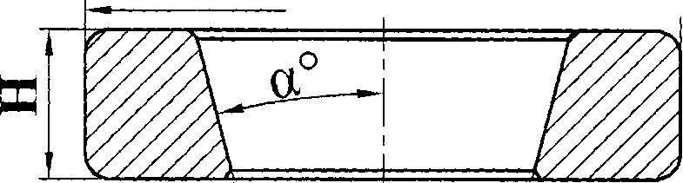

Р roller raceway.

part. 02 D inner.

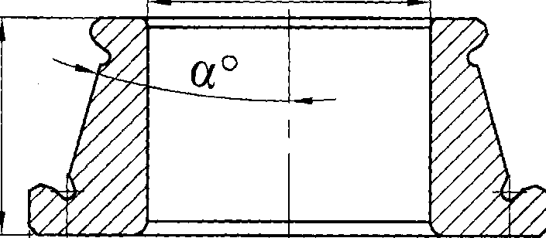

D roller raceway and outer.

part. 04 f D roller.

