Stainless steel flatware rolling mill
The rolling mill is used to thin the steel plate with more extension by cold rolling process. The rolling work can be lengthways or transversely for different product, widely used in stainless steel flatware, cutlery production.
Feature
- Stable performance with compact structure, easy for maintenance.
- High output capacity with low noise for modern production.
- Advanced machine to save material cost, improve product quality.
- Auto lubrication system to ensure well machine performance
- Mill roller made from 9Cr2Mo for more hardness and wear abrasion
Main technical data
Parameter | Roller Diameter | Rolling Speed | Workpiece thickness | Main motor | Dimension  (L*W*H) | Weight
Unit | Mm | r/min | mm | KW | mm | kg
HYJ-300 | 300 | 44.5 | 1.0-4.0 | 7.5 | 2260*1610*1700 | 5000
HYJ-350 | 350 | 34.5 | 2.0-6.0 | 11 | 2310*1730*1780 | 6000
SYJ-250 | 254 | 46 | 4.0-5.0 | 11 | 2350*1600*1350 | 4500
Price
Price basis: FOB CHINA
Payment term: 30% deposit by T/T, the balance by T/T against copy of B/L.
Delivery time: 35 days after receiving down payment.
Unit price: HYJ-300(12inch) USD1400
HYJ-350(14inch) USD1800
SYJ-250 USD1600
Guarantee period: One year since the date B/L.
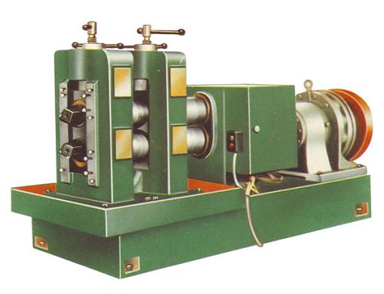
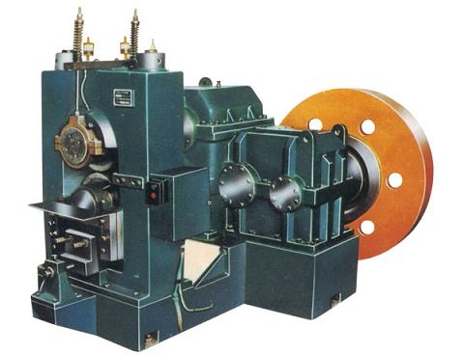

Transverse Lengthways

