SINOMACH products highlight at 13th international show of construction equipments and technologies
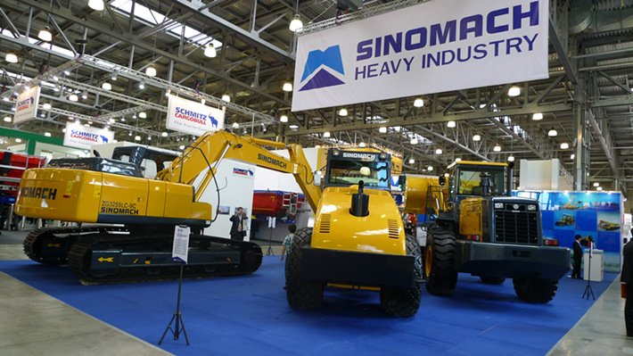

From 29th of May to 2nd of June, Executive deputy General Manager Mr Wang Weiyan leads a team to participate in the 13th international show of construction equipments and technologies(CTT2012) which is held in Moscow. China SINOMACH Heavy Industry Corporation shows its Loader, roller and excavator in the brand of SINOMACH, meanwhile, it is first time to show in overseas market for SINOMACH products.

This exhibition is significant for SINOMACH brand propaganda, as well it is foundation of entering into Russian federation market. During the exhibition, customers from the Republic of Belarus, Ukraine, Estonia and Russia etc are interested in SINOMACH products, what is more, they negotiate with sales representatives in detail for the business.

At present, the scale of overseas machineries and equipments which Russia imported is taking 30% of the imported total amount in Russia, it is offering huge opportunities for Chinese construction machinery manufacturing industry. CTT has been become biggest Exhibition of construction and engineering machinery in the region of East European, Central Asia and Russia Federation.

During the period of visiting Russia, Executive deputy General Manager Mr Wang Weiyan paid a visit for the Russian market, and what is more, he has inspected the partner who have cooperation intention and have larger strength in the locality.

